Wire Antennas for Ham Radio
Iulian Rosu YO3DAC / VA3IUL, http://www.qsl.net/va3iul
Note: Dimensions of the antennas presented below are either in: feet ('), inch ("), meters (m), or centimeters (cm)
01 - Tee Antenna  02 - Half-Lamda Tee Antenna  03 - Twin-Led Marconi Antenna  04 - Swallow-Tail Antenna  05 - Random Length Radiator Wire Antenna  06 - Windom Antenna  07 - Windom Antenna - Feed with coax cable  08 - Quarter Wavelength Vertical Antenna  09 - Folded Marconi Tee Antenna  10 - Zeppelin Antenna  11 - EWE Antenna  12 - Dipole Antenna - Balun  13 - Multiband Dipole Antenna  14 - Inverted-Vee Antenna  15 - Sloping Dipole Antenna  16 - Vertical Dipole  17 - Delta Fed Dipole Antenna  18 - Bow-Tie Dipole Antenna  19 - Bow-Tie Folded Dipole Antenna for RX  20 - Multiband Tuned Doublet Antenna  21 - G5RV Antenna  22 - Wideband Dipole Antenna  23 - Wideband Dipole for Receiving  24 - Tilted Folded Dipole Antenna  25 - Right Angle Marconi Antenna  26 - Linearly Loaded Tee Antenna  27 - Reduced Size Dipole Antenna  28 - Doublet Dipole Antenna  29 - Delta Loop Antenna  30 - Half Delta Loop Antenna  31 - Collinear Franklin Antenna  32 - Four Element Broadside Antenna  33 - The Lazy-H Array Antenna  34 - Sterba Curtain Array Antenna  35 - T-L DX Antenna  36 - 1.9 MHz Full-wave Loop Antenna  37 - Multi-Band Portable Antenna  38 - Off-center-fed Full-wave Doublet Antenna  39 - Terminated Sloper Antenna  40 - Double Extended Zepp Antenna  41 - TCFTFD Dipole Antenna  42 - Vee-Sloper Antenna  43 - Rhombic Inverted-Vee Antenna  44 - Counterpoise Longwire  45 - Bisquare Loop Antenna  46 - Piggyback Antenna for 10m  47 - Vertical Sleeve Antenna for 10m  48 - Double Windom Antenna  49 - Double Windom for 9 Bands  50 - Collinear Trap Antenna  51 - Short Dipole Antenna for 40m - 80m - 160m  52 - Center Fed-Zepp Antenna for 80m - 40m  53 - All Bands Antenna  54 - All-Bands Dipole Antenna  55 - Multiband Z Antenna  56 - Multiband Dipole Antenna  57 - Five-Bands No-Tuner Antenna  58 - Dualband Full-wave Loop Antenna for 80m-40m  59 - Loop Antenna for 10m  60 - Lazy Quad Antenna for 10m  61 - Tri-band Delta Loop Antenna for 80m - 40m - 30m  62 - Dual-band Loop Antenna for 30m - 40m  63 - Wire-Beam Antenna for 80m  64 - Dual-Band Sloper Antenna  65 - Inverted-V Beam Antenna for 30m  66 - ZL-Special Beam Antenna for 15m  67 - Half-Sloper Antenna for 160m  68 - Two-Bands Half Sloper for 80m - 40m  69 - Linear Loaded Sloper Antenna for 160m  70 - Super-Sloper Antenna  71 - Tower Pole as a Vertical Antenna for 80m  72 - Clothesline Antenna  73 - Curtain Zepp Antenna for 160m, 80m, 40m  74 - Collinear Array Antenna for 40m, 30m, 20m  75 - 160m Inverted Delta Loop  76 - Half Rhombic Unidirectional Vertical for 20m to 6m  77 - Capacitance Loaded Vertical Antenna for 160m  78 - Fan Dipole Antenna for 80m to 6m  79 - Wire Ground Plane Antenna  80 - Inverted Delta Loop Antenna for 160m  81 - Inverted-L for 160m  82 - 300ohm-Ribbon Dual Band Dipole  83 - Tri-Band Beam for 20m, 15m, 10m  84 - Mini-Horse Yagi Antenna  85 - Backpack J-Pole Antenna for 10m, 6m, 2m  86 - Fan-Dipole Antenna for 80m, 40m, 20m  87 - Capacity Tuned Folded Loop Antenna for 20m  88 - Indoor Loop Antenna for 80m to 30m  89 - Indoor Loop Antenna for 80m  90 - Double-Delta Antenna 80m and 40m  91 - Inductance-Loaded Shortened Dipole for 160m  92 - V-Beam Antenna for 15m  93 - Picnic Vertical Wire Antenna  94 - Laid-Back Quad Antenna for 80m  95 - Phased Loop Antenna  96 - Loop Antenna for TX for 160m  97 - Morgain-Dipole Antenna for 160m and 80m  98 - ZL-Special for 20m, 15m, 10m  99 - Biconical Antenna  100 - Directive Delta-Birdcage Antenna for 20m to 10m  101 - Dual Polarization Antenna for 80m and 40m  102 - Directive 300-ohm-Ribbon Folded Dipole for 15m  103 - Miniature Directive Antenna for 10m  104 - Biquad Antenna 12dBi-Gain for 2.4GHz  105 - Dual-Rhomboid Antenna for 435MHz to 870MHz  106 - Double-Bazooka Antenna for 80m  107 - J-Style Antenna  108 - Vertical / Horizontal / Circular Polarization Antenna  109 - Coax Inverted-L Antenna for 80m  110 - Indoor Compact Loop Antenna for 80m  111 - Helix Antenna  112 - Novice Vertical Antenna for 80m, 40m, 15m, 10m  113 - Stub-Loaded Shortened Dipole for 80m  114 - Six-Band Wire-Stub Trap Antenna for 40m-10m  115 - Multiband Half-Wave Delta-Loop Antenna  116 - Hybrid Vee for 20m, 17m  117 - Six-Shooter Array Antenna, Gain=7.5dB  118 - Multiband Ground-Plane Antenna for 10m, 15m, 20m  119 - Wire Superbeam Antenna for 10m, 15m, 20m  120 - Two Elements Delta-Loop Antenna  121 - Sterba Curtain Antenna  122 - Half-Wave Vertical Zepp Antenna  123 - Lazy-Loop Antenna for 40m  124 - Terminated Folded Dipole for 80m, 40m  125 - Short-Fat Antenna for 15m  126 - Cobra Antenna for 80m  127 - Log-Periodic Wire Antenna for 20m, 15m, 10m  128 - 5-Element Log-Periodic Vertical Antenna for 80m, 40m, 20m  129 - 2m Vertical Wire Antennas  130 - Earth-Mover Inverted-V Antenna for 40m  131 - Coax-Cable Collinear Antennas  132 - Double Bobtail Antenna for 20m  133 - Collinear Zepp Antenna  134 - Taylor Vee Antenna for 20m  135 - Collinear Vertical Antenna 6dB-Gain for 2m, 1.3m, 73cm  136 - Bi-Loop Antenna for 20m  137 - Wire Beam 6dBd-Gain for 10m  138 - Sloping Diamond Antenna 4dB-Gain for 40m  139 - Twisted Loop Antenna for 160m  140 - DX RX Loop Antenna for 160m  141 - Hentenna 3dB-Gain for 10m, 6m, 2m  142 - VK2AAR Wire Antenna for 20m  143 - 2-Elements Quad Antenna for 6m  144 - Hula-Loop Bidirectional 6dB-Gain Antenna for 17m  145 - Moxon Rectangle Beam for 15m-10m  146 - Double-D Beam 4dB-Gain | 147 - KE4PT OCEF All-Band Dipole  148 - Wire Quad Antenna for 40m  149 - Inclined Dipole Antenna for 80m, 40m  150 - Pyramidal Wire Antenna for 80m  151 - Random Wire Antenna All Bands  152 - Multiband Dipole Antenna for 80m, 40m,15m, 10m  153 - Slim Jim Wire Antenna for 4m  154 - Delta Loop for 6m  155 - Re-Configurable Antenna for 160m and 80m  156 - Very Low Frequency Inverted-L Antenna  157 - Reduced Size Half Sloper Antenna for 160m  158 - Tree-Mounted HF Antenna  159 - Multiband Vertical Antenna for 80m, 40m, 20m  160 - Marconi Antenna for 136 kHz  161 - Simple Killer Antenna for 40m  162 - Stub-Directed V Antenna for 80m  163 - KT0NY Over-and-Under DX Antenna for 20m  164 - Horizontal Loop Antennas  165 - Ribbon J-Pole for 2m  166 - Dual Band Ribbon J-Pole for 2m, 70cm  167 - Square Vertical Loop Antenna for 40m  168 - Tri-Band Quad Antenna for 20m, 15m, 10m  169 - 3D Quad Antenna for 80m, 40m, 20m, 15m, 10m  170 - Sloping Wire Antenna for 30m, 20m, 17m, 15m, 12m, 10m  171 - Broadband Dipole Antenna with Coaxial Resonator for 80m  172 - Resonant Feedline Dipole Antenna for 80m  173 - Dual-Band Loading Wire Antenna for 80m, 30m  174 - Stub Matching Antennas  175 - J-Style Vertical Wire Antenna for 10m  176 - Dual Band Vertical with Zepp Feeders for 40m, 20m  177 - RCA Double Doublet for 40m to 12m  178 - RCA Spiderweb Antenna for 40m to 6m  179 - Folded Dipole with Shorted Straps  180 - Twin-Lead Marconi Antenna for 160m, 80m  181 - Broadband Antenna Quarter-Wave Balun for 80m  182 - Three-Quarter-Wave Folded Doublet for Dual-Band  183 - Three-Quarter-Wave Folded Doublet No-Switch for Dual-Band  184 - Wideband Omni-Directional Discone Antenna  185 - Wideband Rhombic Antenna for 40m to 10m  186 - Pre-Cut Linear Array Antenna 3dB-Gain for 40m  187 - X-Array Antenna 6dB-Gain for 20m, 15m, 10m  188 - Double-Bruce Array Antenna 5dB-Gain for 20m, 10m  189 - Bi-Square Broadside Array 4dB-Gain for 20m, 15m, 10m  190 - Six-Shooter Broadside Array 7.5dB-Gain for 20m, 15m, 10m  191 - Triplex Flat-Top Beam 4.5dB-Gain for 20m, 15m, 10m  192 - Dual-Band Tilt Antenna for 20m, 10m  193 - Super Space Multiband Dipole Antenna for 80m to 10m  194 - Bi-Square Beam Antenna Gain=5.5dB for 10m  195 - Cousin of G5RV Multiband Antenna for 40m to 10m  196 - Cayman Quad Antenna for 20m  197 - Hentenna Gain=3dB with Bazooka Match for 6m  198 - X-Beam Antenna Gain=3dB for 20m  199 - Twin Delta Loop Antenna Gain=6dB for 160m, 80m, 40m  200 - Inverted-V Beam Antenna for 30m  201 - FD4 Windom Antenna for 80m, 40m, 20m, 10m  202 - Two Elements Phased Delta Loop for 40m  203 - Three Elements Wire Yagi for 10m  204 - Low Radiation Angle Full-Wave Loop Antenna for 80m  205 - Collinear Antenna Gain=3dB for 2m  206 - X-Ray Monoband Antenna Gain=6.5dBd  207 - Broadside Collinear Curtain Array for 20m  208 - Shrunk Loop Antenna for 80m, 40m  209 - λ/3 Multiband Dipole for 40m, 20m, 17m, 15m, 13m, 10m  210 - K3LR Sloper Antenna Gain=3dB for 160m  211 - Mini Folded Vertical Monopole Antenna for 160m, 80m, 40m  212 - Three Band Dipole for 80m, 40m, 20m  213 - Stub Matched Dipole Antenna  214 - Inverted-Vee Antenna with Bazooka Match  215 - Multiband Long Wire Antenna for 40m, 20m, 15m, 10m  216 - Converted Vee Antenna for 80m, 40m  217 - Swiss Quad Antenna for 20m, 15m, 10m  218 - Japanese Quad Antenna for 20m, 15m, 10m  219 - Seven-Elements Triangle Beam Antenna for 20m  220 - Log Periodic Wire Antenna for 40m  221 - Three-Elements 90-degrees Wire Beam for 20m  222 - Two-Elements Wire Beam for 20m  223 - Suitcase-Fit Dipole Antenna for 80m, 40m, 20m  224 - Multiband Coaxial Dipole for 80m, 40m  225 - Vertical Log Periodic Antenna for 80m, 40m  226 - Inverted Vertical Log Periodic Antenna for 40m  227 - Double Extended Zepp Antenna Gain=7dB for 15m  228 - Double Lazy-H Antenna G=10dB for 70cm  229 - Wire Log Periodic Antenna G=12dB for 15m, 20m  230 - Five-Elements Vertical Log Periodic for 80m, 40m, 20m  231 - Sloping Delta Loop Antenna for 40m  232 - Doublet Antenna for 160m  233 - Log Periodic Wire Beam for 40m  234 - G3LDO Wire Beam Antenna for 20m, 15m, 10m  235 - Phased Delta Loop Array for 20m  236 - Dual Band V-dipole for 80m, 40m  237 - Collinear Array 5dB-Gain for 15m  238 - Two-Band Quad Loop Antenna 80m, 40m  239 - K7CW Quad Antenna  240 - Broadband Short Dipole for 80m  241 - Off-Center Fed Dipole for 40m, 20m, 10m  242 - Broadband Sloper Antenna for 80m  243 - Two-Frequency Dipole Antenna for 80m  244 - Top Loaded Vertical Antenna for 160m  245 - Two Loop Beam Antenna for 20m, 15m  246 - Corner-Fed Delta Loop Antenna for 80m, 40m, 20m  247 - Loaded Delta Loop Antenna for 40m, 20m  248 - Compact Size Dipole for 80m  249 - JAWS 3dB Gain Antenna for 40m  250 - Inverted-V Antenna for 160m  251 - Lazy-U Antenna for 160m  252 - AF3V Compact Antenna for 160m  253 - Hot Beam Wire Antenna for 40m  254 - Sloping Delta Loop for 40m  255 - K6FD Multiband Antenna with T-tuner  256 - Dual Band Dipole Antenna for 17m, 10m  257 - Compact Travel Dipole Antenna for 10m, 15m, 20m  258 - End-Fire Antenna for 160m, 80m, 40m, 20m  259 - Four Band Loop for 40m, 20m, 15m, 10m  260 - Carolina Windom Antenna for 80 to 10m  261 - Shortened Loaded Dipole for 40m  262 - Shortened Loaded Dipole for 80m  263 - Low Radiation Angle Inverted Delta Loop for 80m  264 - Compact Dipole Antenna for 40m, 15m  265 - Vertical Delta Loop for 40m to 10m  266 - Delta Loop Antenna for 17m  267 - Bi-Square Beam Gain=3dBd for 17m  268 -Trap Dipole Antenna for 17m,13m  269 - Hanging Unipole Antenna for 160m, 80m  270 - Wideband Sloping Vee Antenna - 30m to 6m  271 - 5/8 Wavelength Antenna  272 - C-Pole Vertical Antenna  273 - Bobtail Antenna for 30m  274 - Bobtail Antenna for 40m  275 - Two Elements Vertical Loop Antenna for 40m  276 - Double Extended Zepp Antenna for 40m  277 - Reversible Moxon Flip Beam for 40m  278 - Spitwire Antenna for 40m  279 - Fork Antenna for 40m  280 - Veebeam Antenna 3dB-Gain for All Bands  281 - Vertical Moxon Antenna for 10m  282 - Half-Square Antenna for 30m  283 - Rotatable Vertical Delta Loop for 20m  284 - Mini-Horse Antenna 10dB-Gain for 40m-to-2m  285 - Compact Moxon Antenna 5dB-Gain for 40m  286 - Two Elements Sloping Delta Loop 8dB-Gain for 10m  287 - Two Elements Phased Vertical Antenna 3dB-Gain for 40m

01 - Tee Antenna
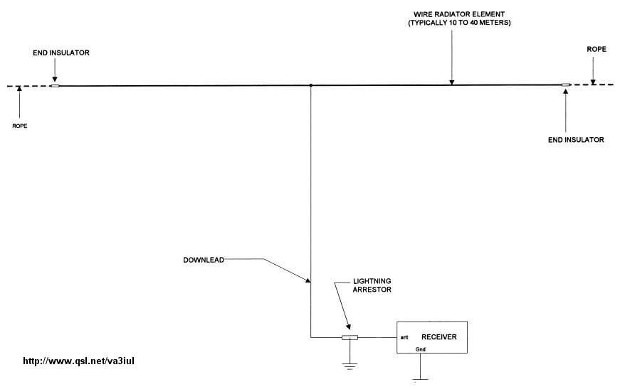
02 - Half-Lamda Tee Antenna
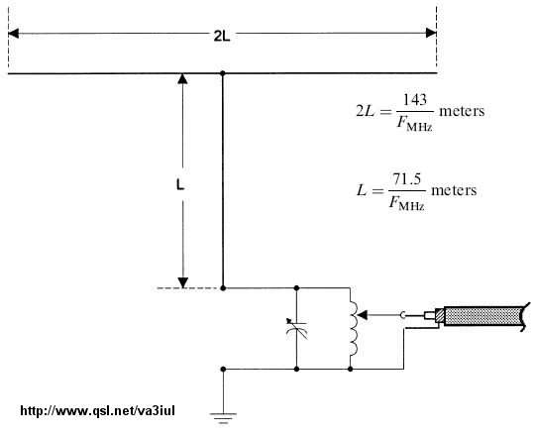
03 - Twin-Led Marconi Antenna
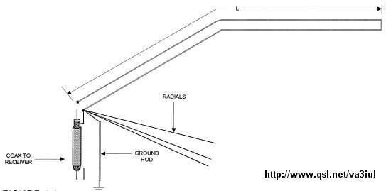
04 - Swallow-Tail Antenna
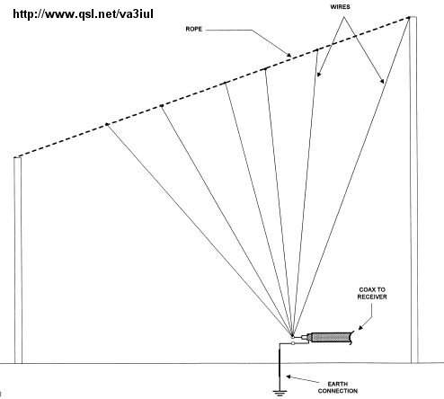
05 - Random Length Radiator Wire Antenna
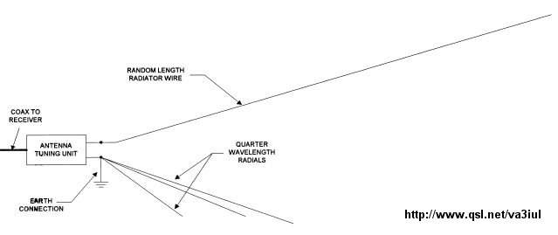
06 - Windom Antenna
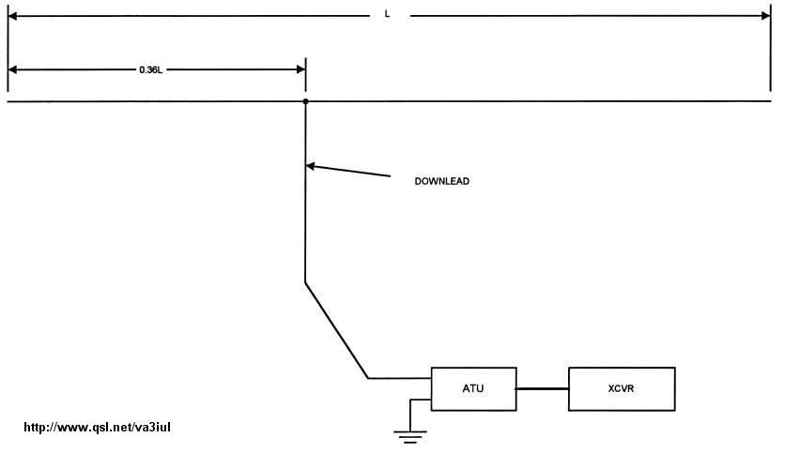
07 - Windom Antenna - Feed with coax cable
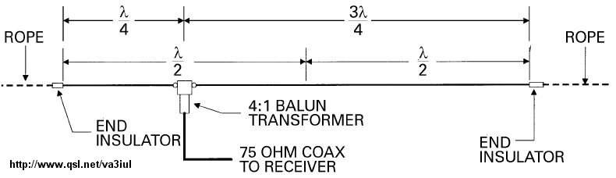
08 - Quarter Wavelength Vertical Antenna
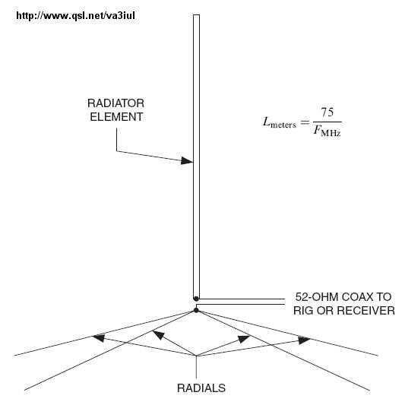
09 - Folded Marconi Tee Antenna
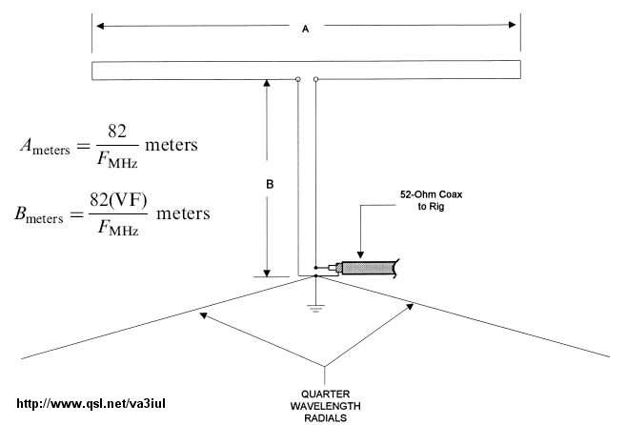
10 - Zeppelin Antenna
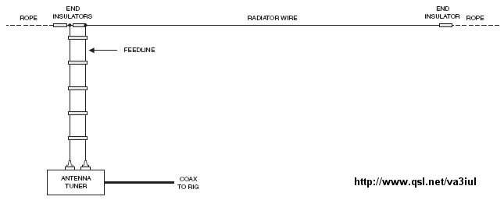
11 - EWE Antenna
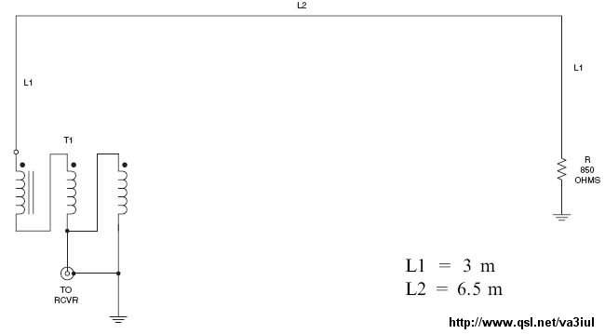
12 - Dipole Antenna - Balun
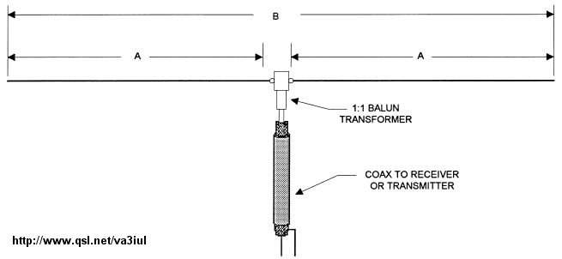
13 - Multiband Dipole Antenna
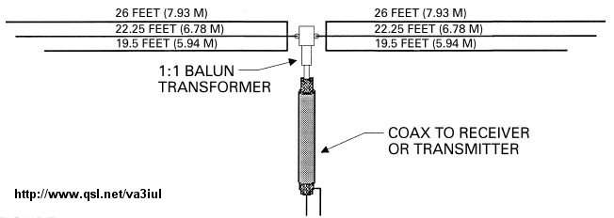
14 - Inverted-Vee Antenna
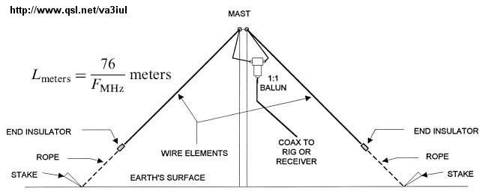
15 - Sloping Dipole Antenna
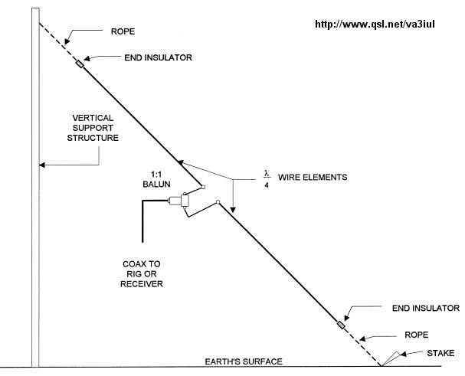
16 - Vertical Dipole
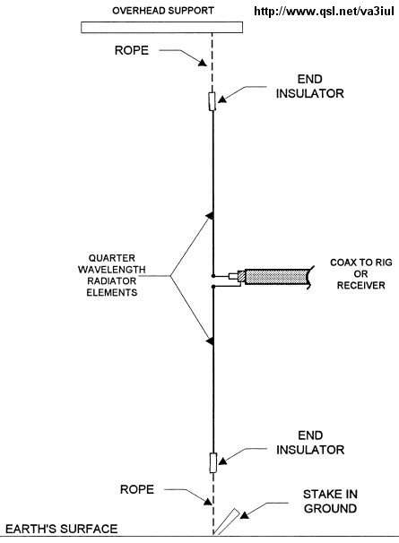
17 - Delta Fed Dipole Antenna
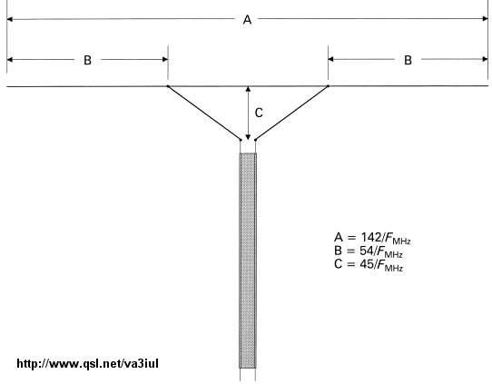
18 - Bow-Tie Dipole Antenna
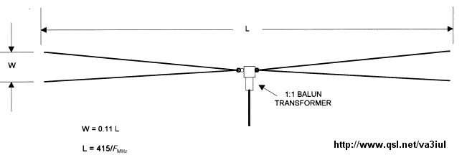
19 - Bow-Tie Folded Dipole Antenna for RX
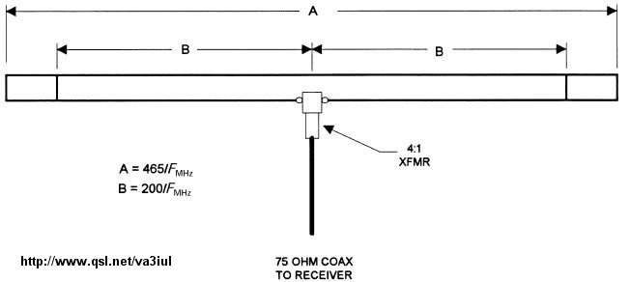
20 - Multiband Tuned Doublet Antenna
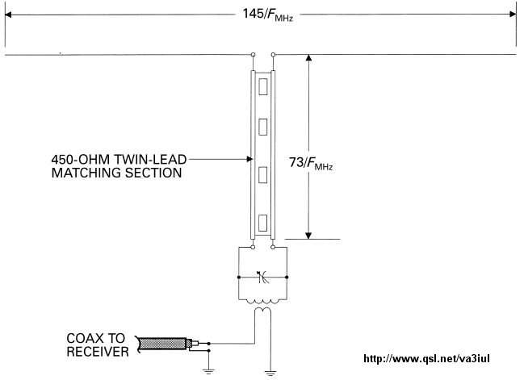
21 - G5RV Antenna
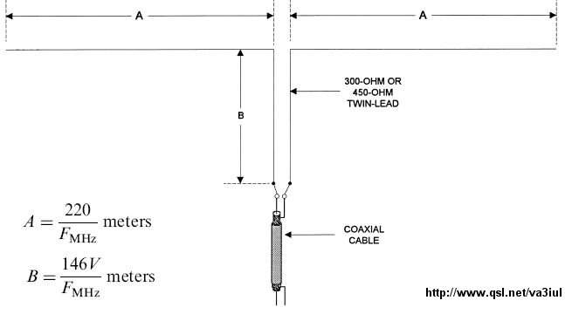
22 - Wideband Dipole Antenna
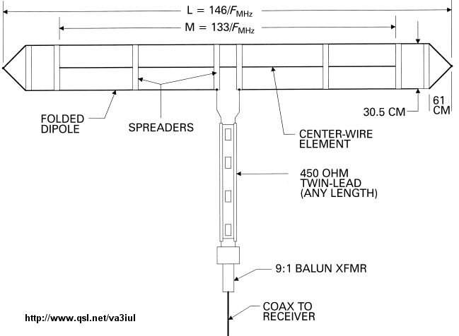
23 - Wideband Dipole for Receiving
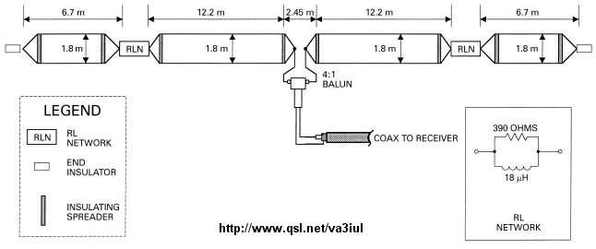
24 - Tilted Folded Dipole Antenna
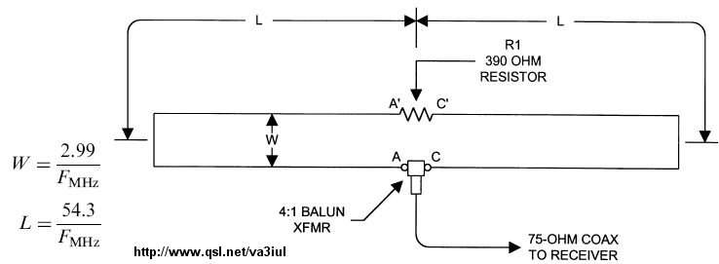
25 - Right Angle Marconi Antenna
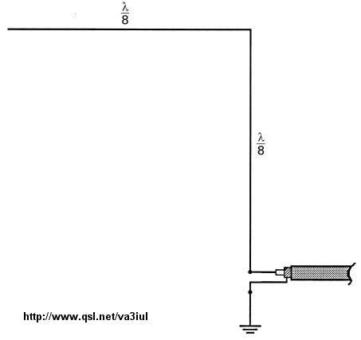
26 - Linearly Loaded Tee Antenna
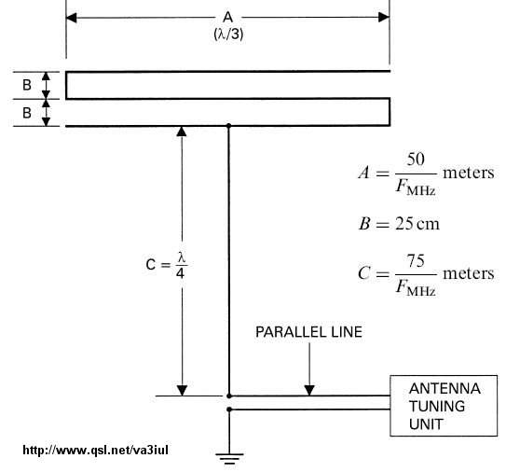
27 - Reduced Size Dipole Antenna
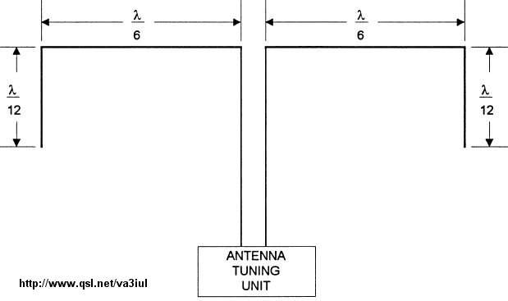
28 - Doublet Dipole Antenna
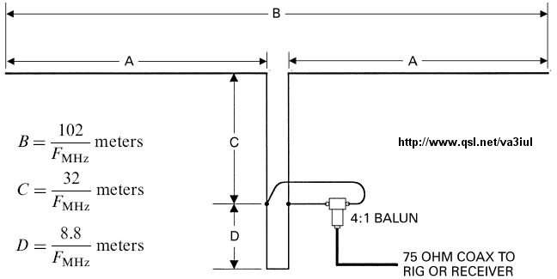
29 - Delta Loop Antenna
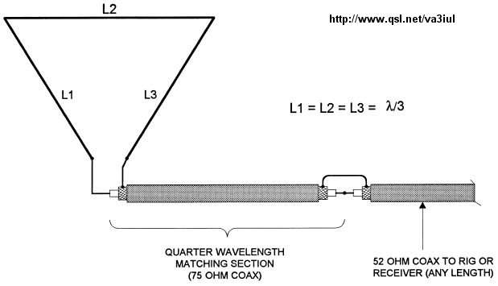
30 - Half Delta Loop Antenna
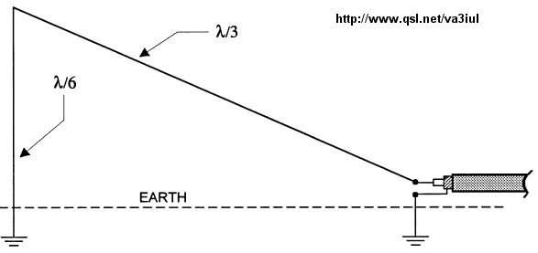
31 - Collinear Franklin Antenna
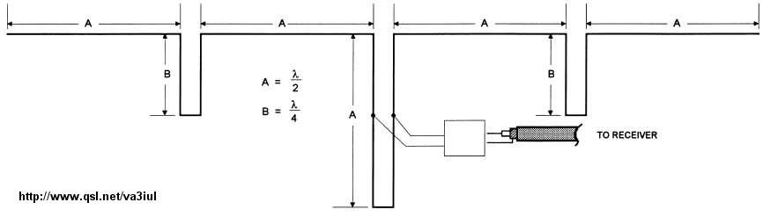
32 - Four Element Broadside Antenna
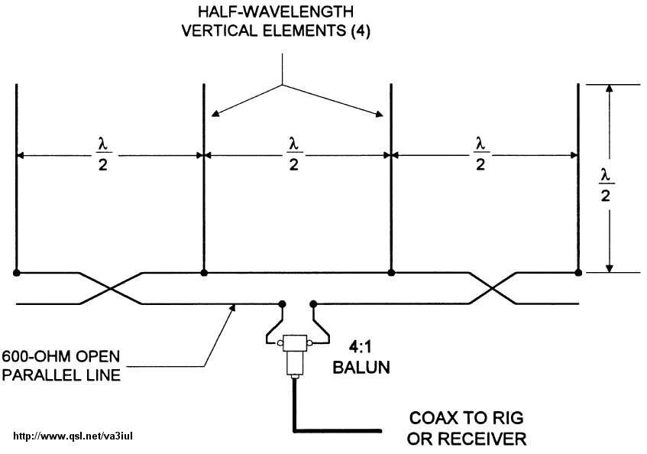
33 - The Lazy-H Array Antenna
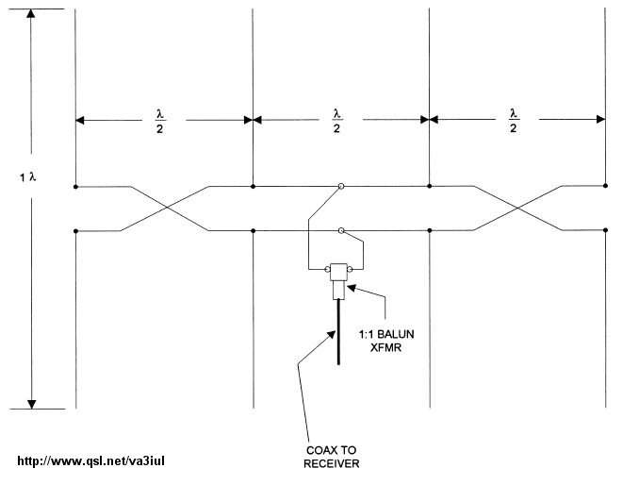
34 - Sterba Curtain Array Antenna
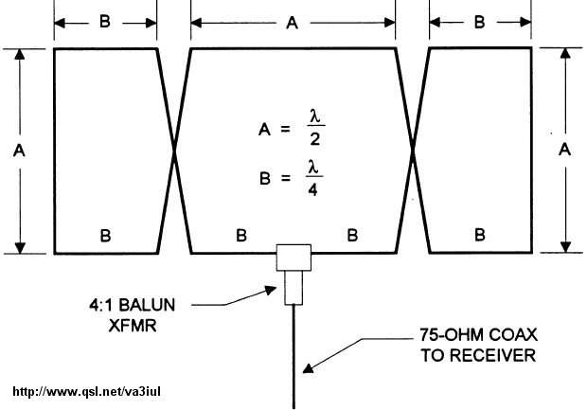
35 - T-L DX Antenna
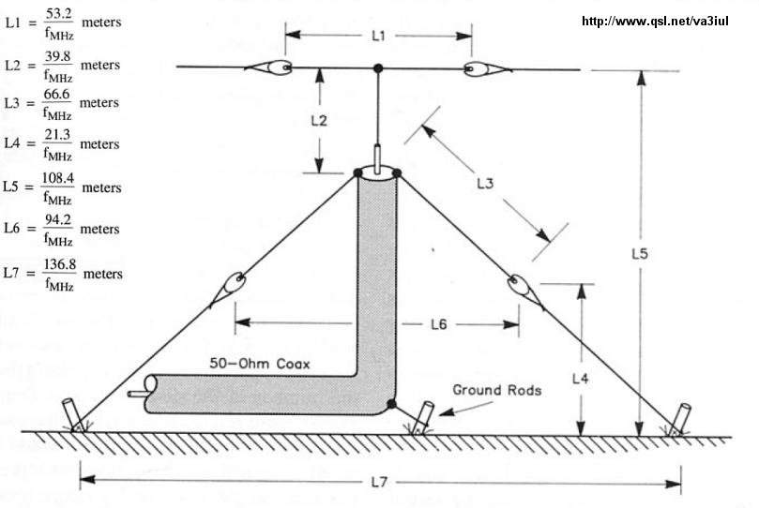

36 - 1.9 MHz Full-wave Loop Antenna

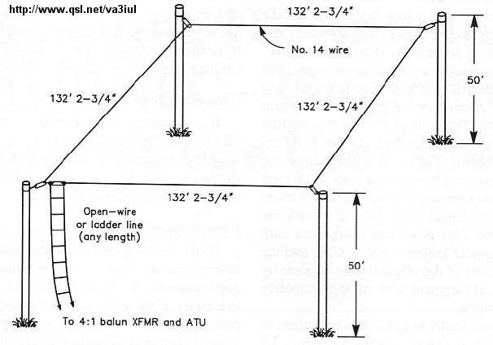

37 - Multi-Band Portable Antenna

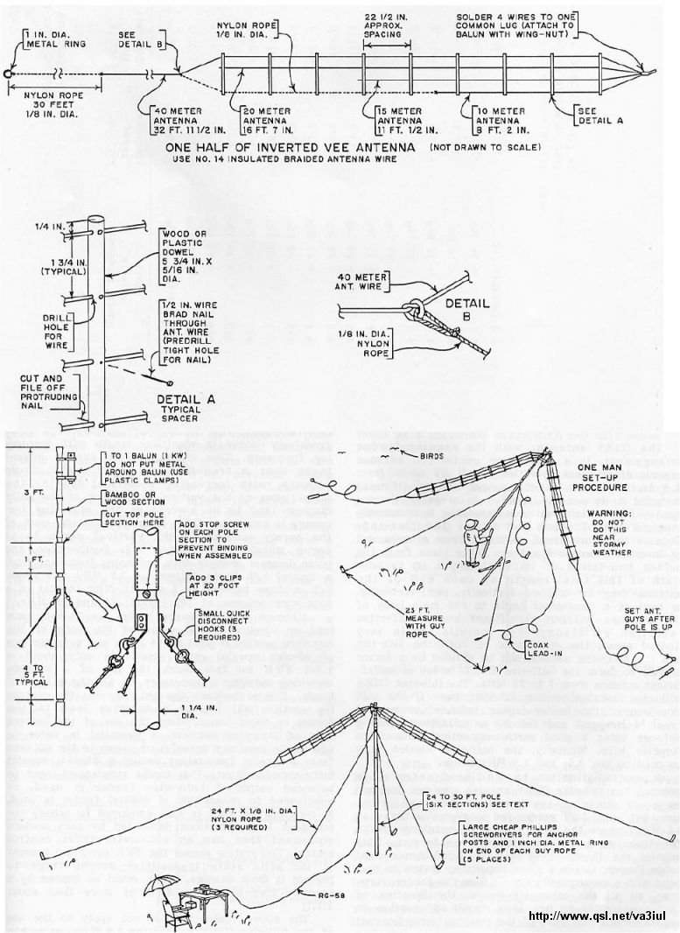

38 - Off-center-fed Full-wave Doublet Antenna

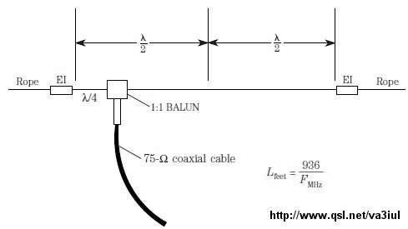

39 - Terminated Sloper Antenna

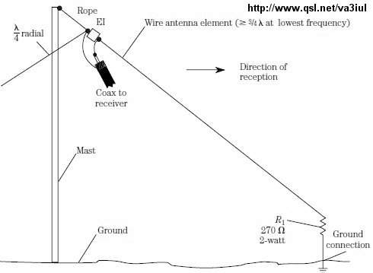

40 - Double Extended Zepp Antenna

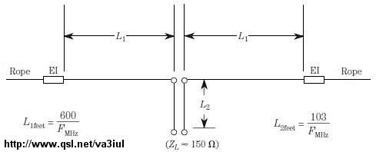

41 - TCFTFD Dipole Antenna

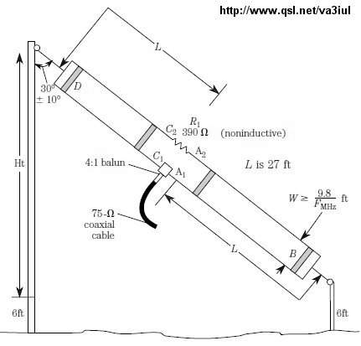

42 - Vee-Sloper Antenna

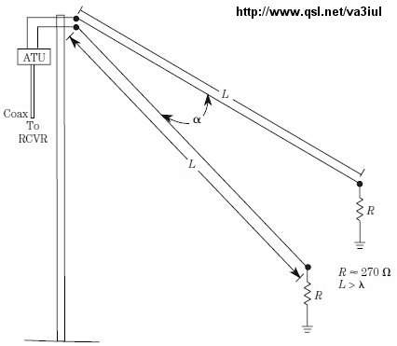

43 - Rhombic Inverted-Vee Antenna

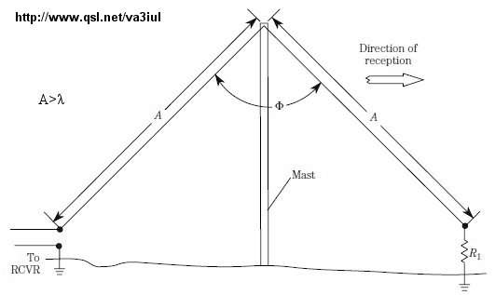

44 - Counterpoise Longwire

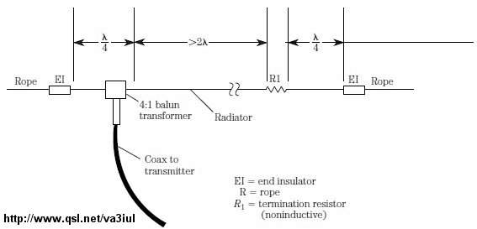

45 - Bisquare Loop Antenna

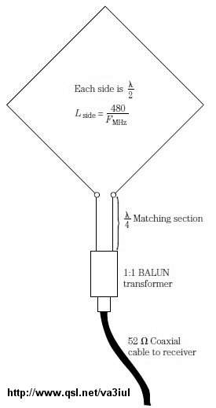

46 - Piggyback Antenna for 10m

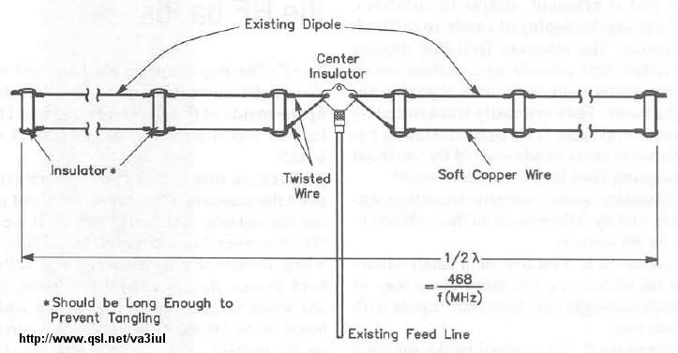

47 - Vertical Sleeve Antenna for 10m

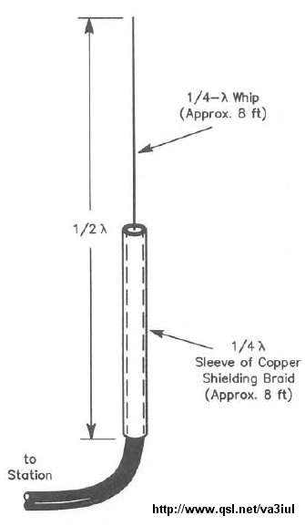

48 - Double Windom Antenna

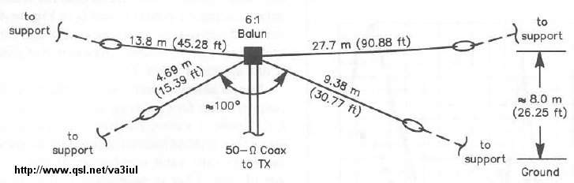

49 - Double Windom for 9 Bands

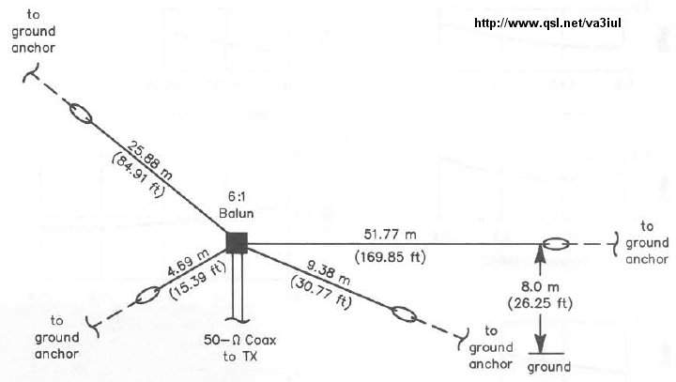

50 - Collinear Trap Antenna

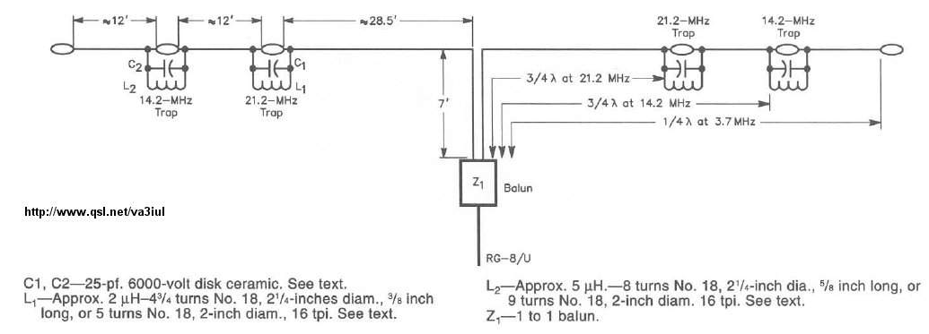

51 - Short Dipole Antenna for 40m - 80m - 160m

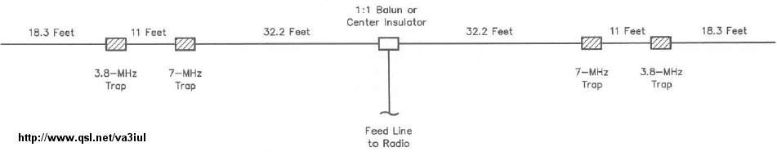

52 - Center Fed-Zepp Antenna for 80m - 40m

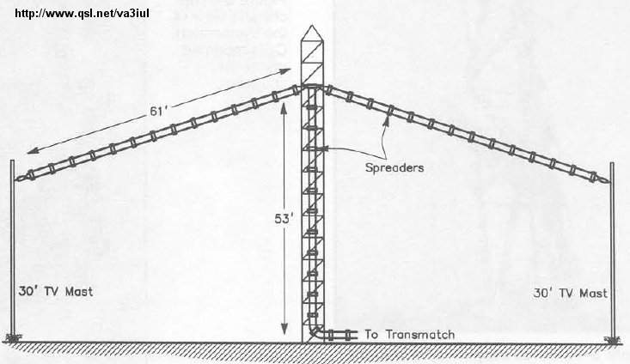

53 - All-Bands Antenna

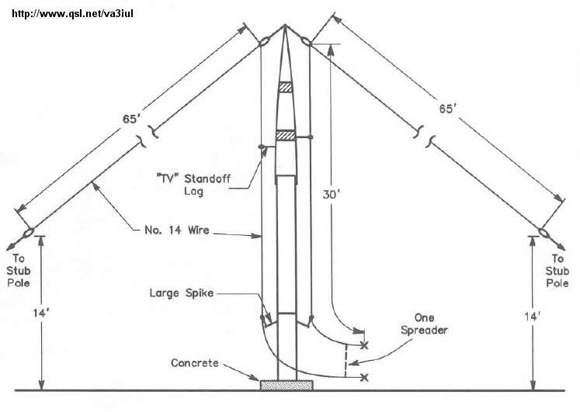

54 - All-Bands Dipole Antenna

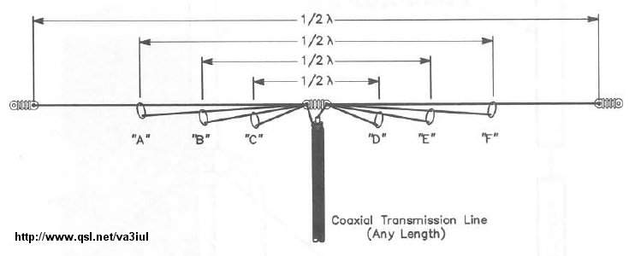

55 - Multiband Z Antenna

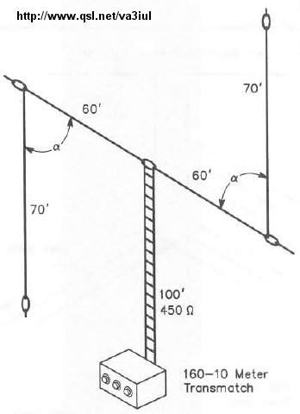

56 - Multiband Dipole Antenna

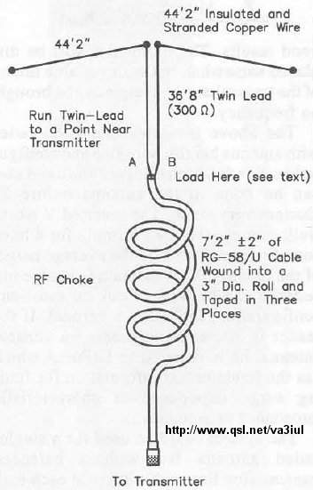

57 - Five-Bands No-Tuner Antenna

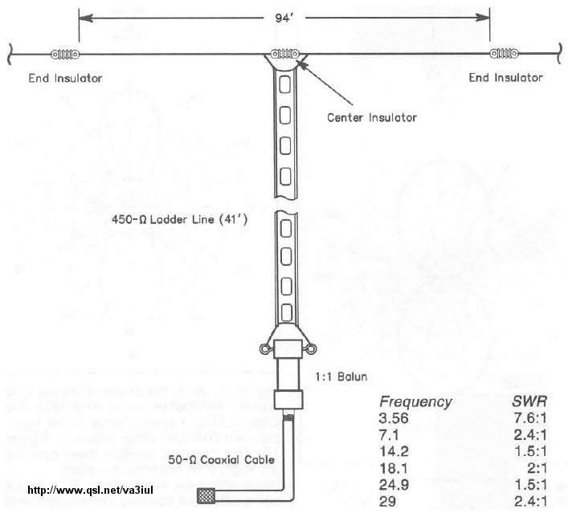

58 - Dualband Full-wave Loop Antenna for 80m-40m

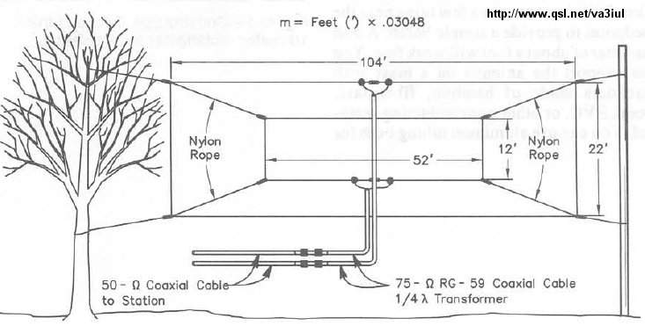

59 - Loop Antenna for 10m

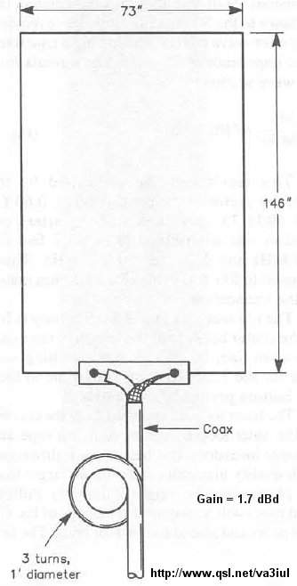

60 - Lazy Quad Antenna for 10m

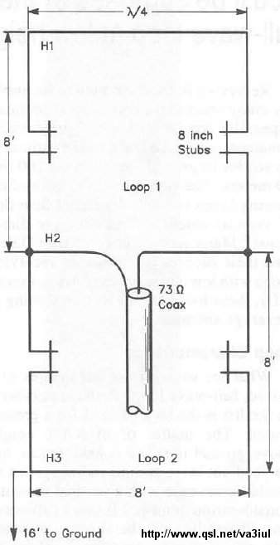

61 - Tri-band Delta Loop Antenna for 80m - 40m - 30m

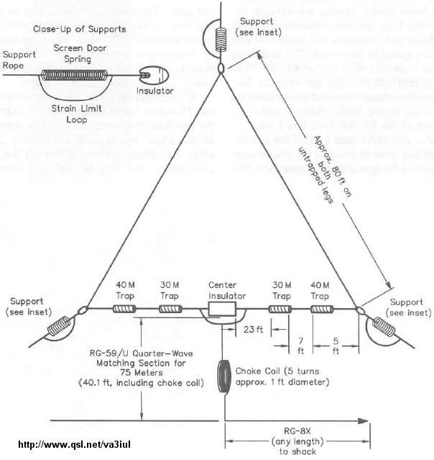

62 - Dual-band Loop Antenna for 30m - 40m

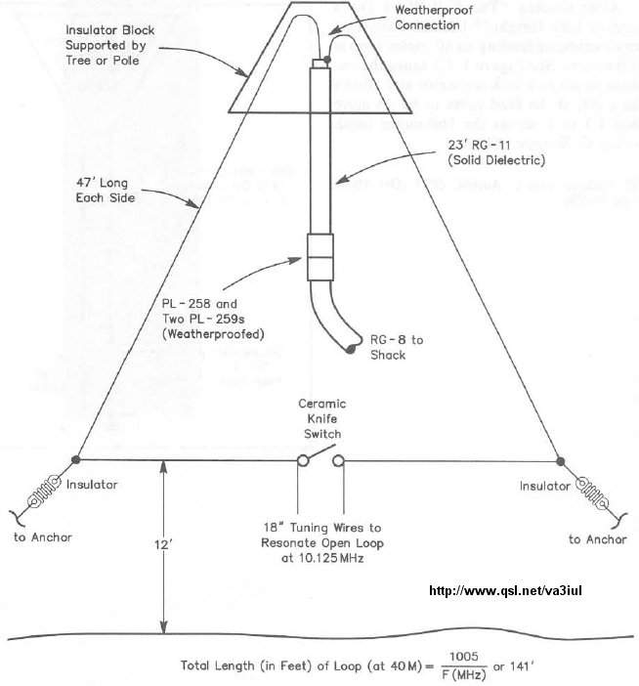

63 - Wire-Beam Antenna for 80m

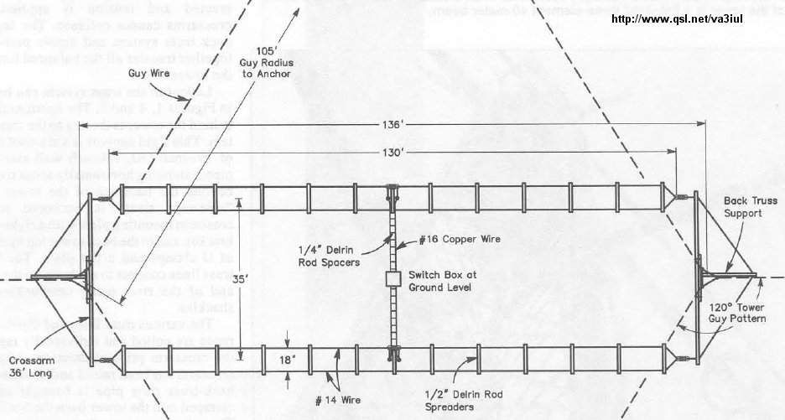

64 - Dual-Band Sloper Antenna

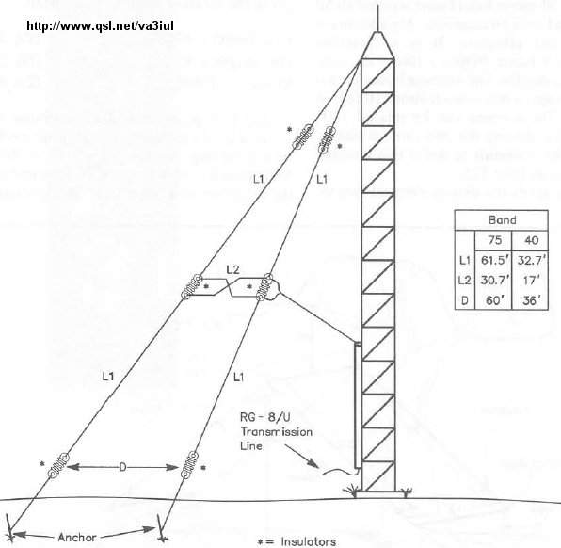

65 - Inverted-V Beam Antenna for 30m

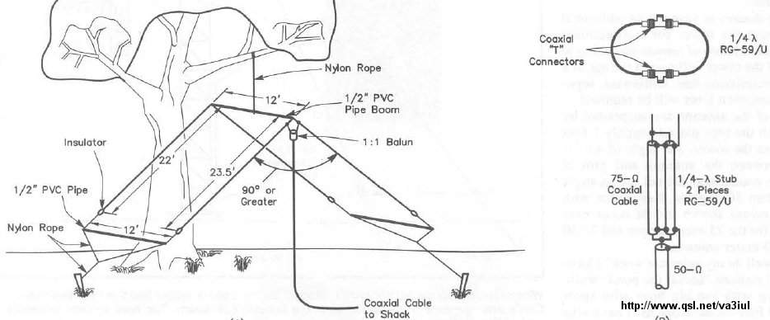

66 - ZL-Special Beam Antenna for 15m

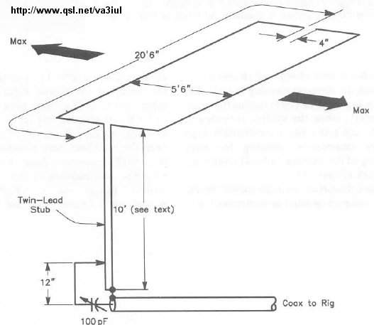

67 - Half-Sloper Antenna for 160m

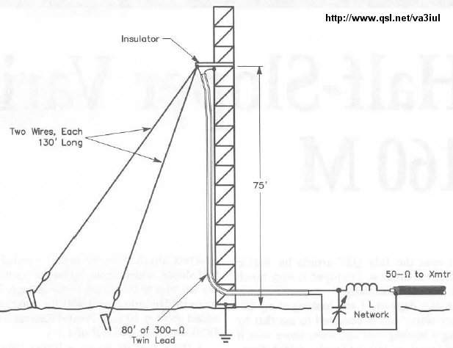

68 - Two-Bands Half Sloper for 80m - 40m

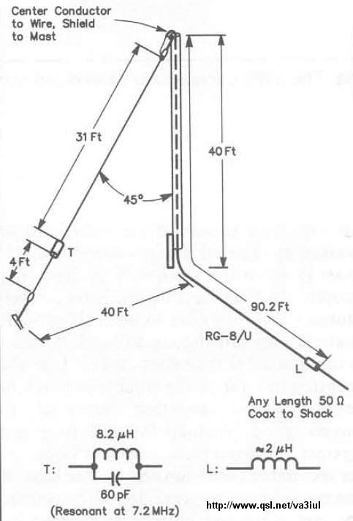

69 - Linear Loaded Sloper Antenna for 160m

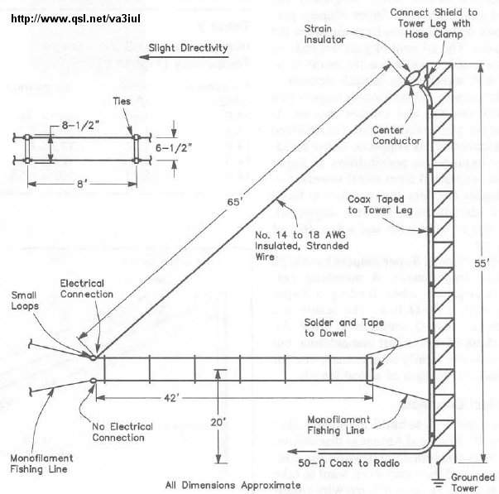

70 - Super-Sloper Antenna

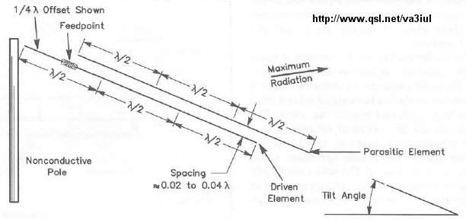

71 - Tower Pole as a Vertical Antenna for 80m

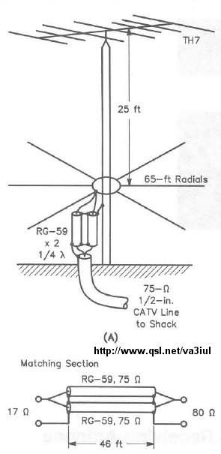

72 - Clothesline Antenna

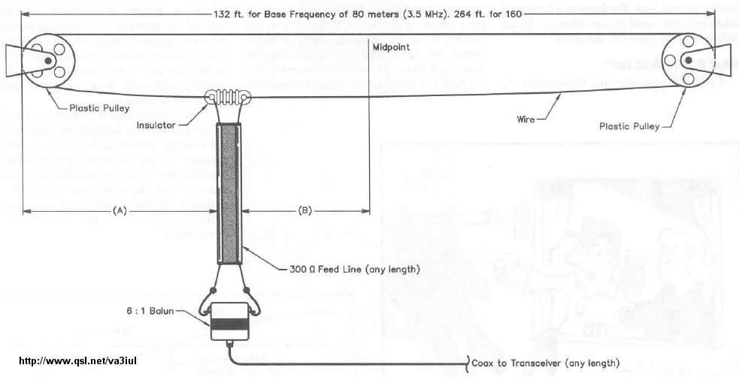

73 - Curtain Zepp Antenna for 160m, 80m, 40m

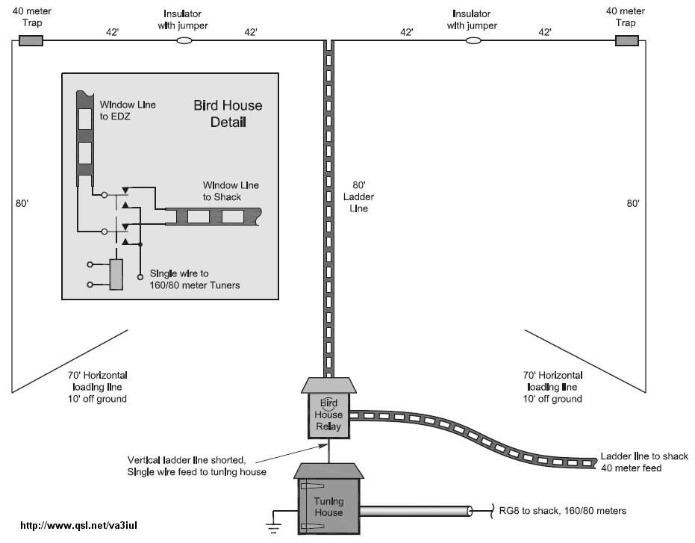

74 - Collinear Array Antenna for 40m, 30m, 20m

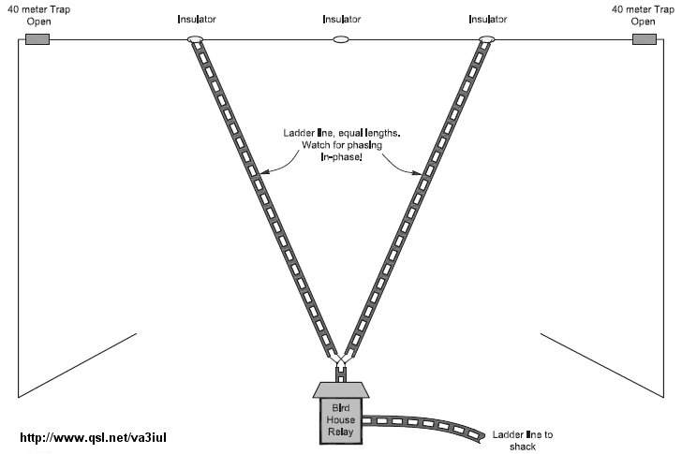

75 - 160m Inverted Delta Loop

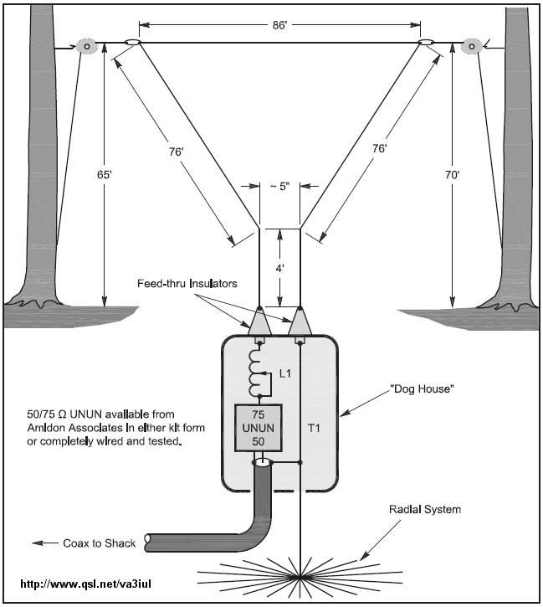

76 - Half Rhombic Unidirectional Vertical for 20m to 6m

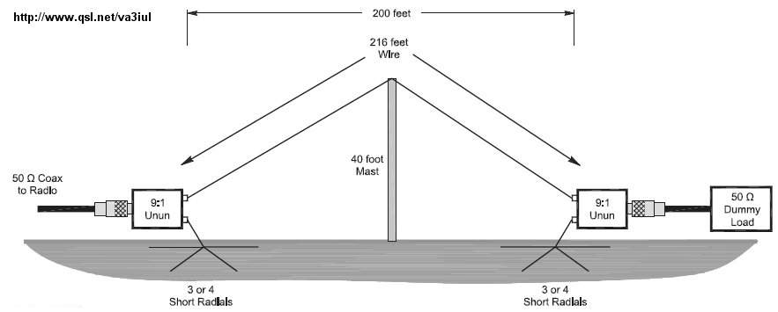

77 - Capacitance Loaded Vertical Antenna for 160m

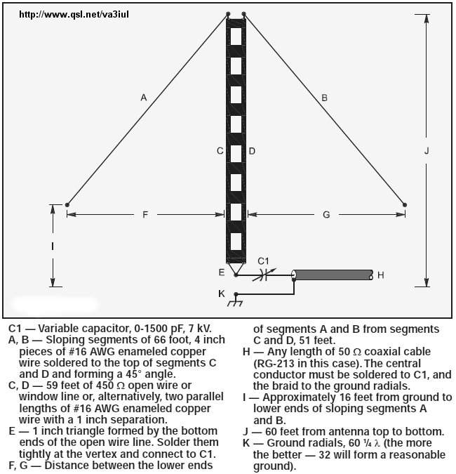

78 - Fan Dipole Antenna for 80m to 6m

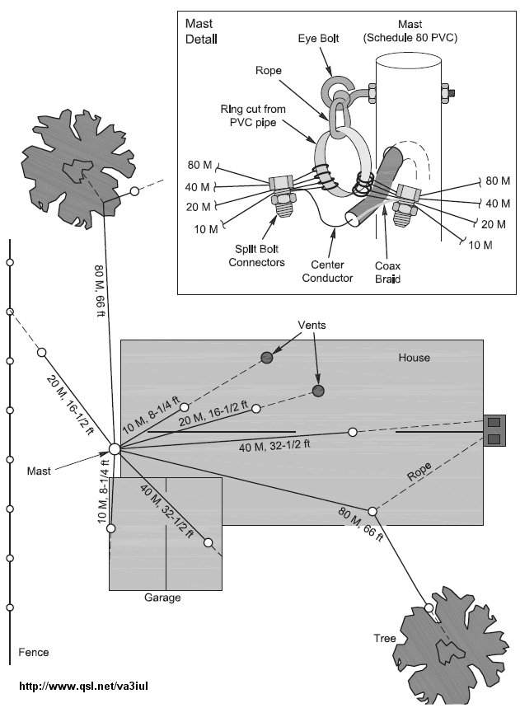

79 - Wire Ground Plane Antenna

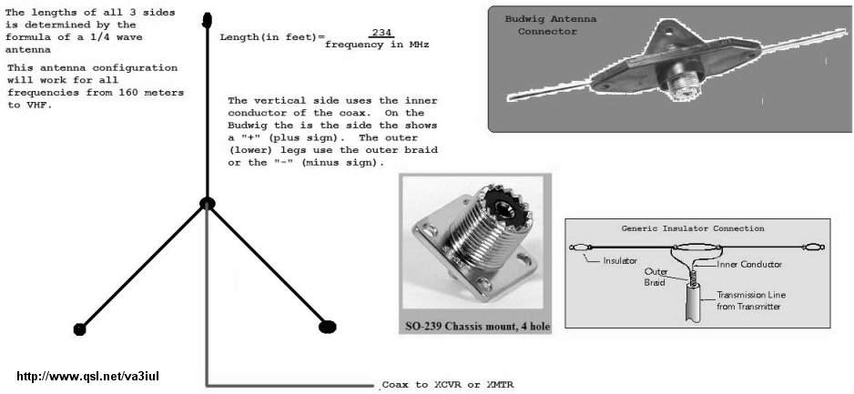

80 - Inverted Delta Loop Antenna for 160m

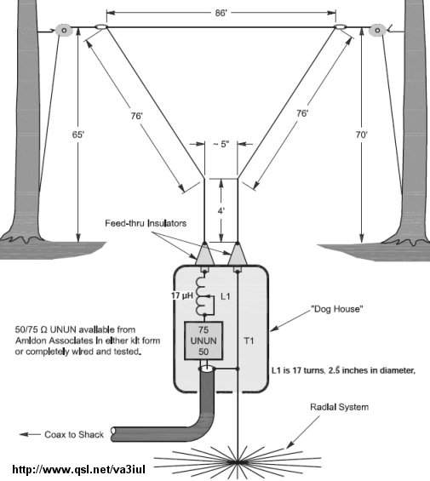

81 - Inverted-L for 160m

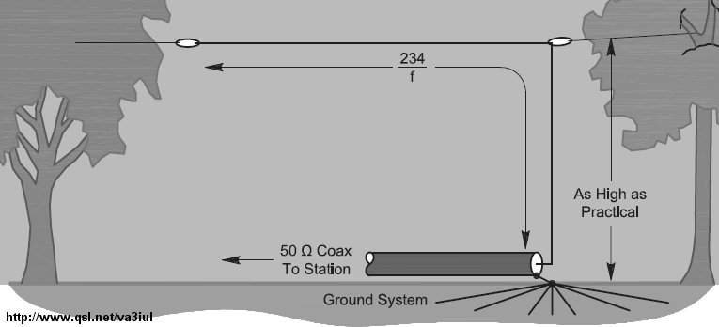

82 - 300ohm-Ribbon Dual Band Dipole

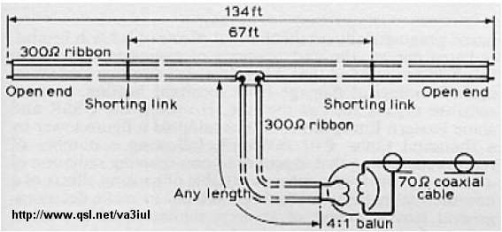

83 - Tri-Band Beam for 20m, 15m, 10m

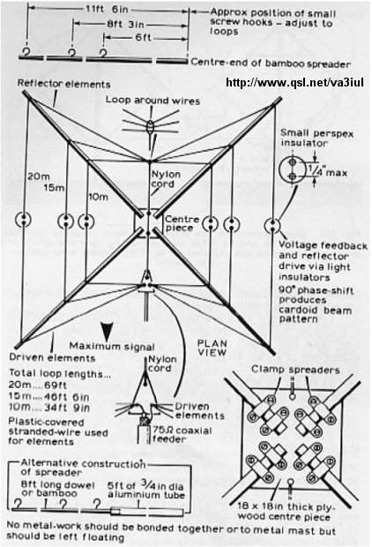

84 - Mini-Horse Yagi Antenna

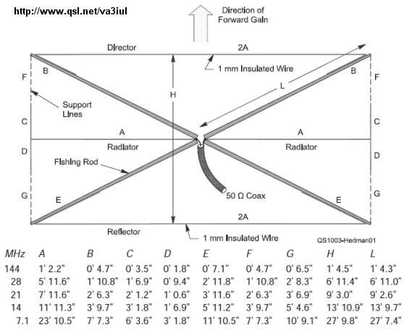

85 - Half-Rhombic Directive Antenna for 20m to 6m

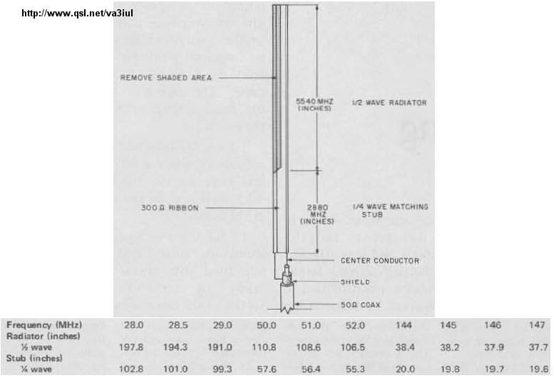

86 - Fan-Dipole Antenna for 80m, 40m, 20m

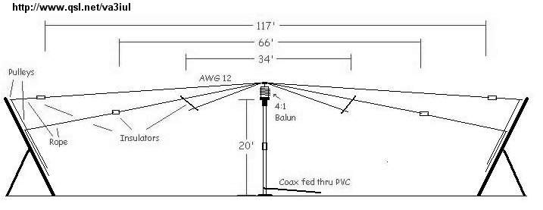

87 - Capacity Tuned Folded Loop Antenna for 20m

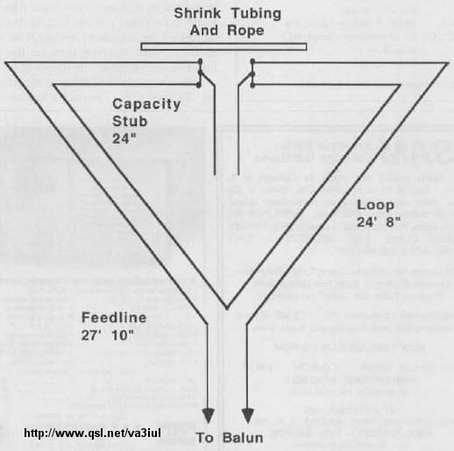

88 - Indoor Loop Antenna for 80m to 30m

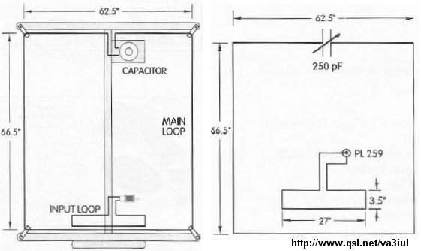

89 - Indoor Loop Antenna for 80m

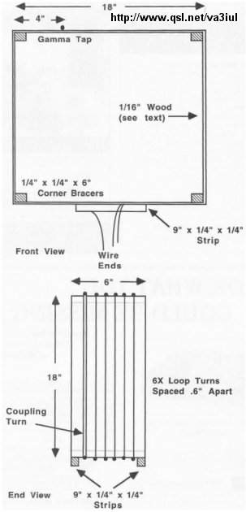

90 - Double-Delta Antenna 80m and 40m

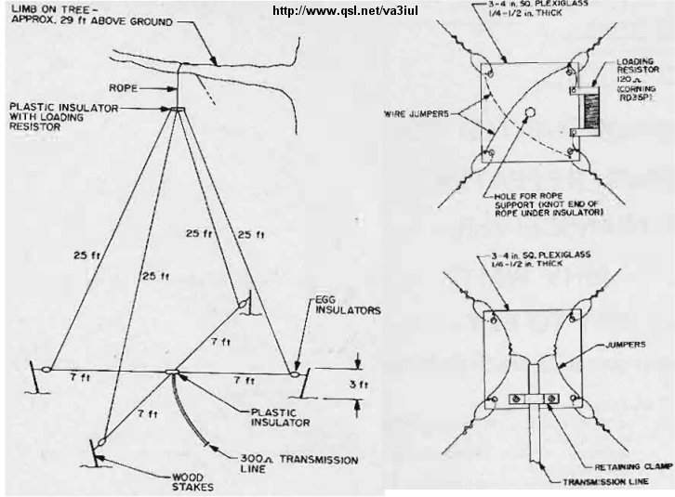

91 - Inductance-Loaded Shortened Dipole for 160m

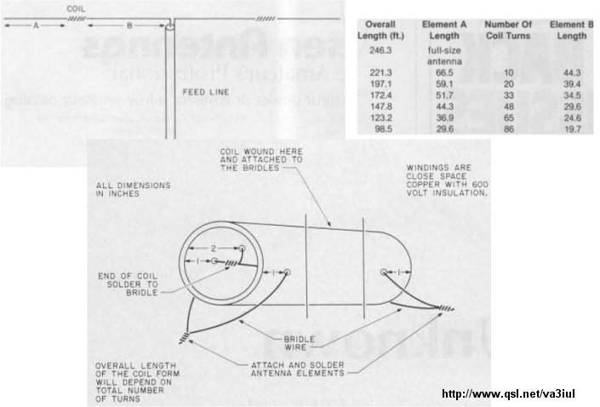

92 - V-Beam Antenna for 15m

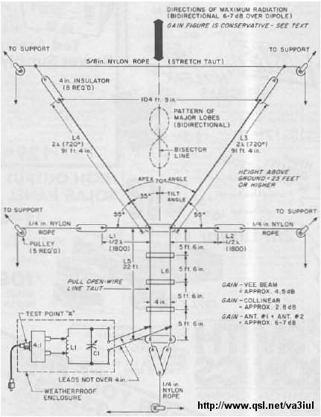

93 - Picnic Vertical Wire Antenna

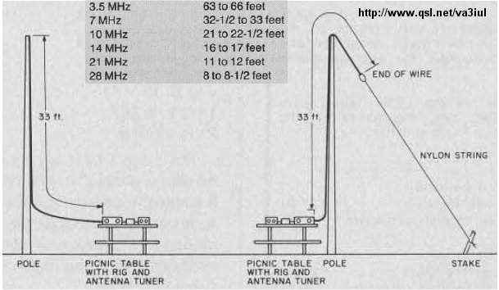

94 - Laid-Back Quad Antenna for 80m

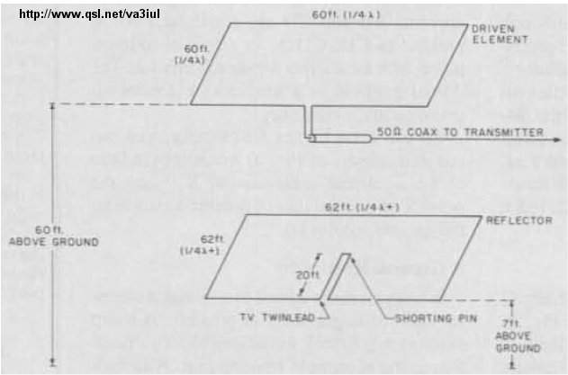

95 - Phased Loop Antenna

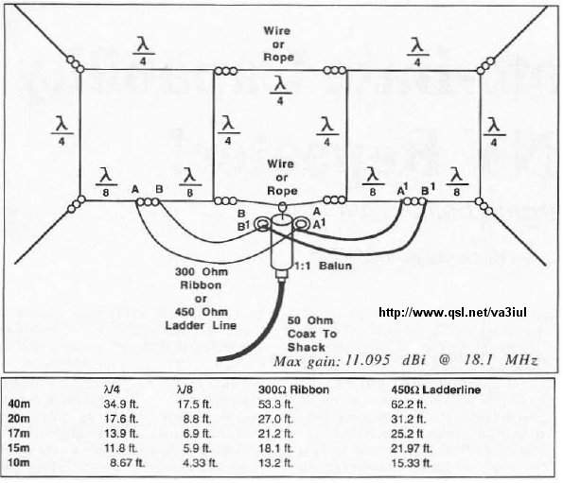

96 - Loop Antenna for TX for 160m

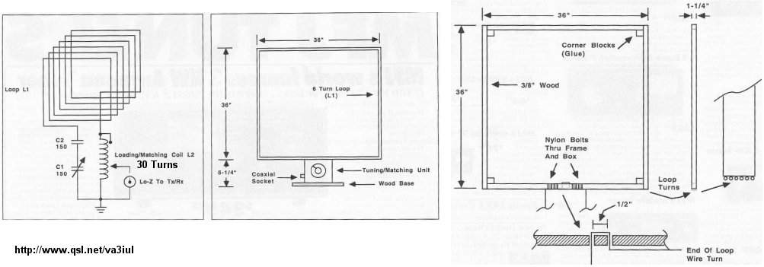

97 - Morgain-Dipole Antenna for 160m and 80m

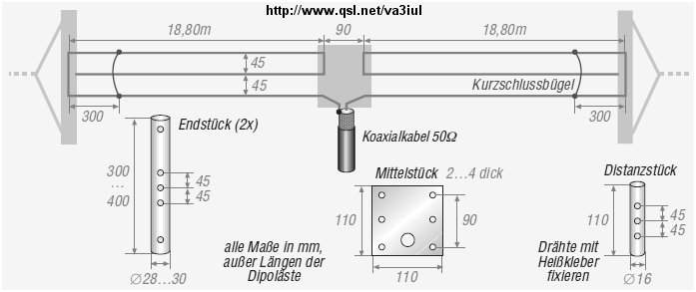

98 - ZL-Special for 20m, 15m, 10m

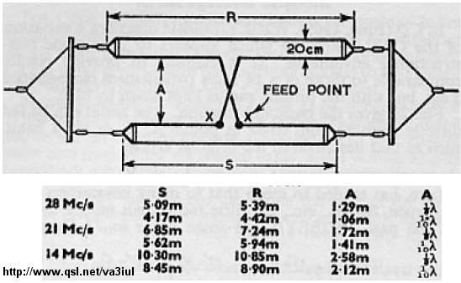

99 - Biconical Antenna

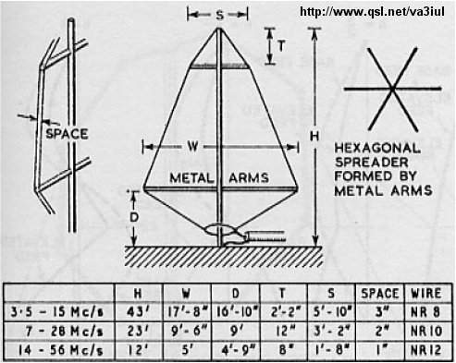

100 - Directive Delta-Birdcage Antenna for 20m to 10m

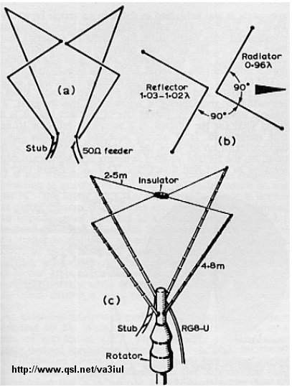

101 - Dual Polarization Antenna for 80m and 40m

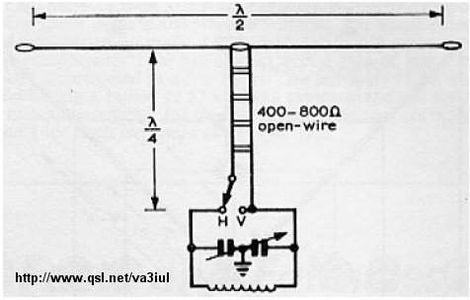

102 - Directive 300-ohm-Ribbon Folded Dipole for 15m

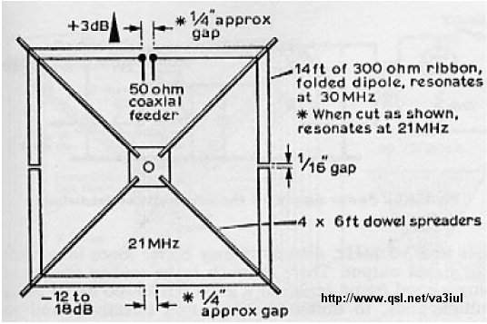

103 - Miniature Directive Antenna for 10m

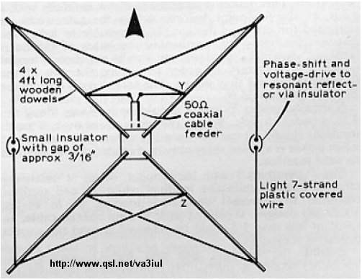

104 - Biquad Antenna 12dBi-Gain for 2.4GHz

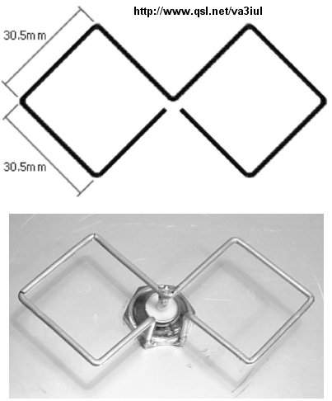

105 - Dual-Rhomboid Antenna for 435MHz to 870MHz

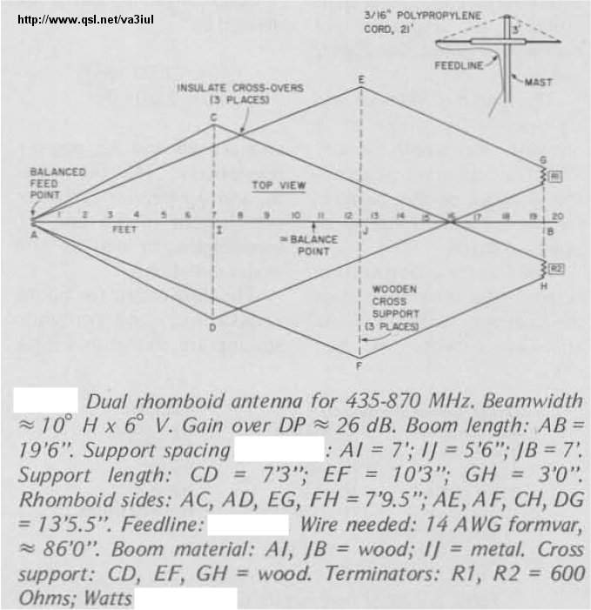

106 - Double-Bazooka Antenna for 80m

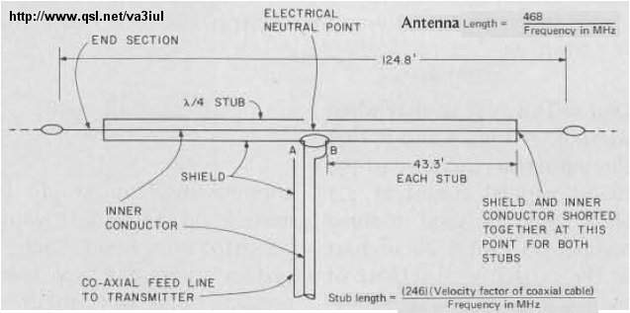

107 - J-Style Antenna

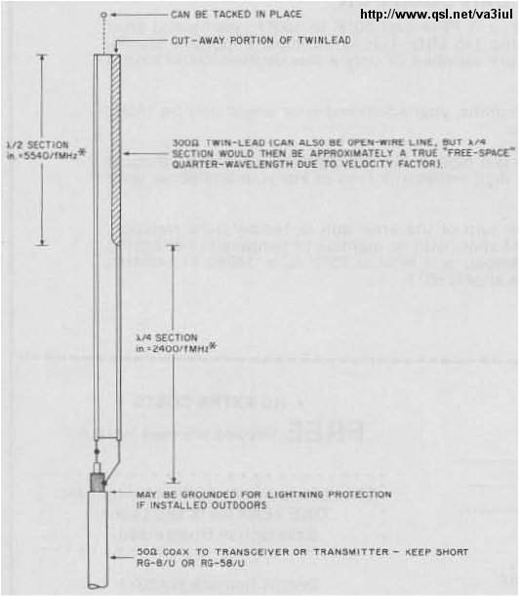

108 - Vertical / Horizontal / Circular Polarization Antenna

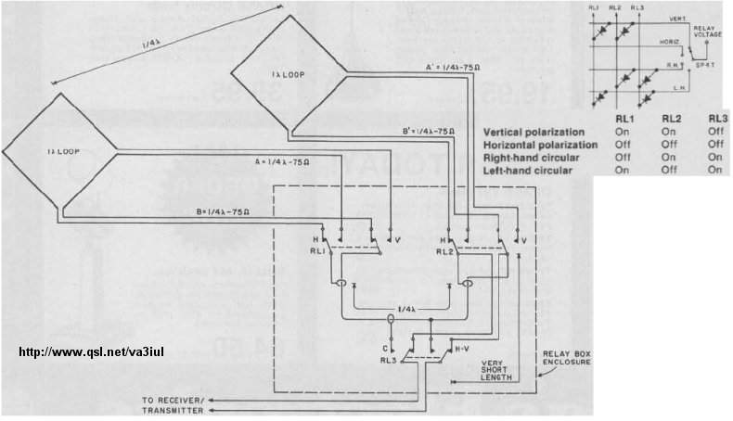

109 - Coax Inverted-L Antenna for 80m

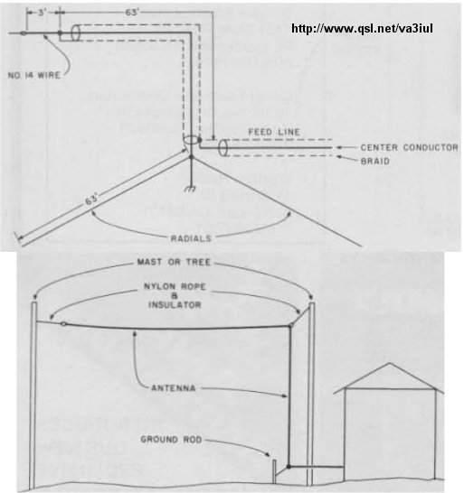

110 - Indoor Compact Loop Antenna for 80m

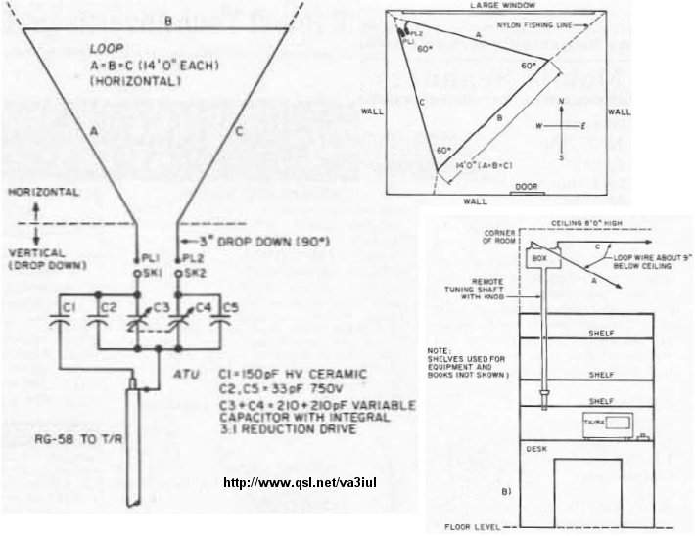

111 - Helix Antenna

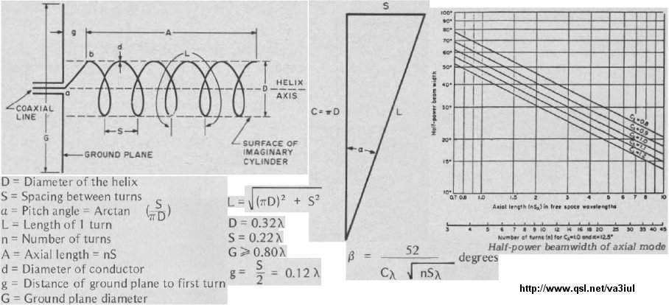

112 - Novice Vertical Antenna for 80m, 40m, 15m, 10m

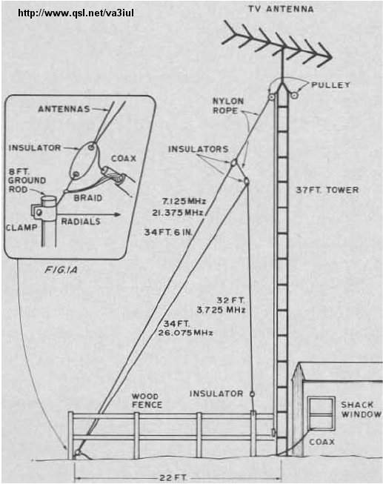

113 - Stub-Loaded Shortened Dipole for 80m

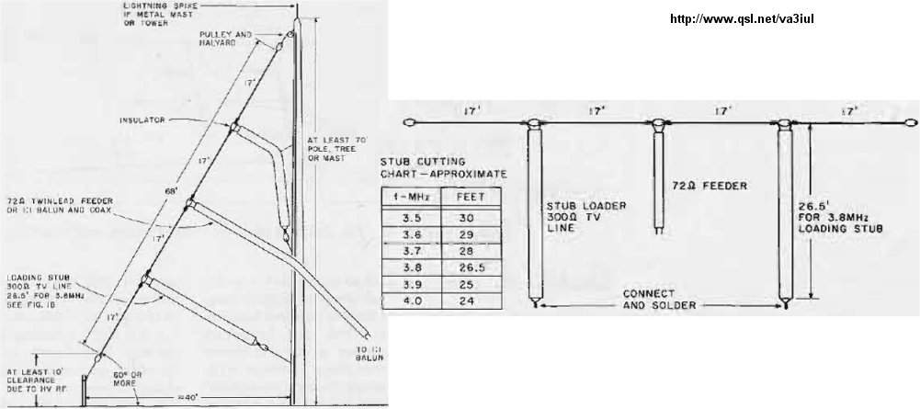

114 - Six-Band Wire-Stub Trap Antenna for 40m-10m

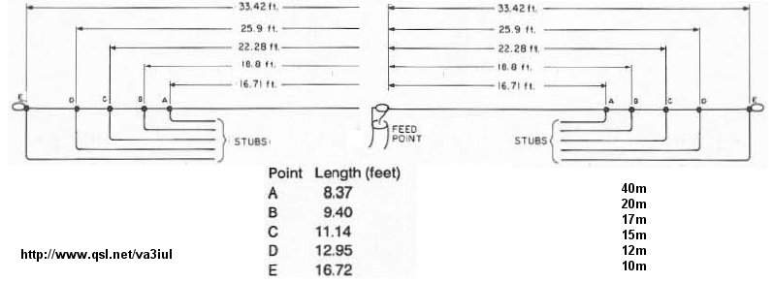

115 - Multiband Half-Wave Delta-Loop Antenna

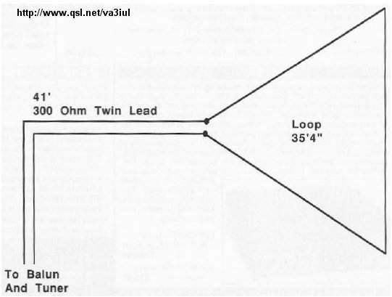

116 - Hybrid Vee for 20m, 17m

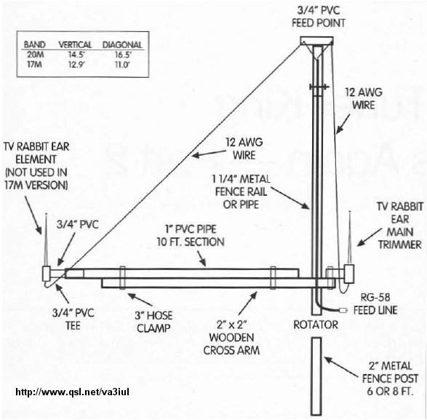

117 - Six-Shooter Array Antenna, Gain=7.5dB

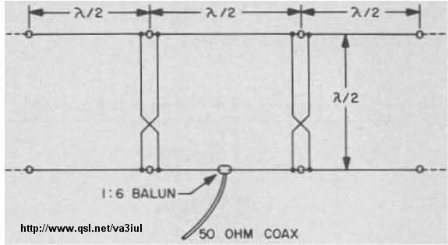

118 - Multiband Ground-Plane Antenna for 10m, 15m, 20m

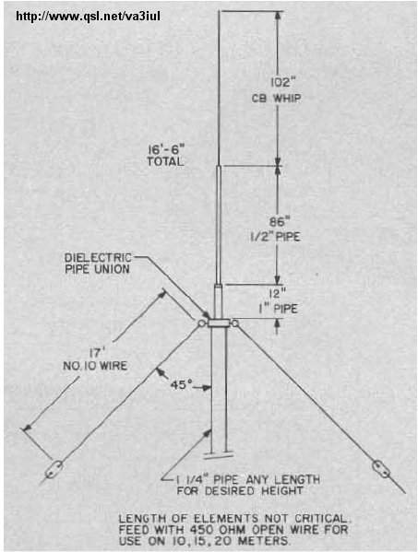

119 - Wire Superbeam Antenna for 10m, 15m, 20m

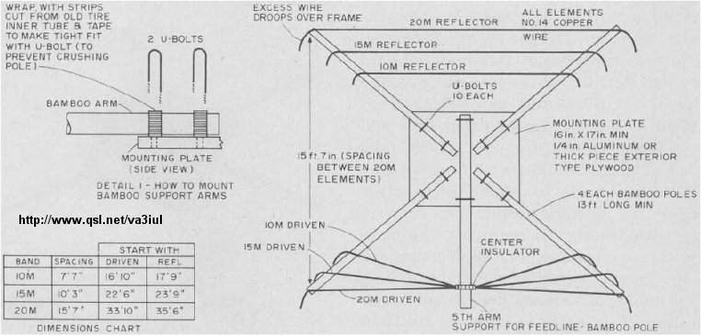

120 - Two Elements Delta-Loop Antenna

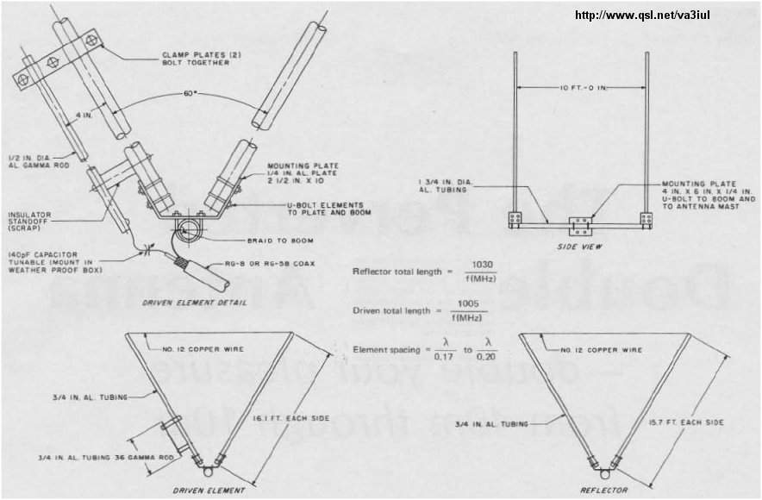

121 - Sterba Curtain Antenna

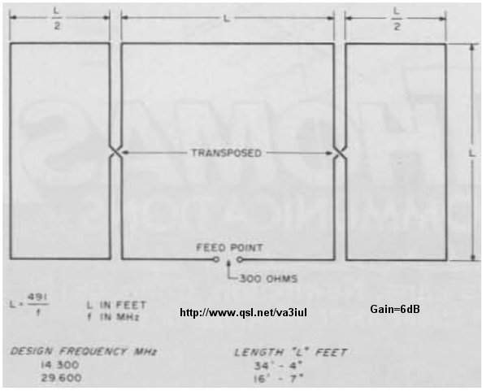

122 - Half-Wave Vertical Zepp Antenna

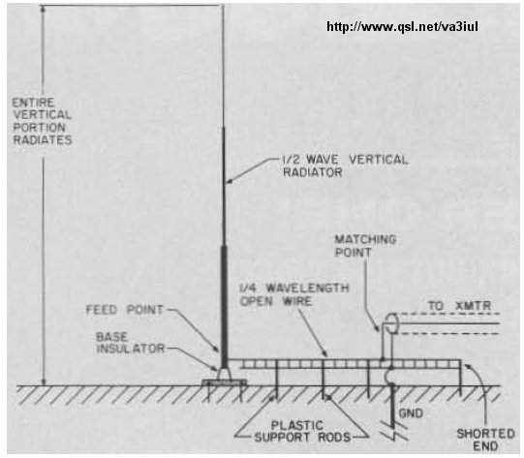

123 - Lazy-Loop Antenna for 40m

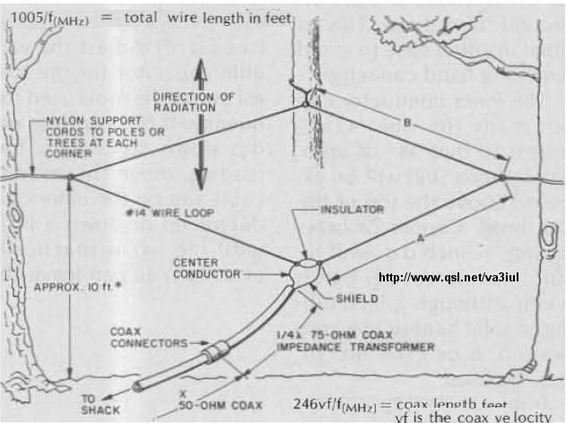

124 - Terminated Folded Dipole for 80m, 40m

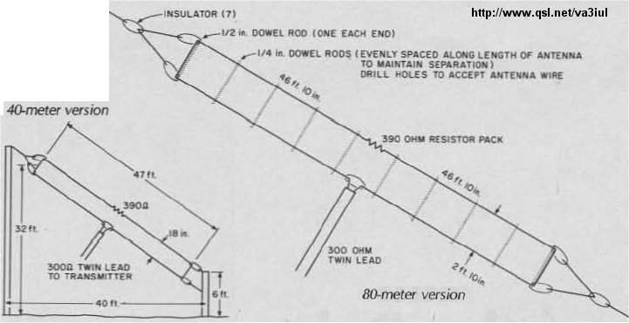

125 - Short-Fat Antenna for 15m

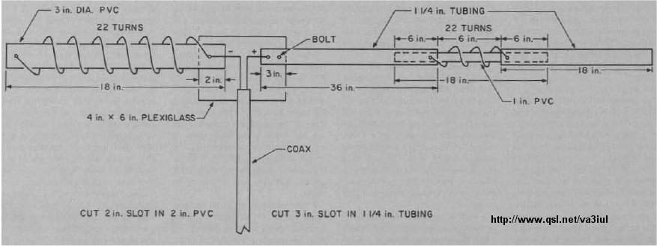

126 - Cobra Antenna for 80m

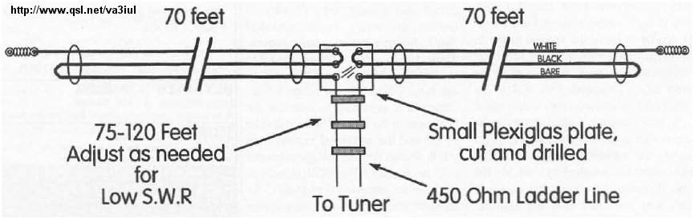

127 - Log-Periodic Wire Antenna for 20m, 15m, 10m

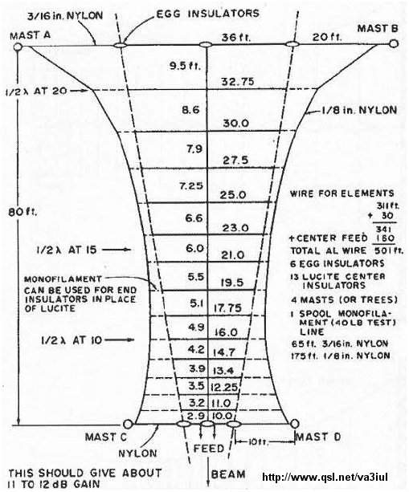

128 - 5-Element Log-Periodic Vertical Antenna for 80m, 40m, 20m

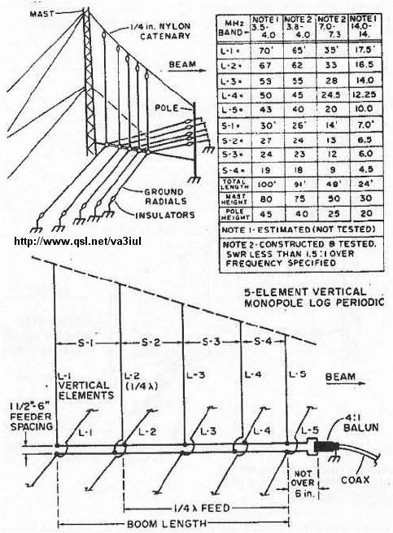

129 - 2m Vertical Wire Antennas

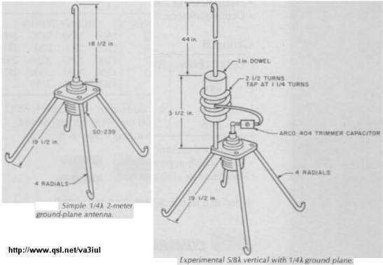

130 - Earth-Mover Inverted-V Antenna for 40m

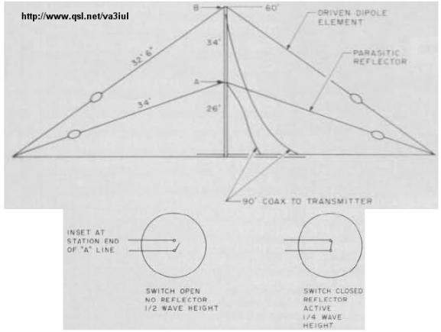

131 - Coax-Cable Collinear Antennas

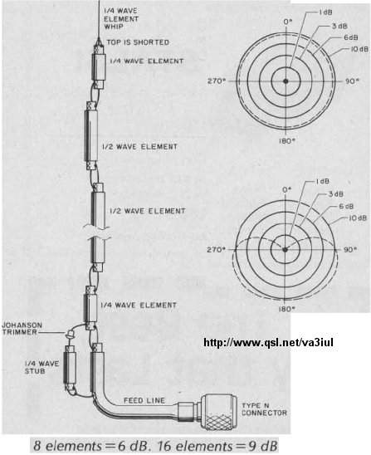

132 - Double Bobtail Antenna for 20m

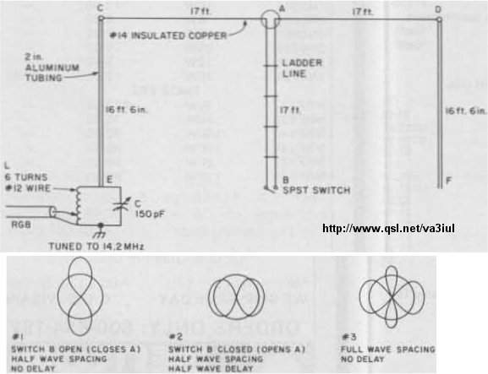

133 - Collinear Zepp Antenna

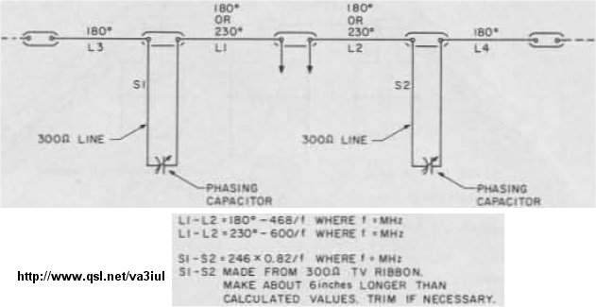

134 - Taylor Vee Antenna for 20m

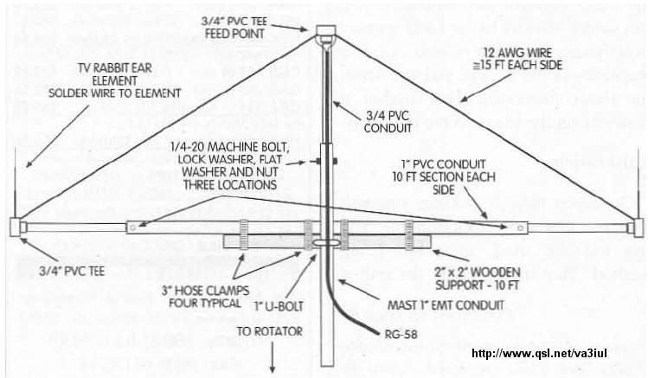

135 - Collinear Vertical Antenna 6dB-Gain for 2m, 1.3m, 73cm

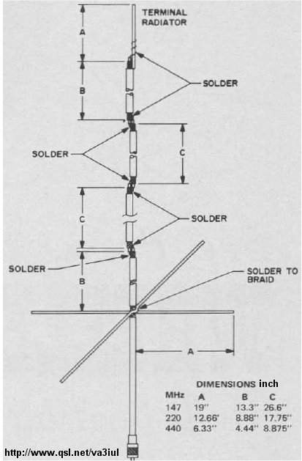

136 - Bi-Loop Antenna for 20m

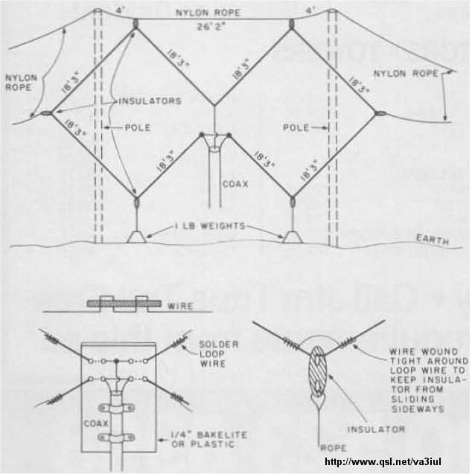

137 - Wire Beam 6dBd-Gain for 10m

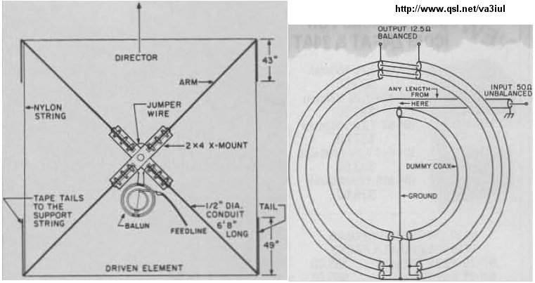

138 - Sloping Diamond Antenna 4dB-Gain for 40m

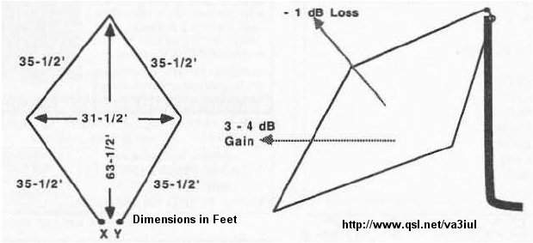

139 - Twisted Loop Antenna for 160m

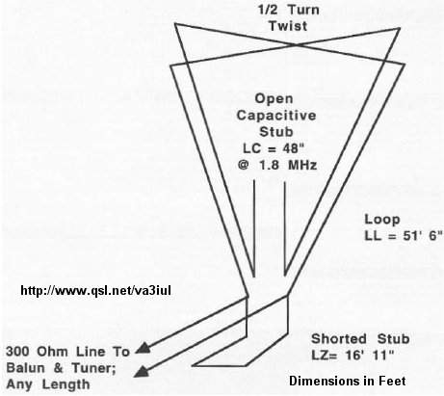

140 - DX RX Loop Antenna for 160m

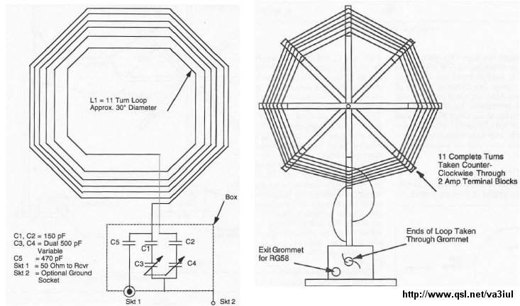

141 - Hentenna 3dB-Gain for 10m, 6m, 2m

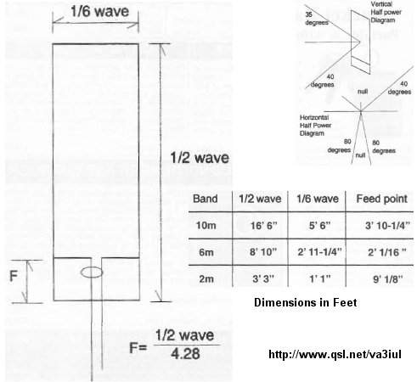

142 - VK2AAR Wire Antenna for 20m

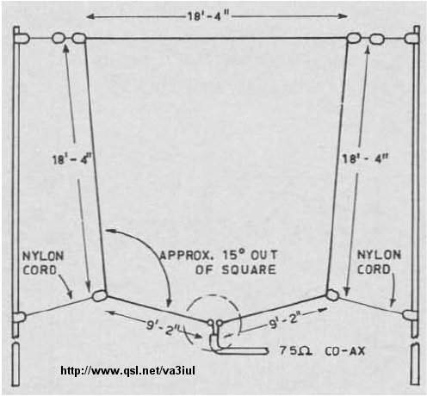

143 - 2-Elements Quad Antenna for 6m

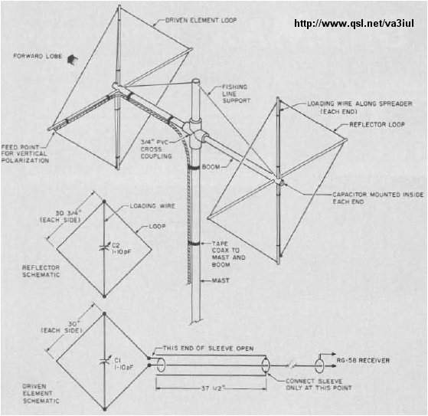

144 - Hula-Loop Bidirectional 6dB-Gain Antenna for 17m

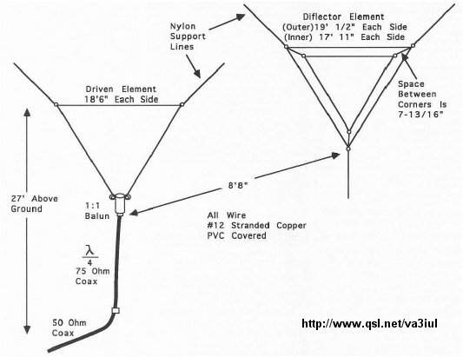

145 - Moxon Rectangle Beam for 15m-10m

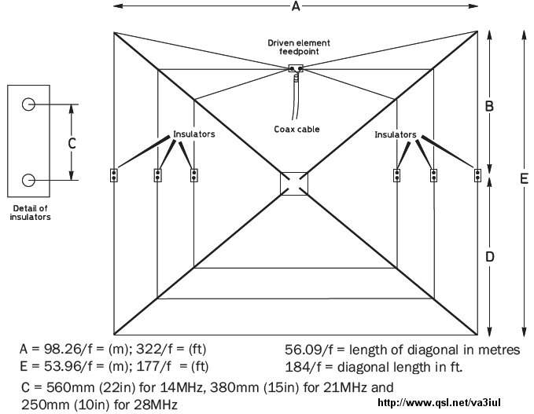

146 - Double-D Beam 4dB-Gain

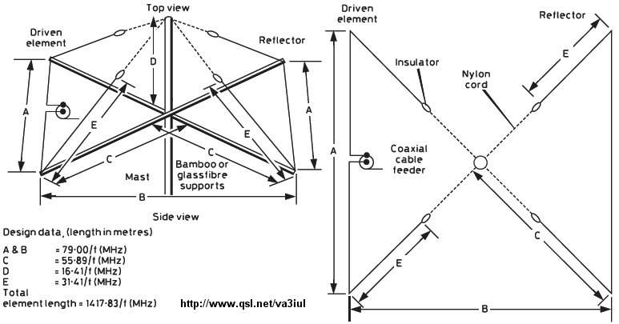

147 - KE4PT OCEF All-Band Dipole

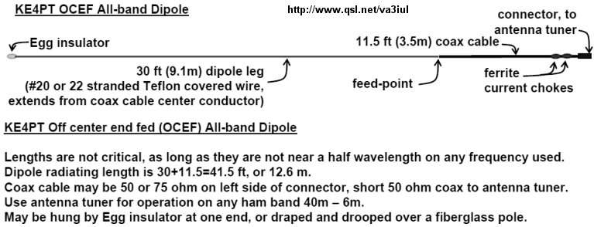

148 - Wire Quad Antenna for 40m

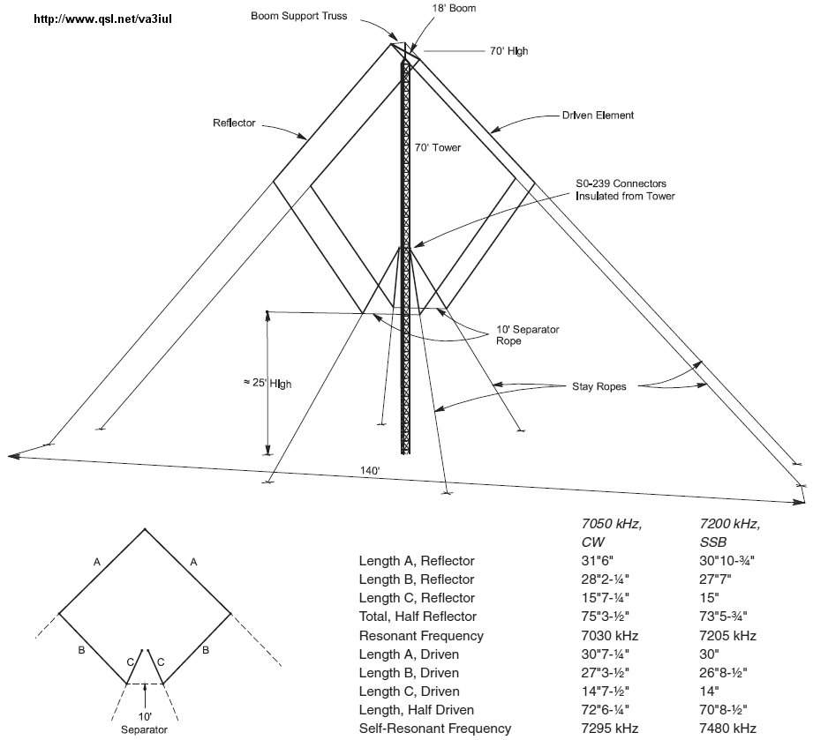

149 - Inclined Dipole Antenna for 80m, 40m

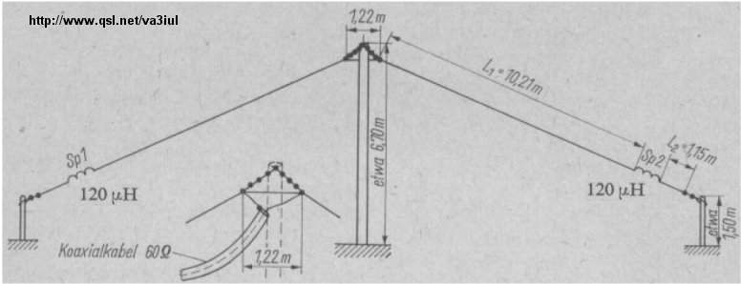

150 - Pyramidal Wire Antenna for 80m

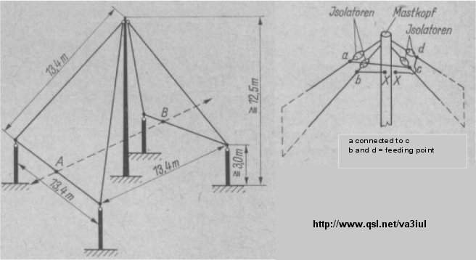

151 - Random Wire Antenna All Bands

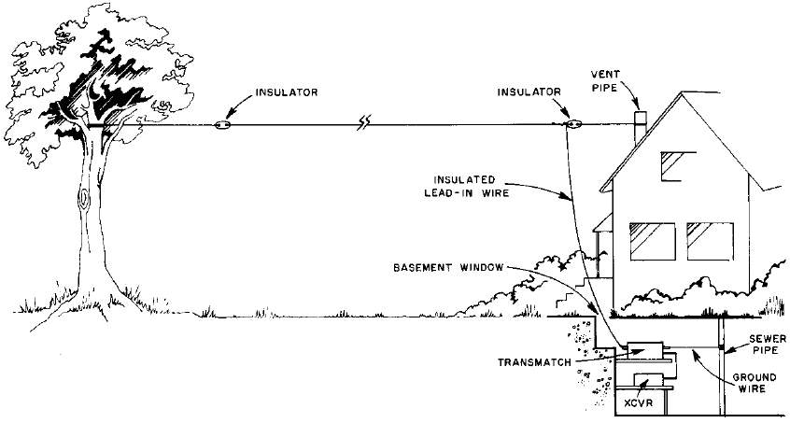

152 - Multiband Dipole Antenna for 80m, 40m,15m, 10m

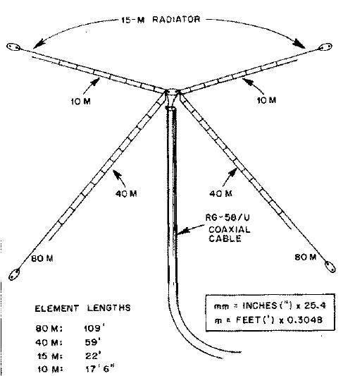

153 - Slim Jim Wire Antenna for 4m

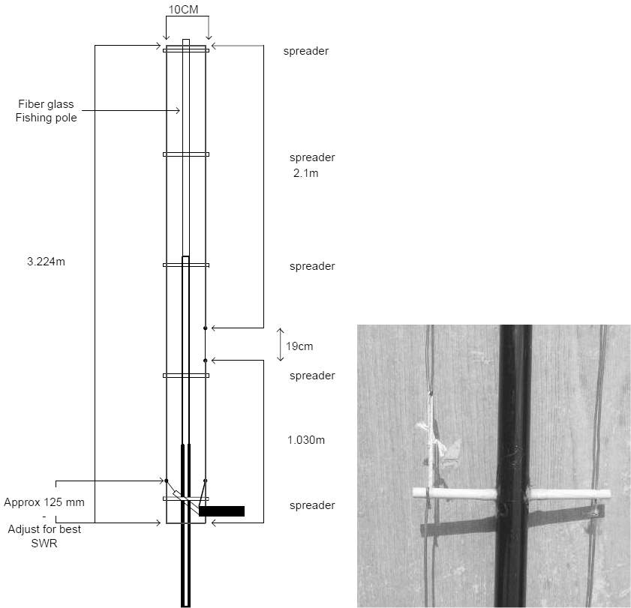

154 - Delta Loop for 6m

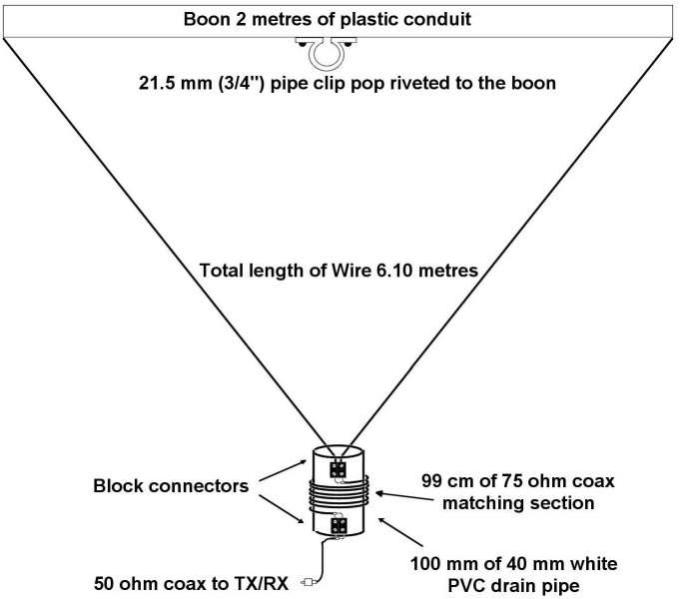

155 - Re-Configurable Antenna for 160m and 80m

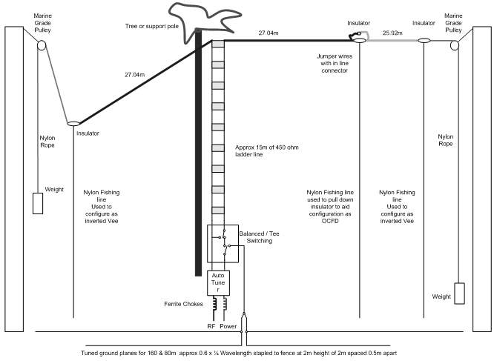

156 - Very Low Frequency Inverted-L Antenna

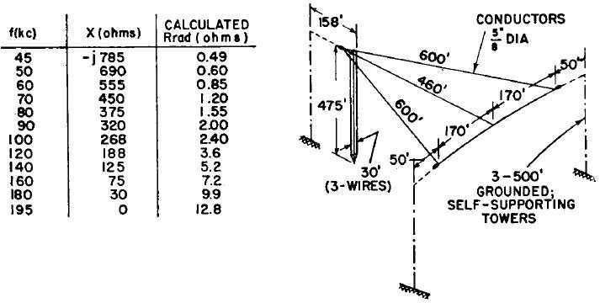

157 - Reduced Size Half Sloper Antenna for 160m

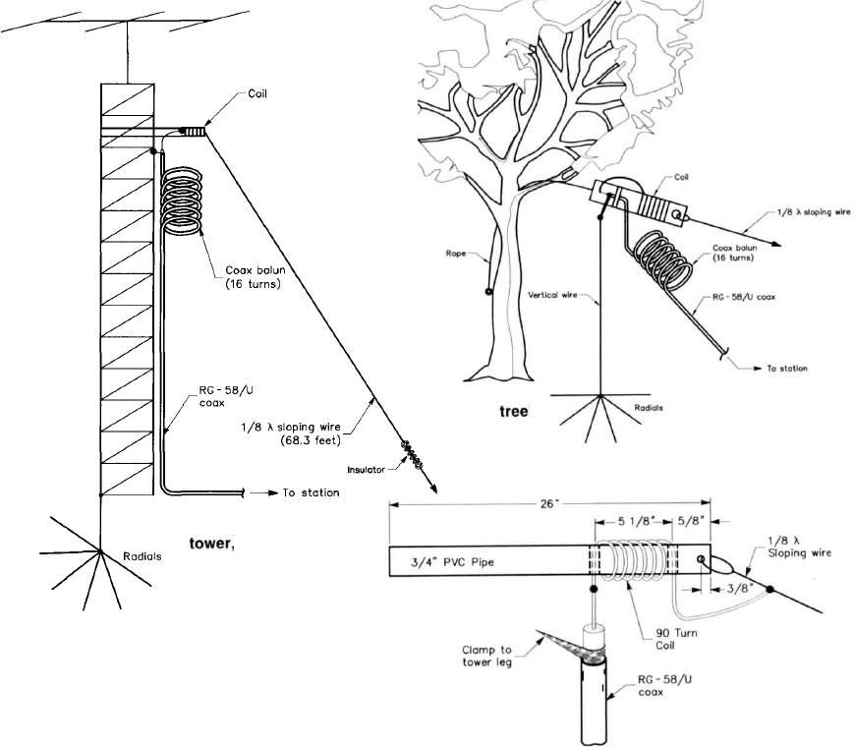

158 - Tree-Mounted HF Antenna

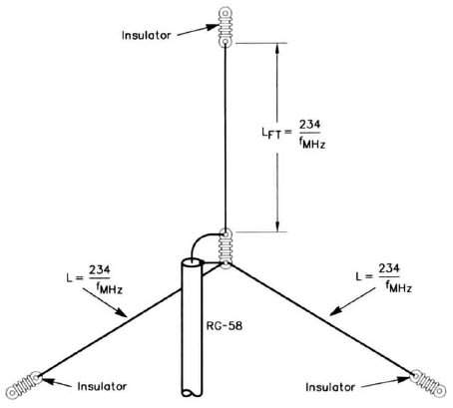

159 - Multiband Vertical Antenna for 80m, 40m, 20m

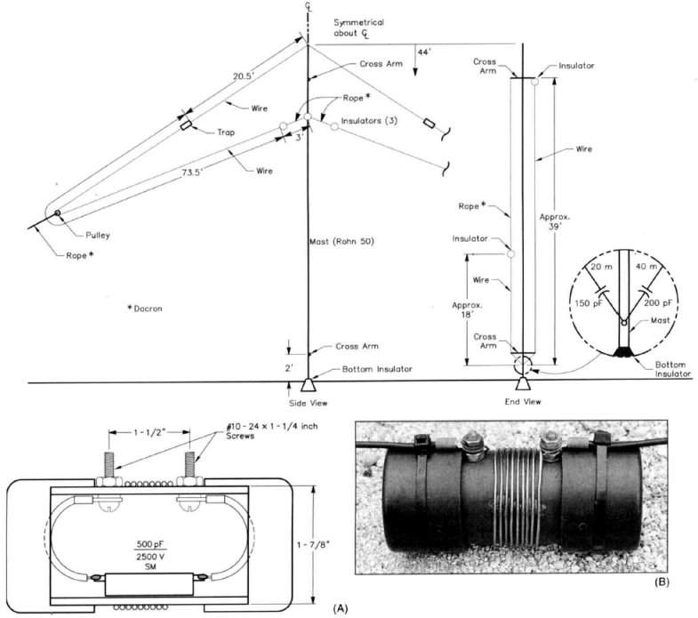

160 - Marconi Antenna for 136 kHz

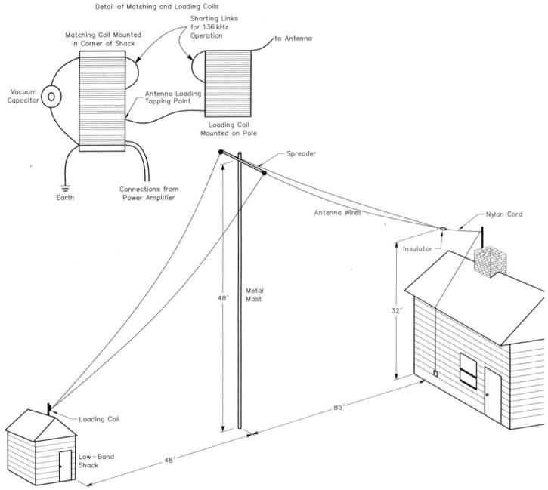

161 - Simple Killer Antenna for 40m

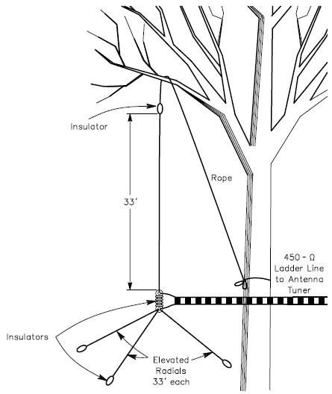

162 - Stub-Directed V Antenna for 80m

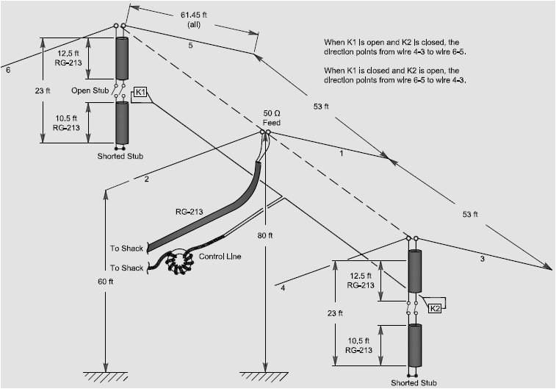

163 - KT0NY Over-and-Under DX Antenna for 20m

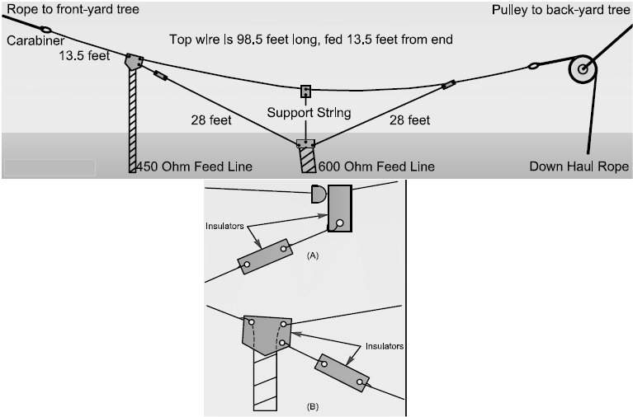

164 - Horizontal Loop Antennas

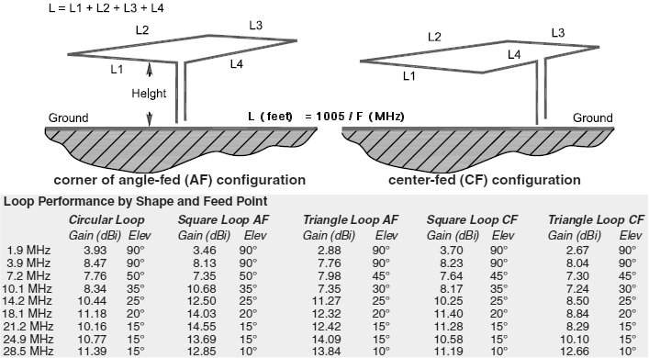

165 - Ribbon J-Pole for 2m

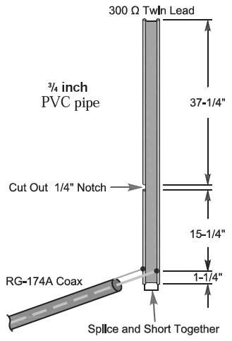

166 - Dual Band Ribbon J-Pole for 2m, 70cm

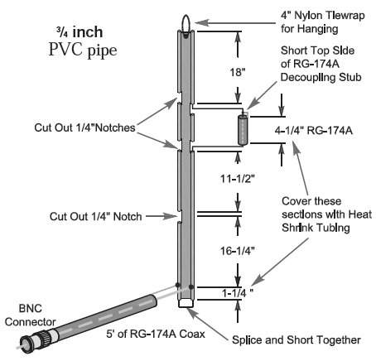

167 - Square Vertical Loop Antenna for 40m

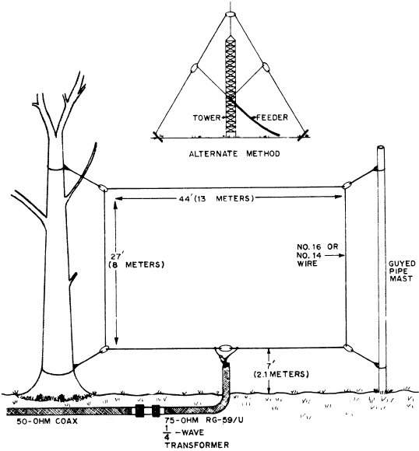

168 - Tri-Band Quad Antenna for 20m, 15m, 10m

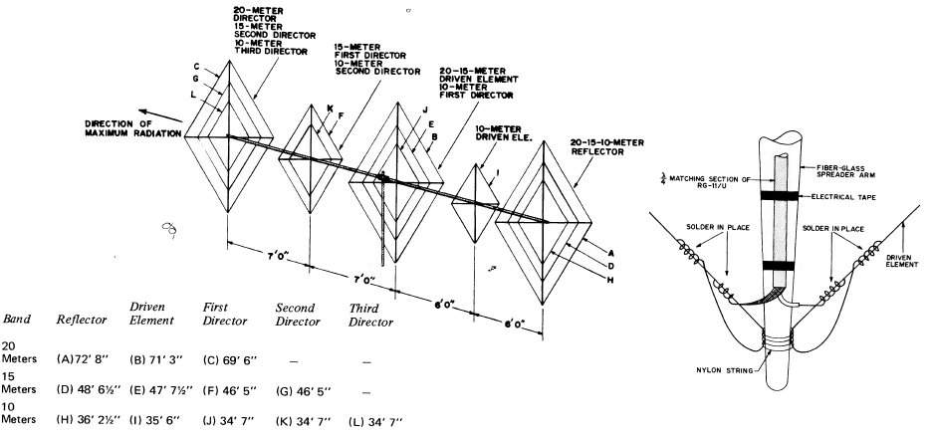

169 - 3D Quad Antenna for 80m, 40m, 20m, 15m, 10m

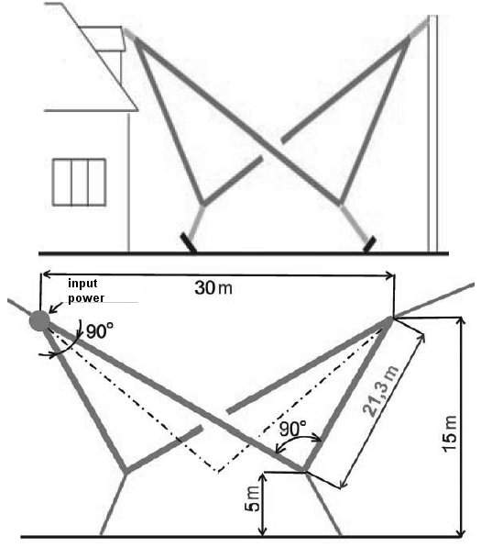

170 - Sloping Wire Antenna for 30m, 20m, 17m, 15m, 12m, 10m

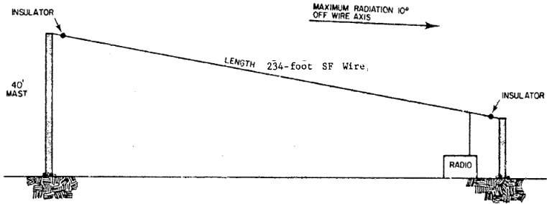

171 - Broadband Dipole Antenna with Coaxial Resonator for 80m

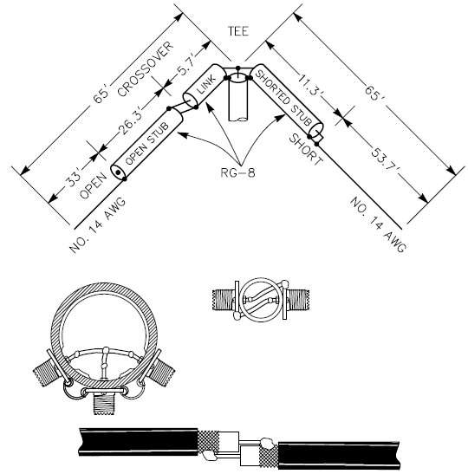

172 - Resonant Feedline Dipole Antenna for 80m

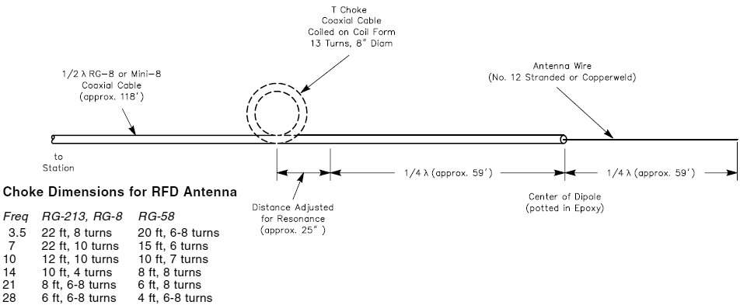

173 - Dual-Band Loading Wire Antenna for 80m, 30m

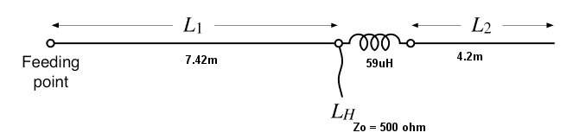

174 - Stub Matching Antennas

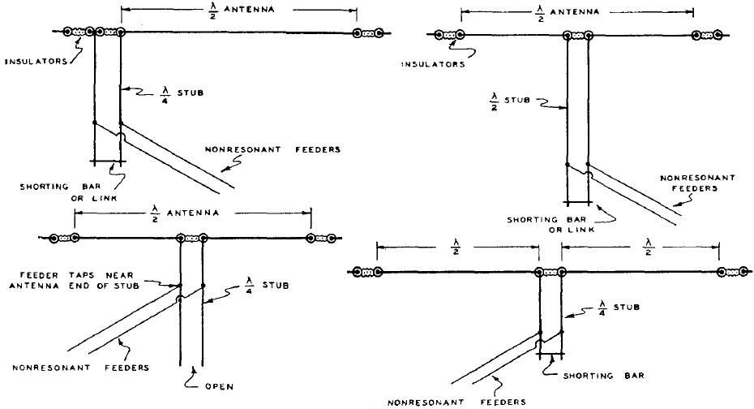

175 - J-Style Vertical Wire Antenna for 10m

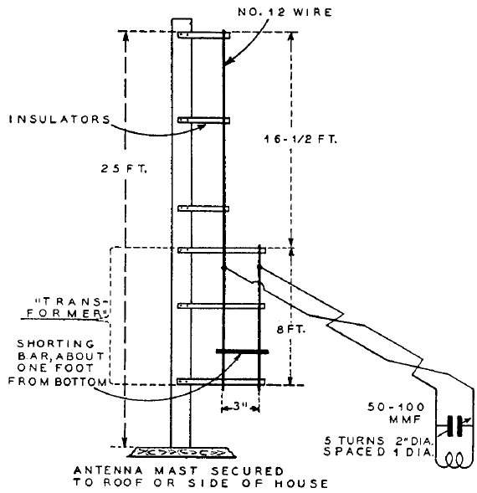

176 - Dual Band Vertical with Zepp Feeders for 40m, 20m

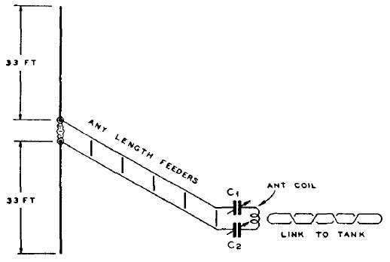

177 - RCA Double Doublet for 40m to 12m

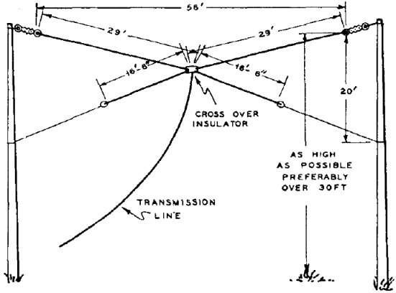

178 - RCA Spiderweb Antenna for 40m to 6m

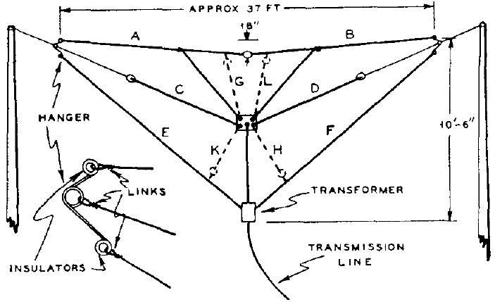

179 - Folded Dipole with Shorted Straps

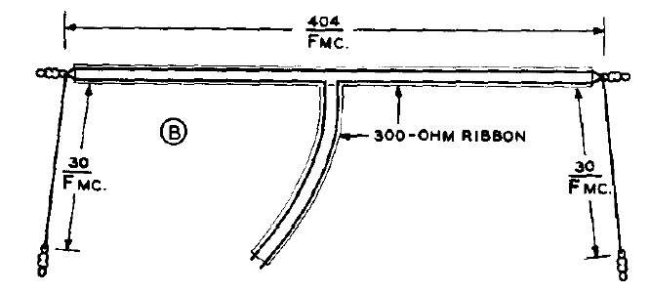

180 - Twin-Lead Marconi Antenna for 160m, 80m

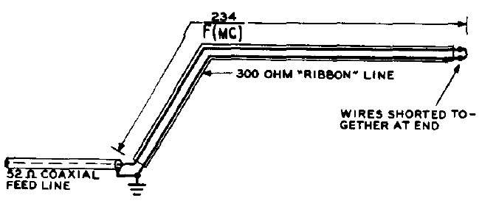

181 - Broadband Antenna Quarter-Wave Balun for 80m

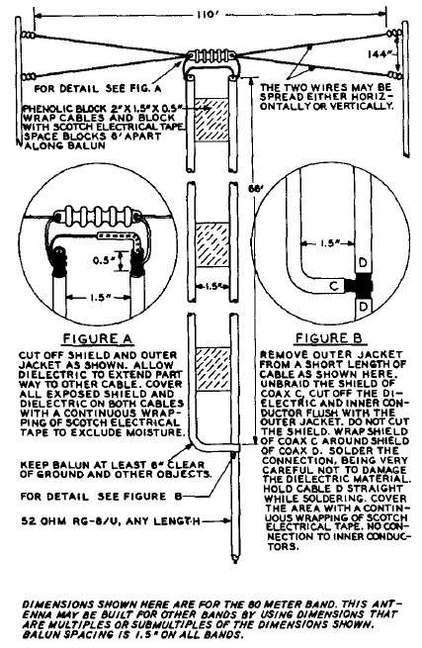

182 - Three-Quarter-Wave Folded Doublet for Dual-Band

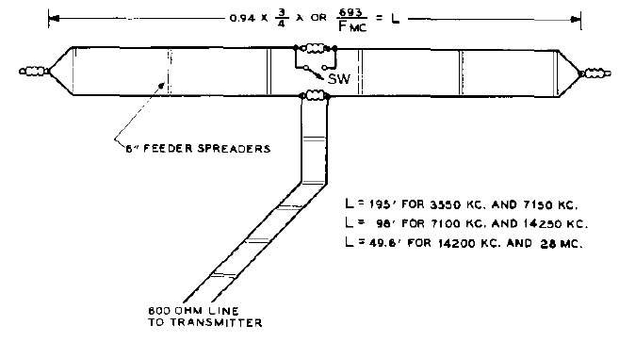

183 - Three-Quarter-Wave Folded Doublet No-Switch for Dual-Band

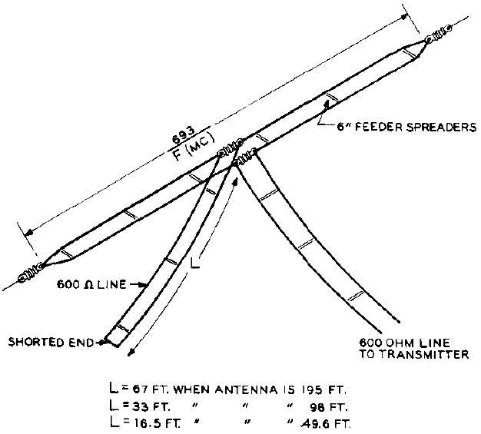

184 - Wideband Omni-Directional Discone Antenna

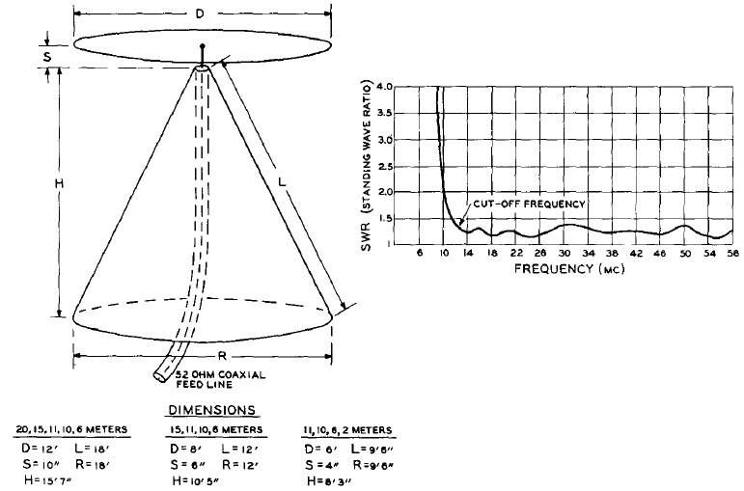

185 - Wideband Rhombic Antenna for 40m to 10m

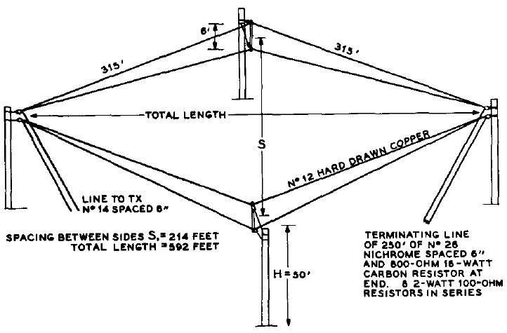

186 - Pre-Cut Linear Array Antenna 3dB-Gain for 40m

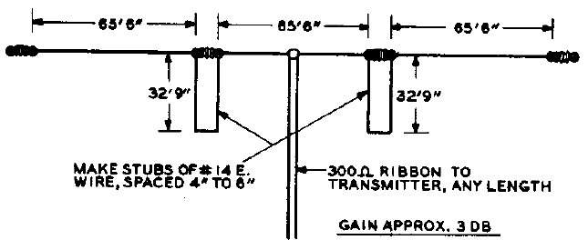

187 - X-Array Antenna 6dB-Gain for 20m, 15m, 10m

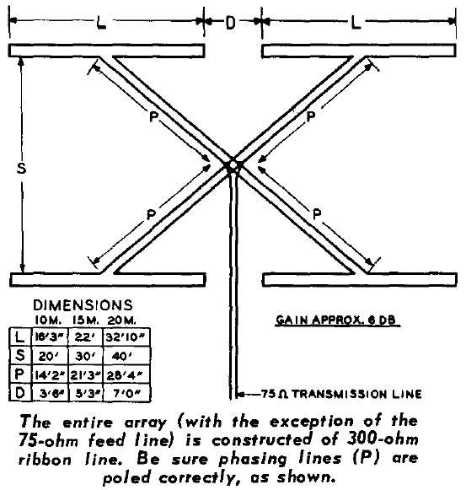

188 - Double-Bruce Array Antenna 5dB-Gain for 20m, 10m

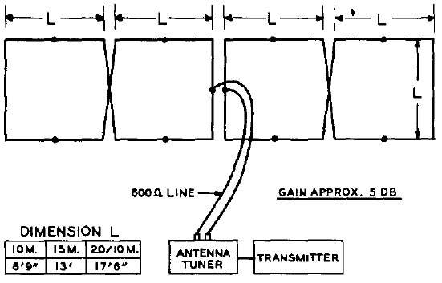

189 - Bi-Square Broadside Array 4dB-Gain for 20m, 15m, 10m

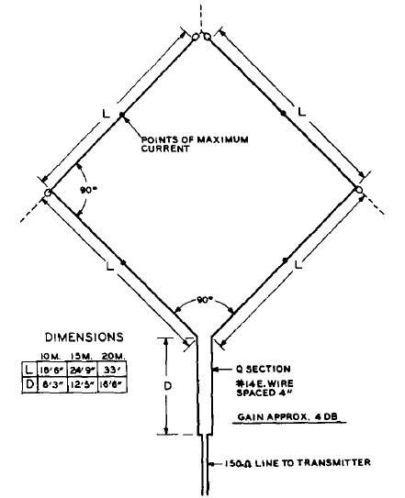

190 - Six-Shooter Broadside Array 7.5dB-Gain for 20m, 15m, 10m

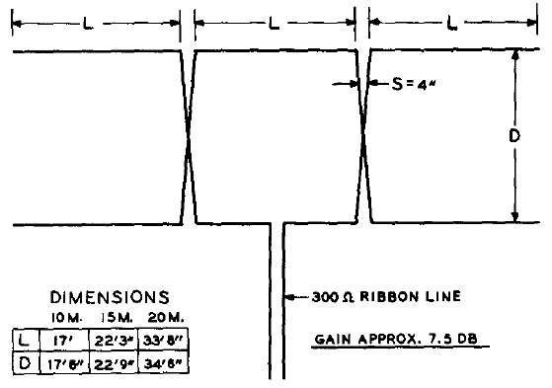

191 - Triplex Flat-Top Beam 4.5dB-Gain for 20m, 15m, 10m

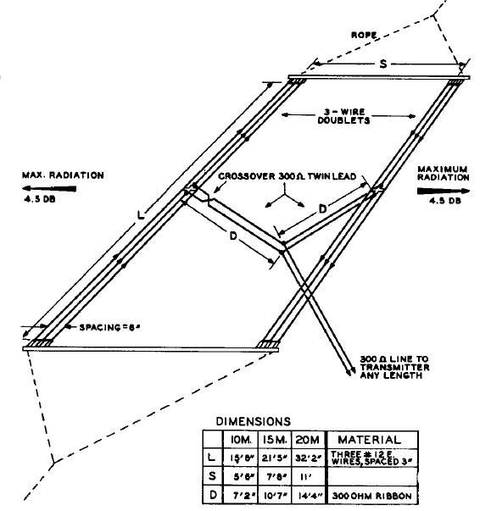

192 - Dual-Band Tilt Antenna for 20m, 10m

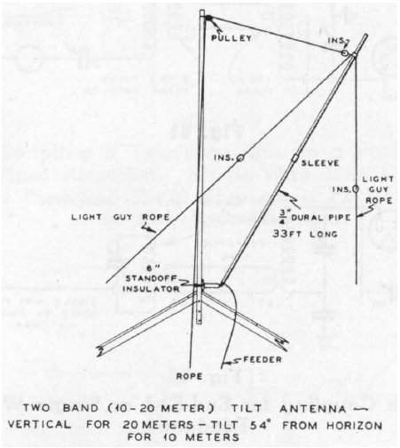

193 - Super Space Multiband Dipole Antenna for 80m to 10m

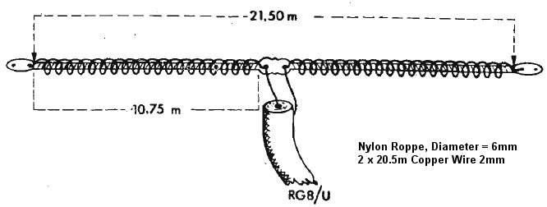

194 - Bi-Square Beam Antenna Gain=5.5dB for 10m

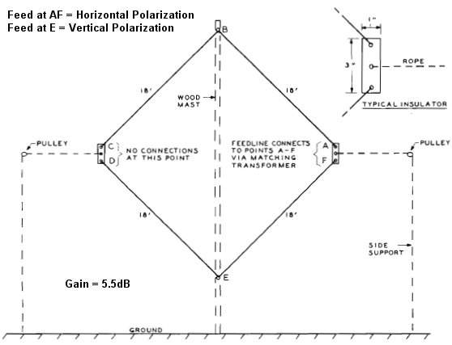

195 - Cousin of G5RV Multiband Antenna for 40m to 10m

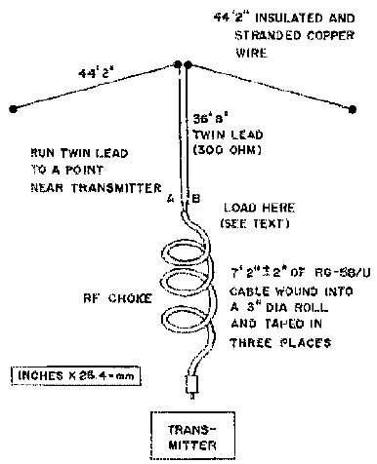

196 - Cayman Quad Antenna for 20m

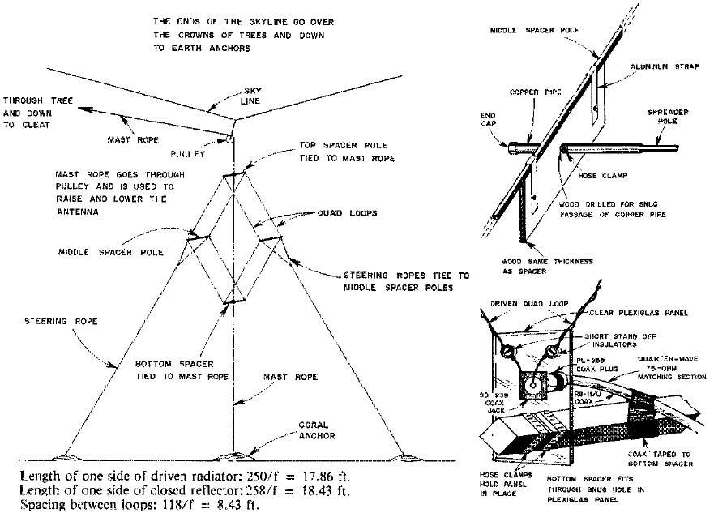

197 - Hentenna Gain=3dB with Bazooka Match for 6m

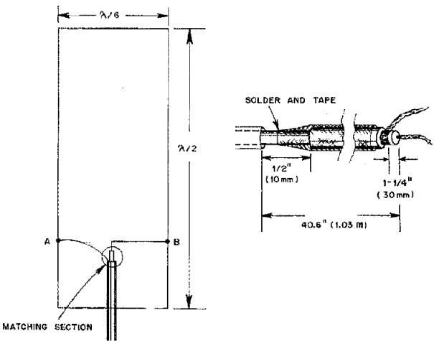

198 - X-Beam Antenna Gain=3dB for 20m

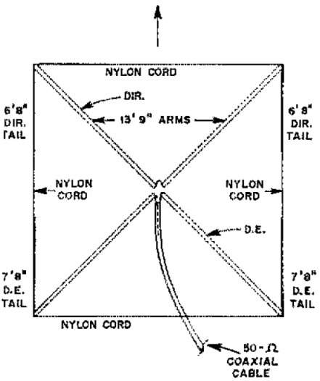

199 - Twin Delta Loop Antenna Gain=6dB for 160m, 80m, 40m

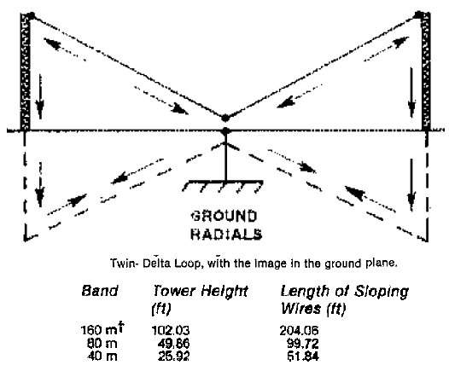

200 - Inverted-V Beam Antenna for 30m

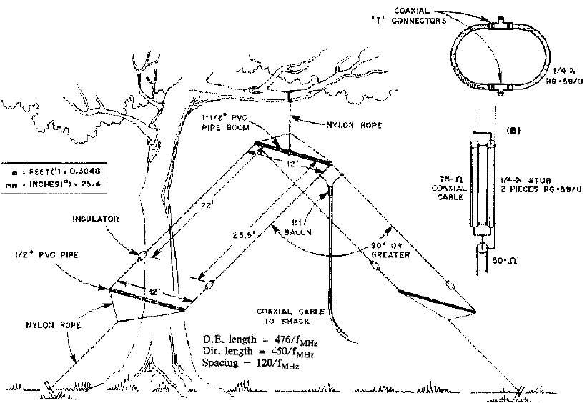

201 - FD4 Windom Antenna for 80m, 40m, 20m, 10m

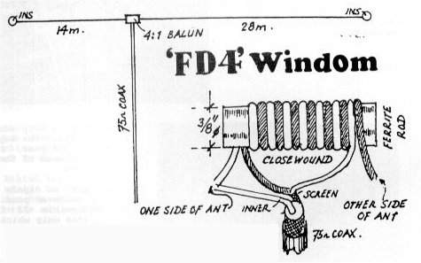

202 - Two Elements Phased Delta Loop for 40m

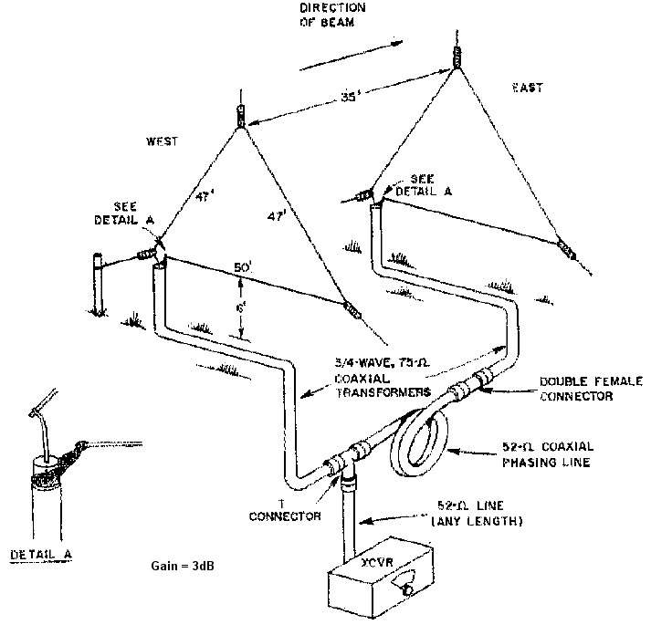

203 - Three Elements Wire Yagi for 10m

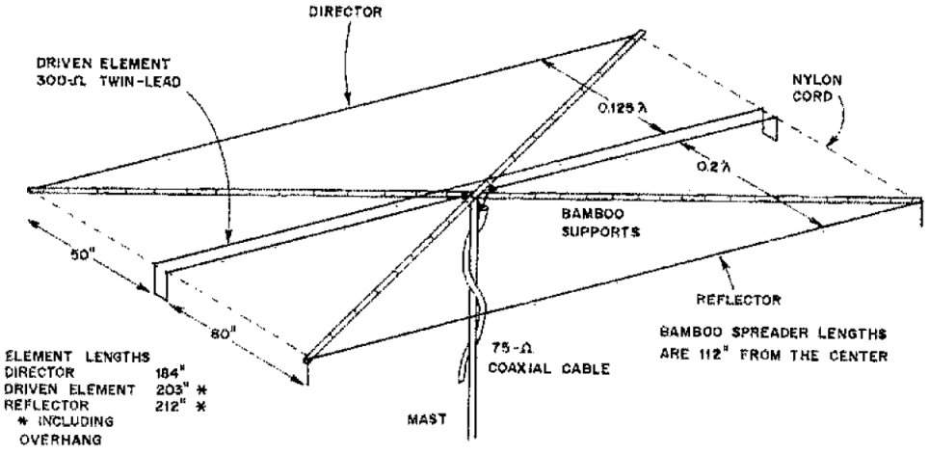

204 - Low Radiation Angle Full-Wave Loop Antenna for 80m

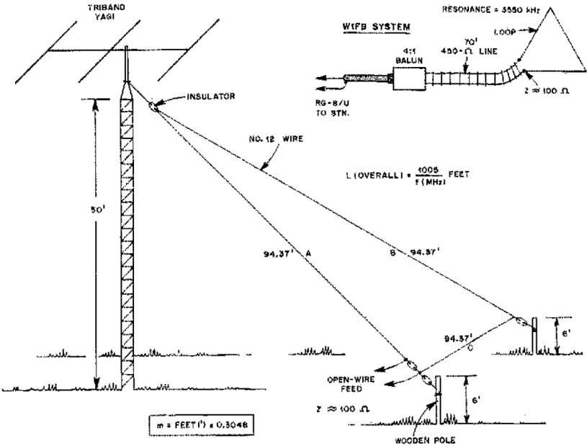

205 - Collinear Antenna Gain=3dB for 2m

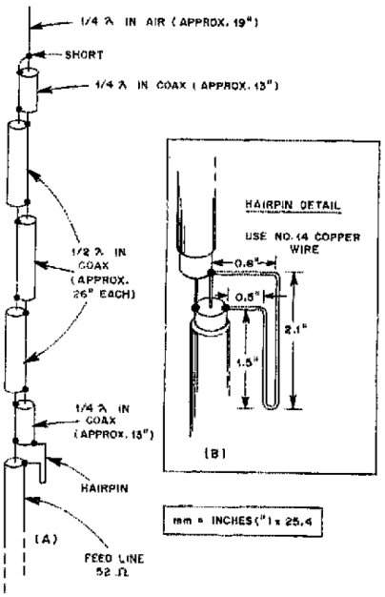

206 - X-Ray Monoband Antenna Gain=6.5dBd

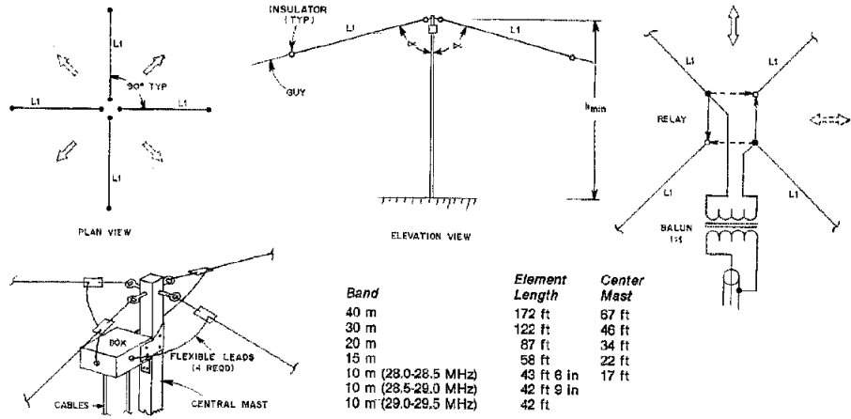

207 - Broadside Collinear Curtain Array for 20m

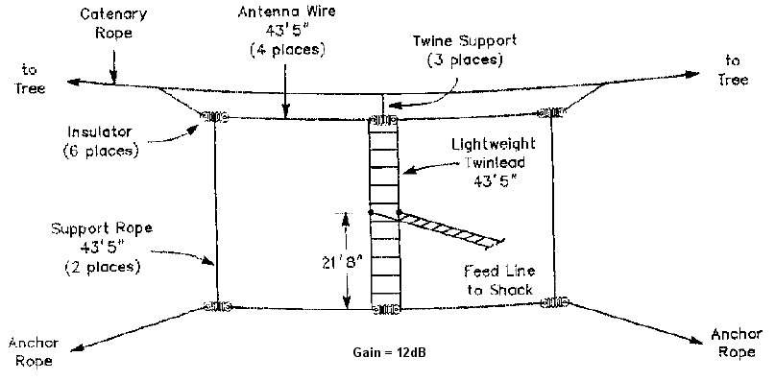

208 - Shrunk Loop Antenna for 80m, 40m

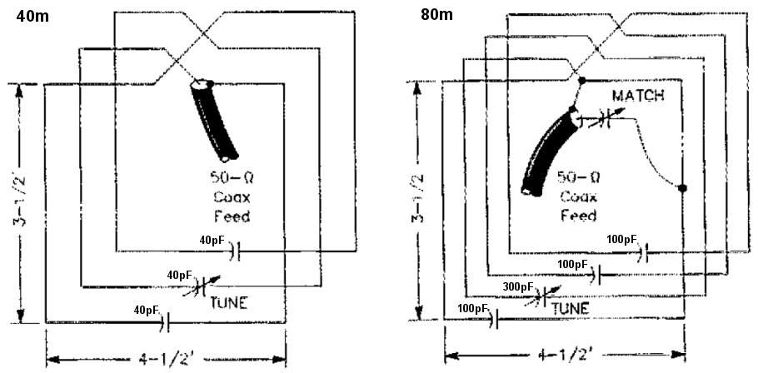

209 - λ/3 Multiband Dipole for 40m, 20m, 17m, 15m, 13m, 10m

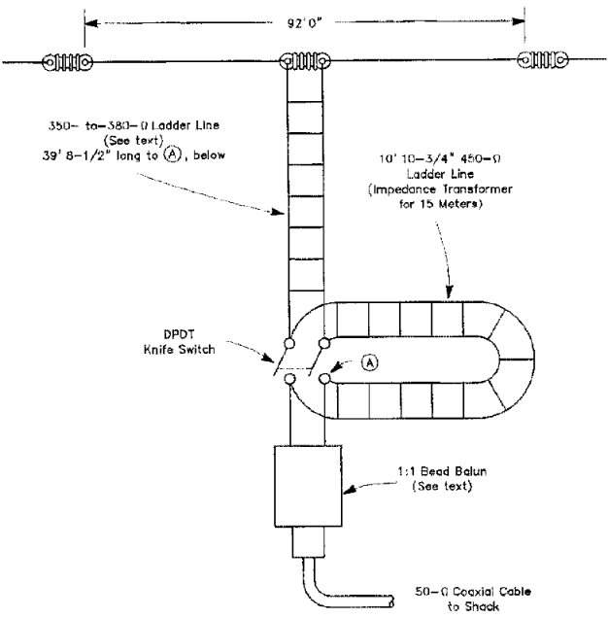

210 - K3LR Sloper Antenna Gain=3dB for 160m

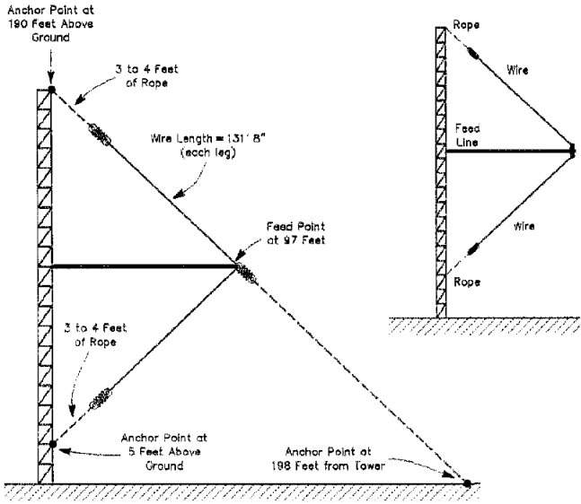

211 - Mini Folded Vertical Monopole Antenna for 160m, 80m, 40m

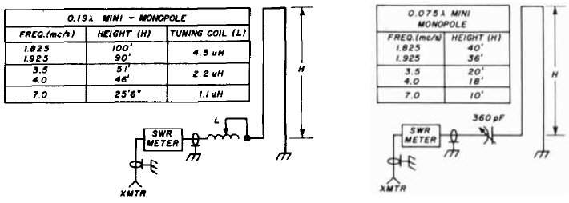

212 - Three Band Dipole for 80m, 40m, 20m

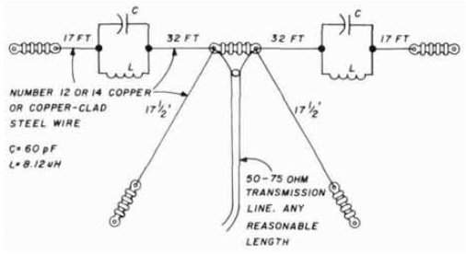

213 - Stub Matched Dipole Antenna

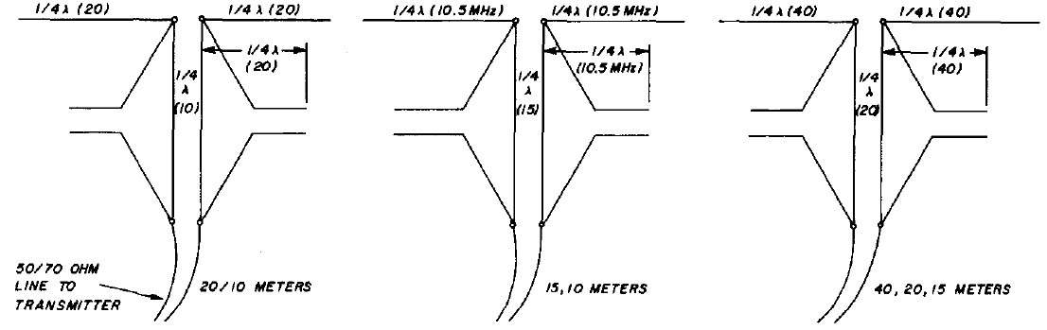

214 - Inverted-Vee Antenna with Bazooka Match

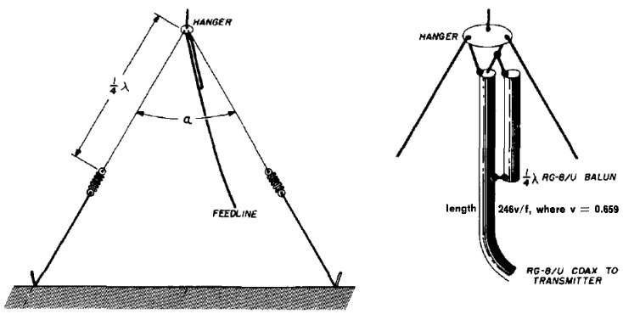

215 - Multiband Long Wire Antenna for 40m, 20m, 15m, 10m

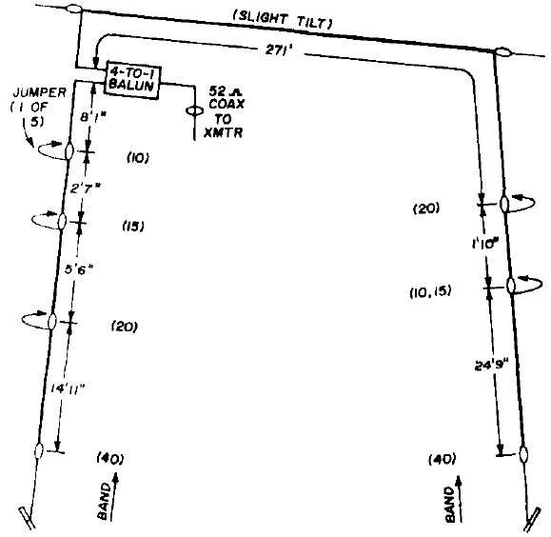

216 - Converted Vee Antenna for 80m, 40m

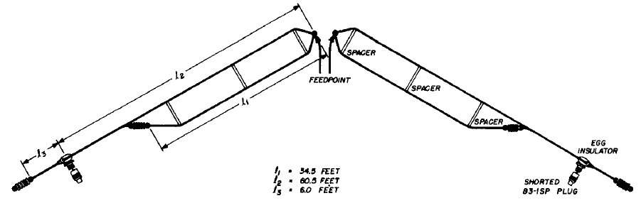

217 - Swiss Quad Antenna for 20m, 15m, 10m

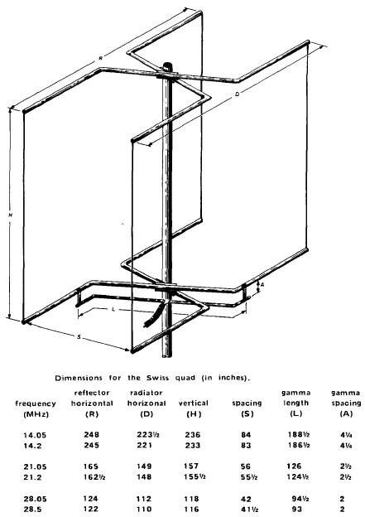

218 - Japanese Quad Antenna for 20m, 15m, 10m

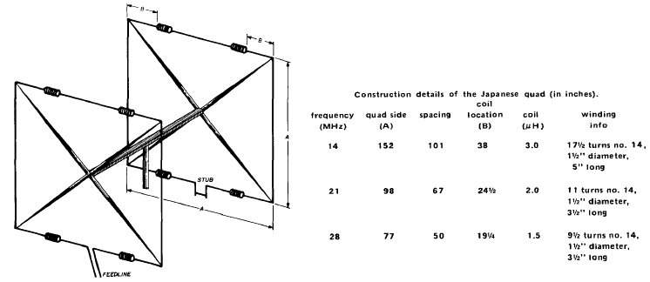

219 - Seven-Elements Triangle Beam Antenna for 20m

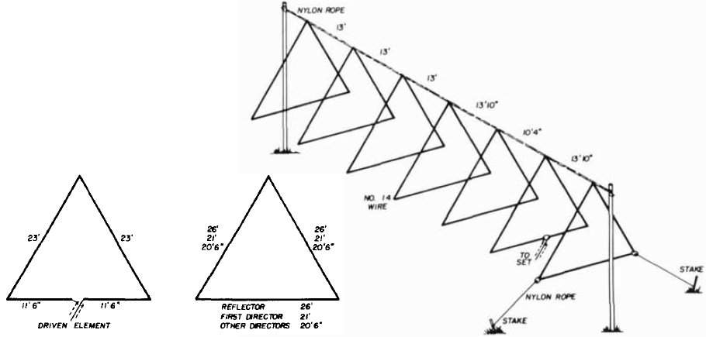

220 - Log Periodic Wire Antenna for 40m

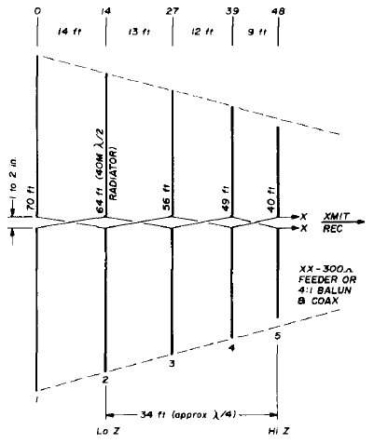

221 - Three-Elements 90-degrees Wire Beam for 20m

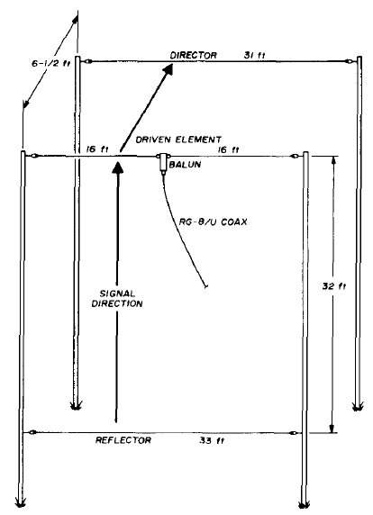

222 - Two-Elements Wire Beam for 20m

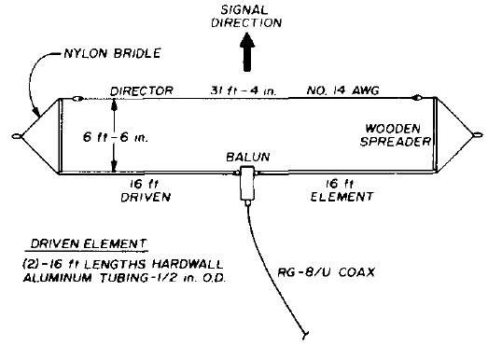

223 - Suitcase-Fit Dipole Antenna for 80m, 40m, 20m

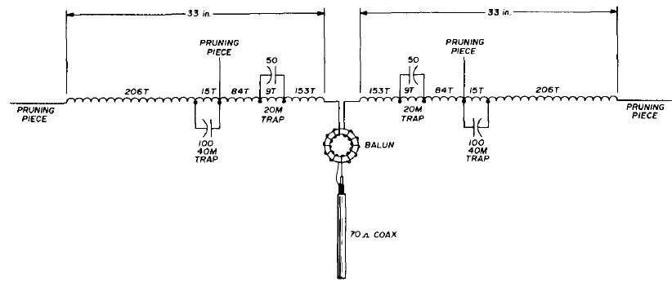

224 - Multiband Coaxial Dipole for 80m, 40m

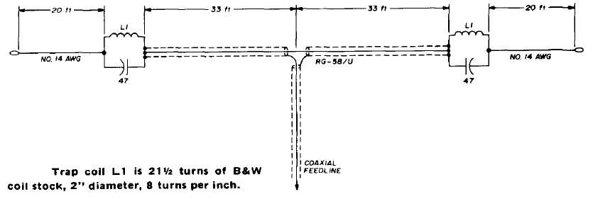

225 - Vertical Log Periodic Antenna for 80m, 40m

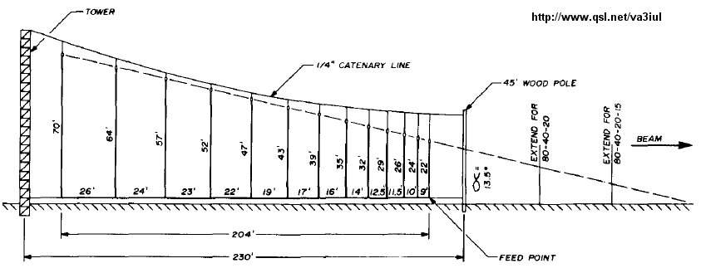

226 - Inverted Vertical Log Periodic Antenna for 40m

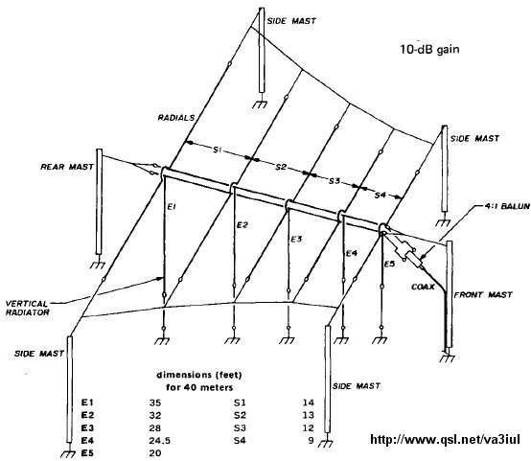

227 - Double Extended Zepp Antenna Gain=7dB for 15m

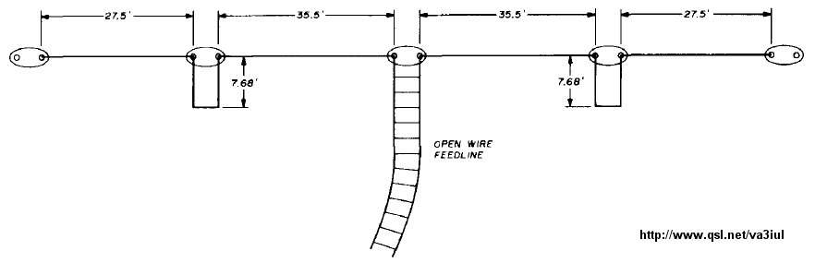

228 - Double Lazy-H Antenna G=10dB for 70cm

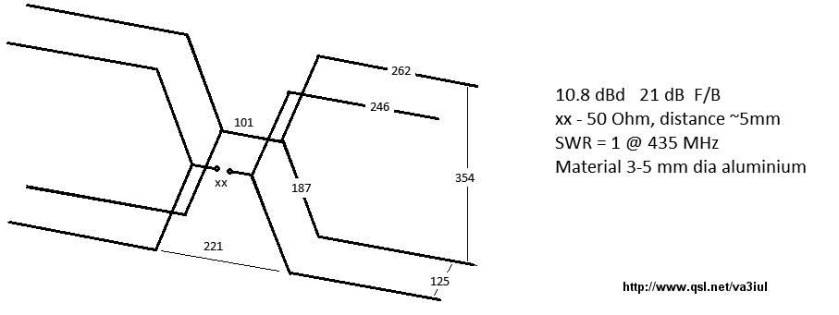

229 - Wire Log Periodic Antenna G=12dB for 15m, 20m

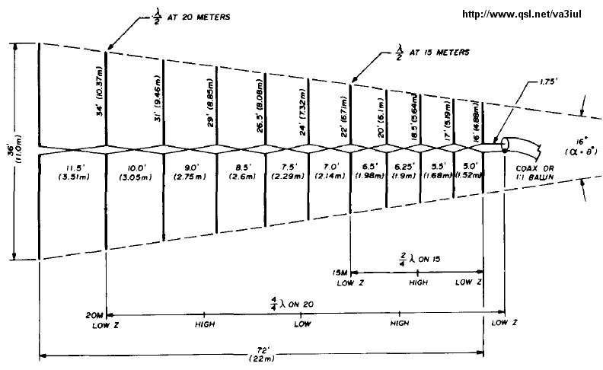

230 - Five-Elements Vertical Log Periodic for 80m, 40m, 20m

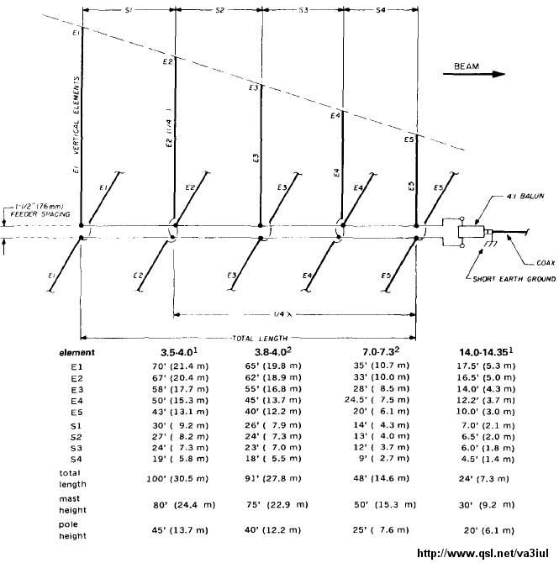

231 - Sloping Delta Loop Antenna for 40m

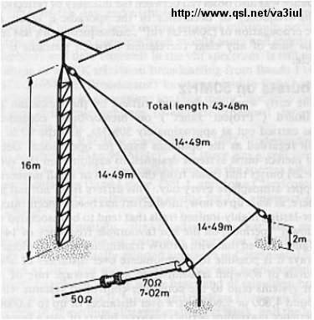

232 - Doublet Antenna for 160m

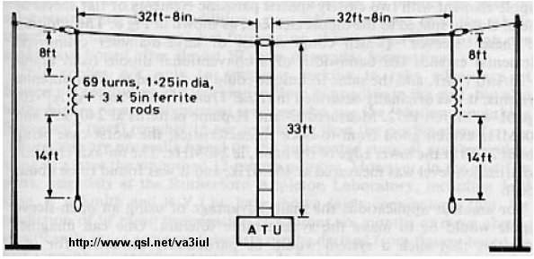

233 - Log Periodic Wire Beam for 40m

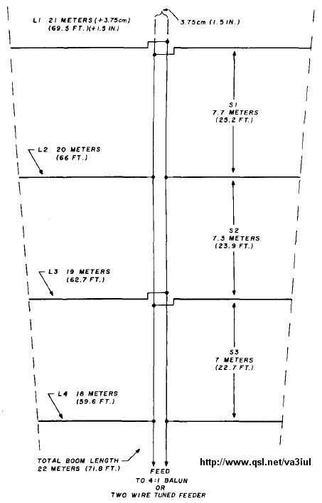

234 - G3LDO Wire Beam Antenna for 20m, 15m, 10m

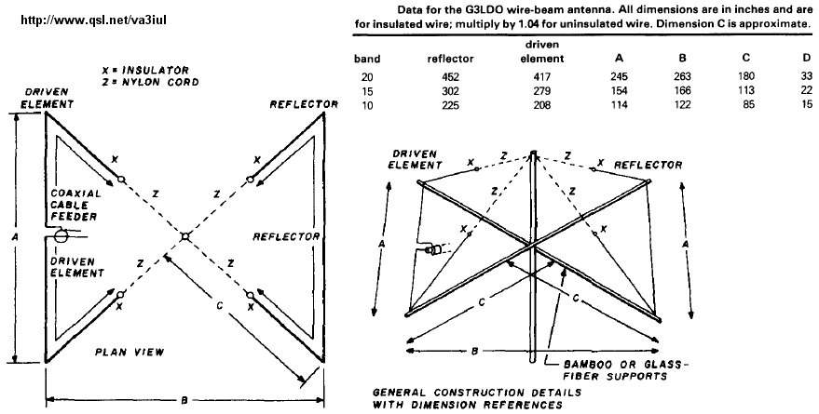

235 - Phased Delta Loop Array for 20m

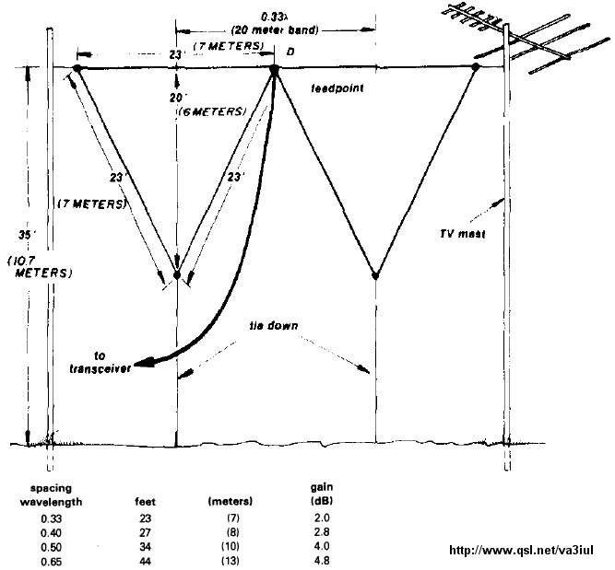

236 - Dual Band V-dipole for 80m, 40m

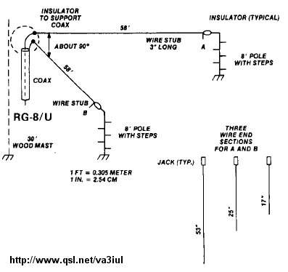

237 - Collinear Array 5dB-Gain for 15m

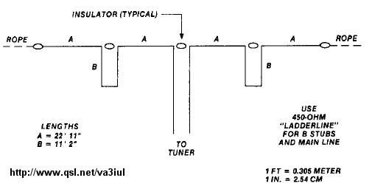

238 - Two-Band Quad Loop Antenna 80m, 40m

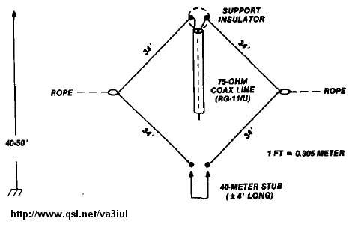

239 - K7CW Quad Antenna

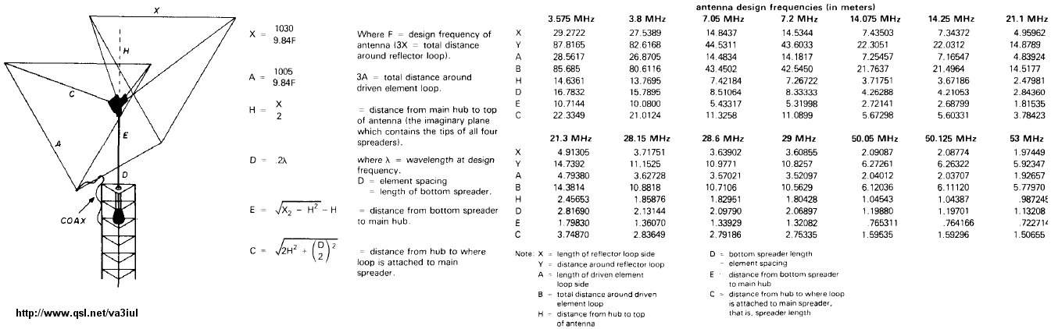

240 - Broadband Short Dipole for 80m

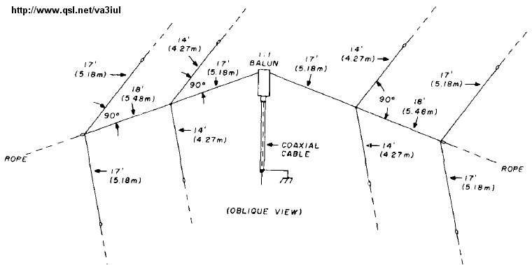

241 - Off-Center Fed Dipole for 40m, 20m, 10m

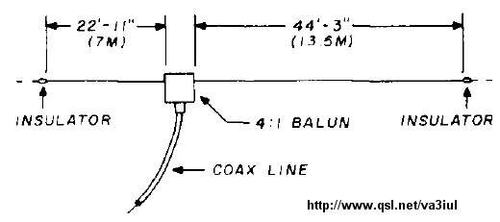

242 - Broadband Sloper Antenna for 80m

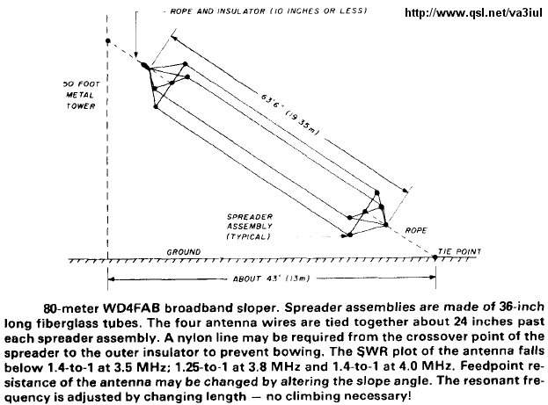

243 - Two-Frequency Dipole Antenna for 80m

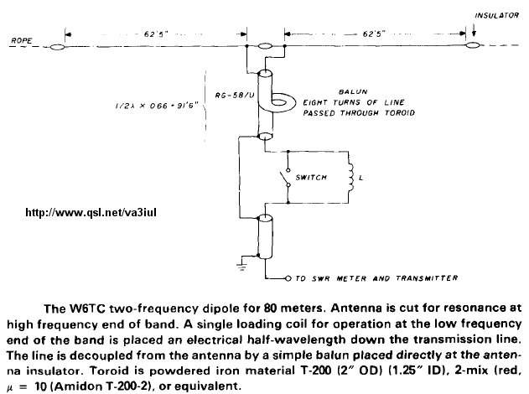

244 - Top Loaded Vertical Antenna for 160m

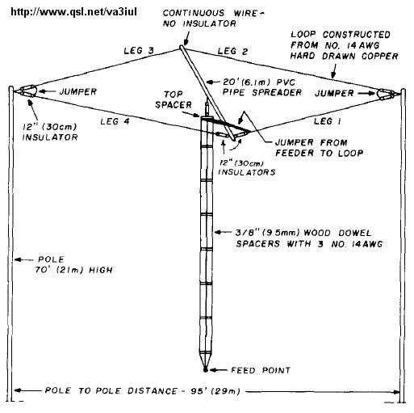

245 - Two Loop Beam Antenna for 20m, 15m

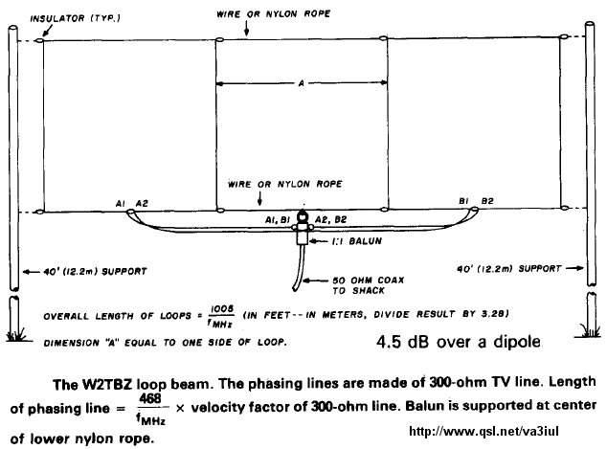

246 - Corner-Fed Delta Loop Antenna for 80m, 40m, 20m

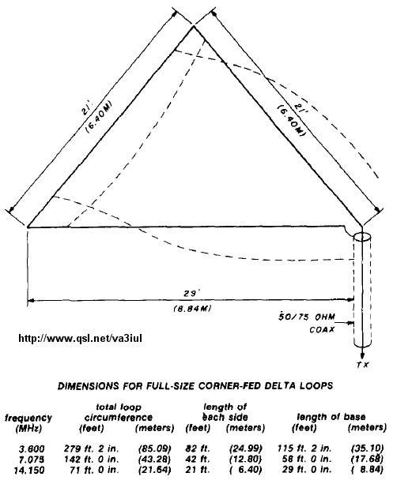

247 - Loaded Delta Loop Antenna for 40m, 20m

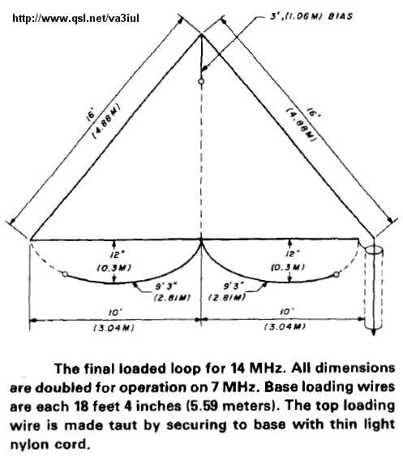

248 - Compact Size Dipole for 80m

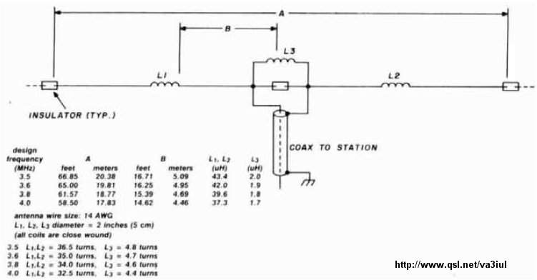

249 - JAWS 3dB Gain Antenna for 40m

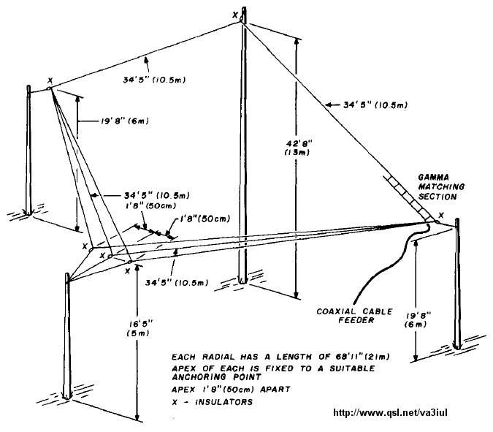

250 - Inverted-V Antenna for 160m

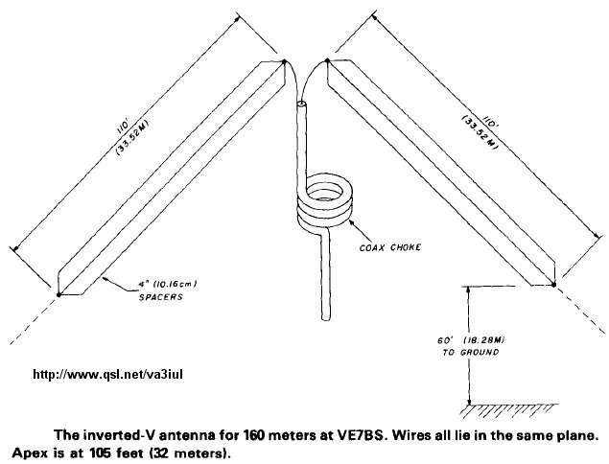

251 - Lazy-U Antenna for 160m

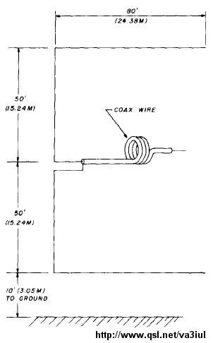

252 - AF3V Compact Antenna for 160m

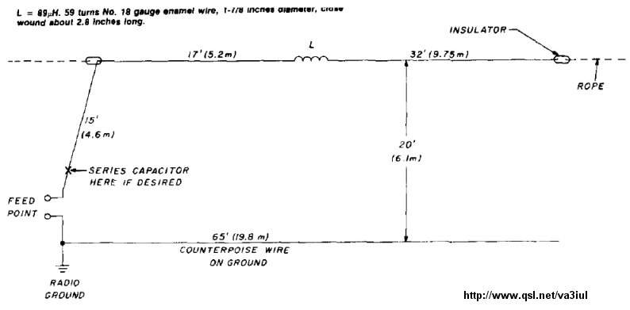

253 - Hot Beam Wire Antenna for 40m

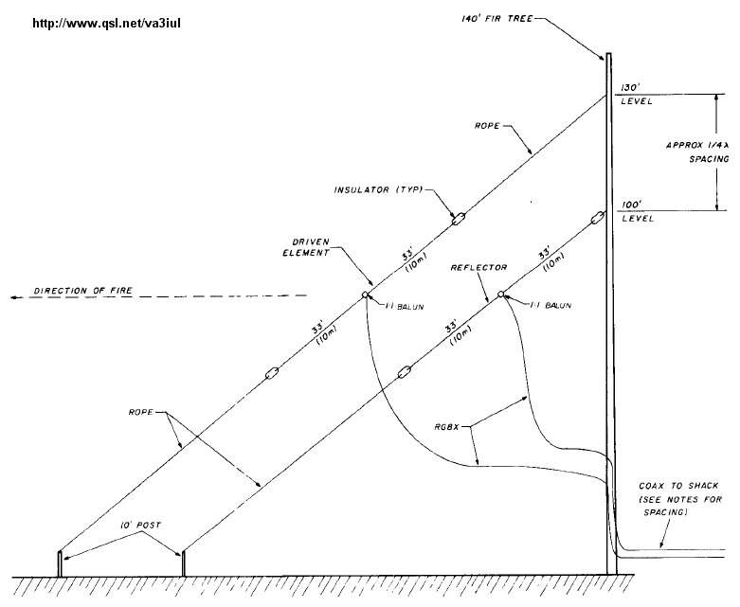

254 - Sloping Delta Loop for 40m

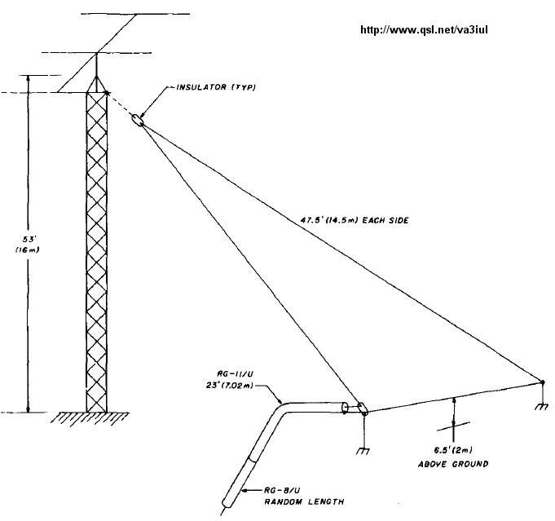

255 - K6FD Multiband Antenna with T-tuner

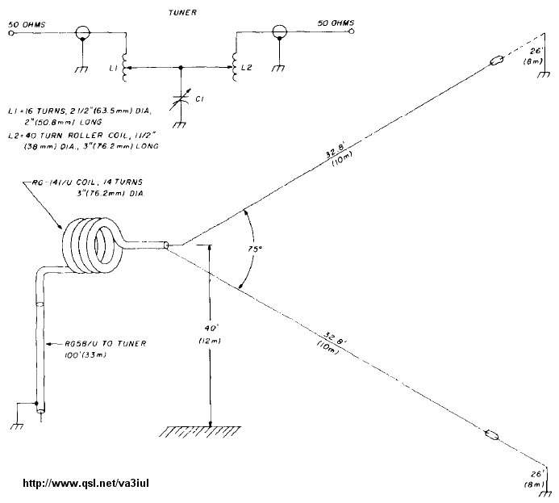

256 - Dual Band Dipole Antenna for 17m, 10m

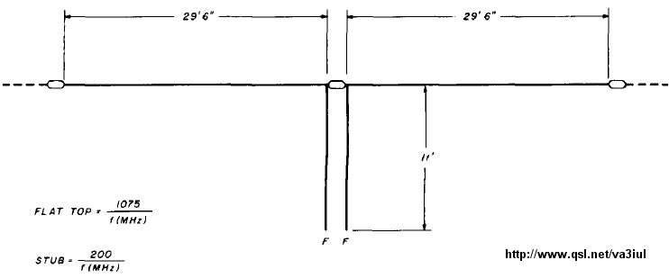

257 - Compact Travel Dipole Antenna for 10m, 15m, 20m

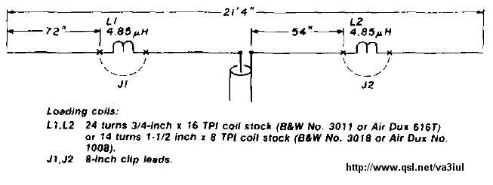

258 - End-Fire Antenna for 160m, 80m, 40m, 20m

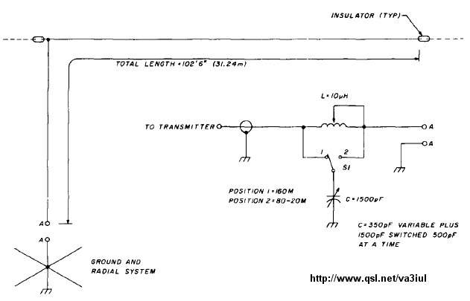

259 - Four Band Loop for 40m, 20m, 15m, 10m

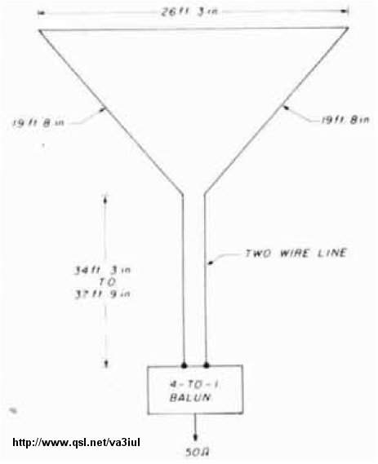

260 - Carolina Windom Antenna for 80 to 10m

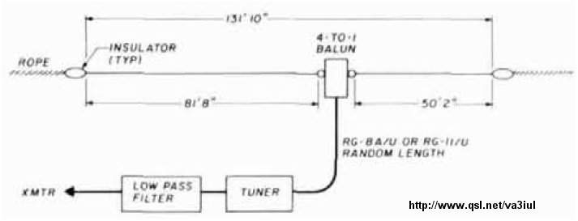

261 - Shortened Loaded Dipole for 40m

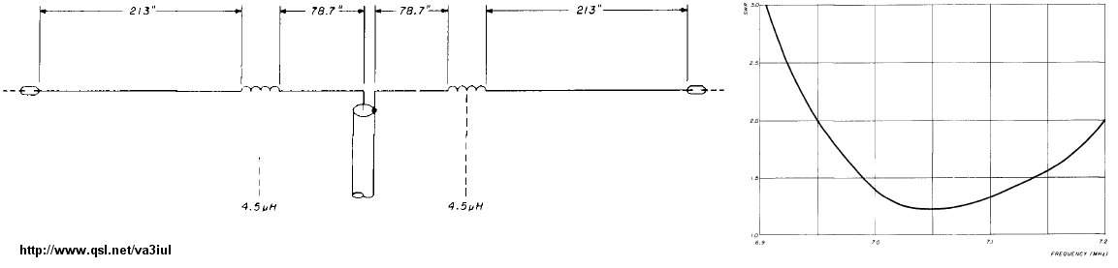

262 - Shortened Loaded Dipole for 80m

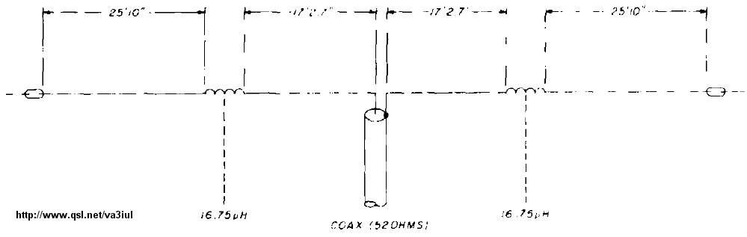

263 - Low Radiation Angle Inverted Delta Loop for 80m

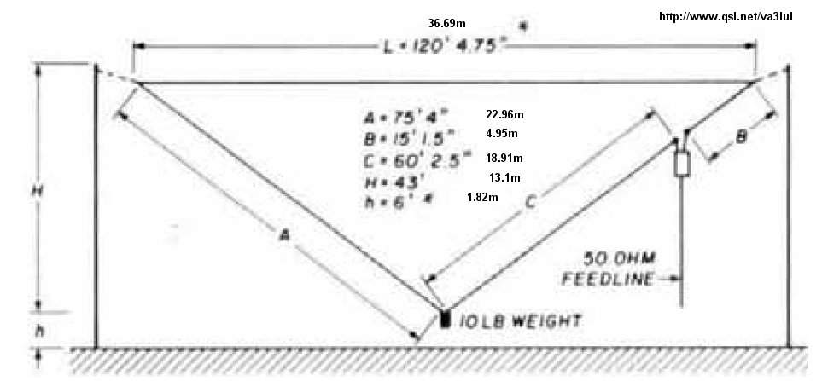

264 - Compact Dipole Antenna for 40m, 15m

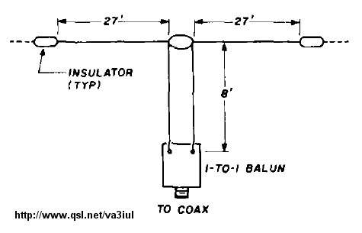

265 - Vertical Delta Loop for 40m to 10m

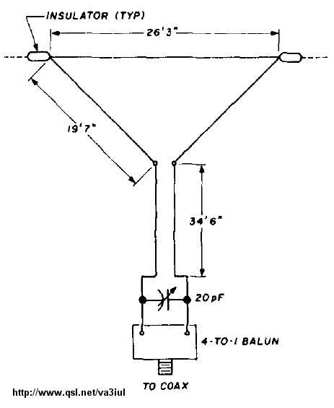

266 - Delta Loop Antenna for 17m

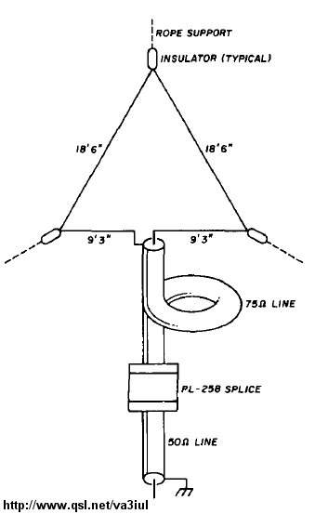

267 - Bi-Square Beam Gain=3dBd for 17m

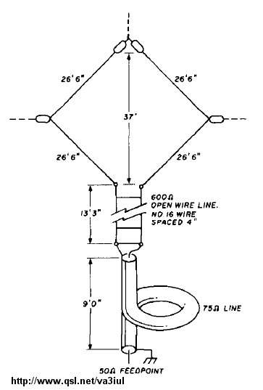

268 -Trap Dipole Antenna for 17m,13m

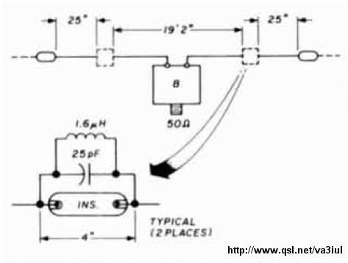

269 - Hanging Unipole Antenna for 160m, 80m

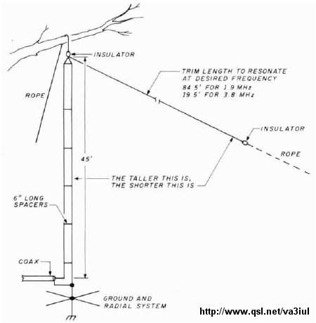

270 - Wideband Sloping Vee Antenna - 30m to 6m

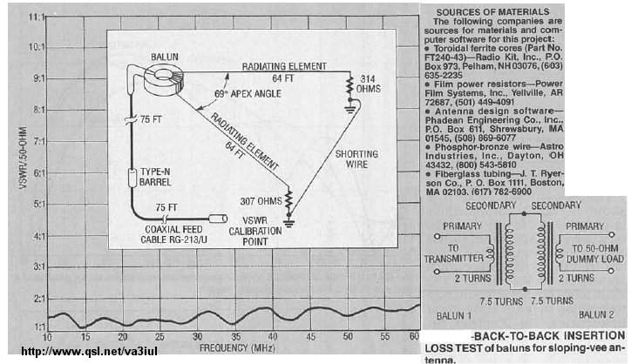

271 - 5/8 Wavelength Antenna

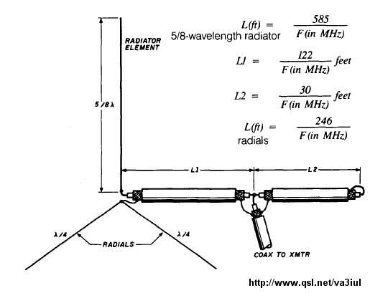

272 - C-Pole Vertical Antenna

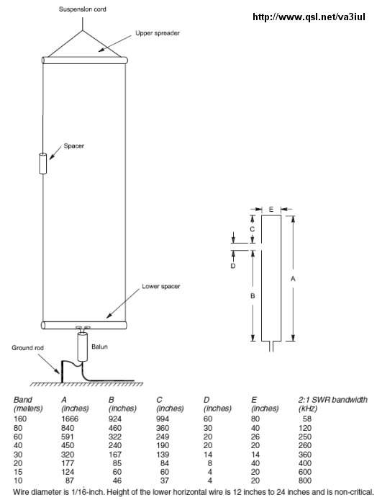

273 - Bobtail Antenna for 30m

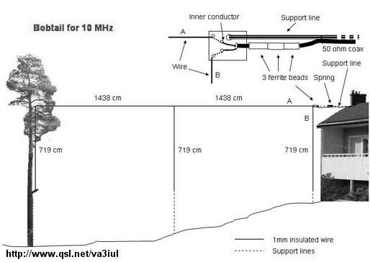

274 - Bobtail Antenna for 40m

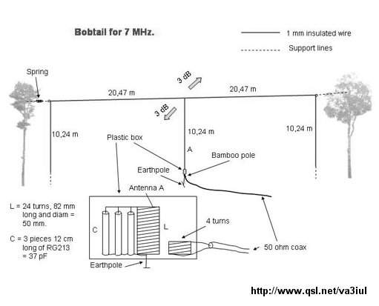

275 - Two Elements Vertical Loop Antenna for 40m

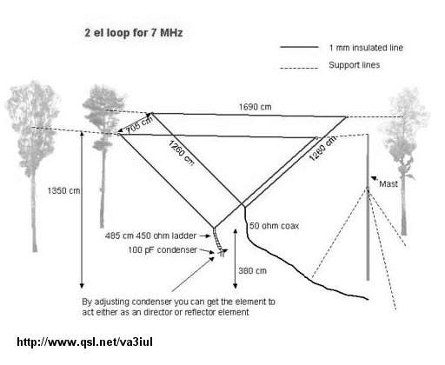

276 - Double Extended Zepp Antenna for 40m

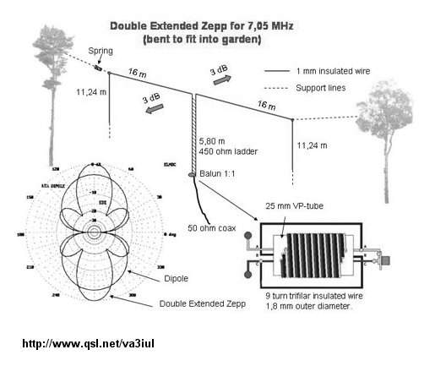

277 - Reversible Moxon Flip Beam for 40m

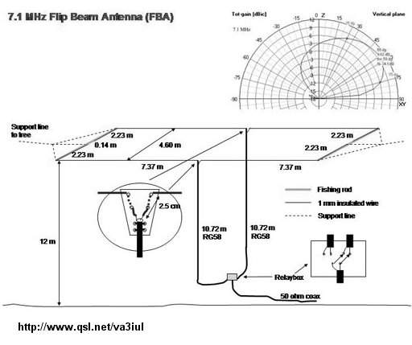

278 - Spitwire Antenna for 40m

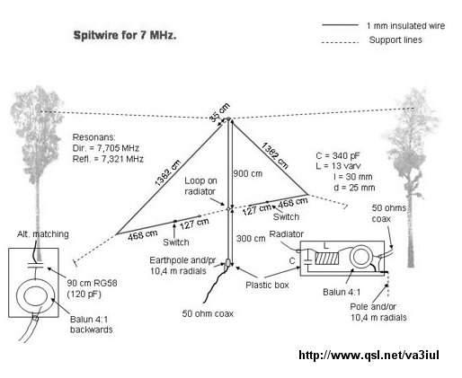

279 - Fork Antenna for 40m

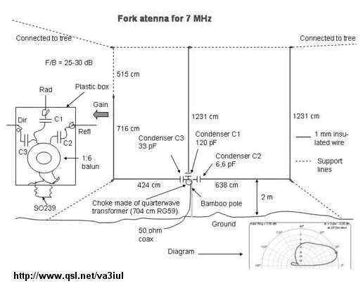

280 - Veebeam Antenna 3dB-Gain for All Bands

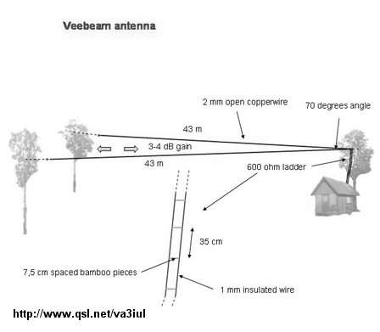

281 - Vertical Moxon Antenna for 10m

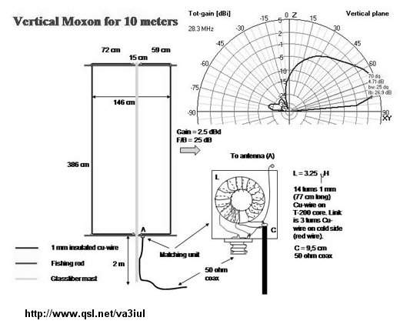

282 - Half-Square Antenna for 30m

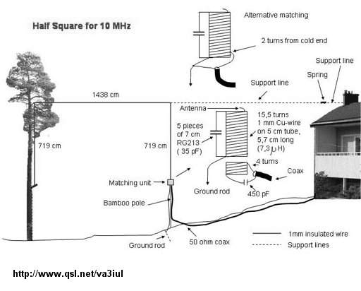

283 - Rotatable Vertical Delta Loop for 20m

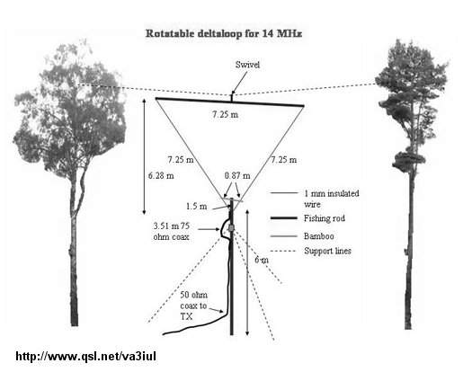

284 - Mini-Horse Antenna 10dB-Gain for 40m-to-2m

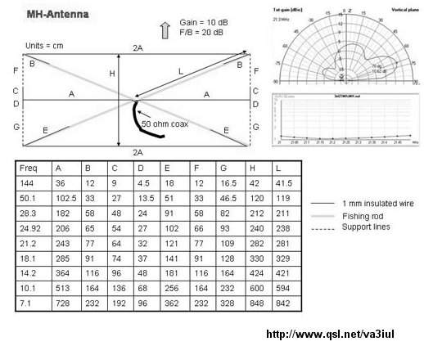

285 - Compact Moxon Antenna 5dB-Gain for 40m

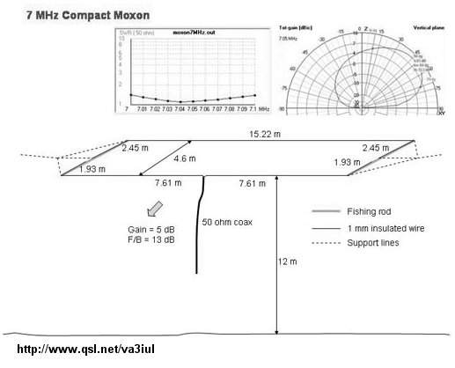

286 - Two Elements Sloping Delta Loop 8dB-Gain for 10m

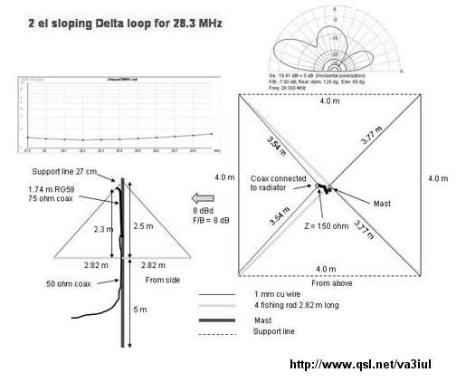

287 - Two Elements Phased Vertical Antenna 3dB-Gain for 40m

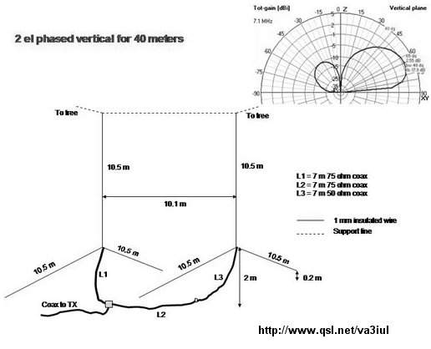

References:

Antenna Toolkit - J. Carr
Practical Antenna Handbook - J. Carr
More Antenna Classics - C. Hutchinson
Amateur Radio Techniques - P. Hawker
The Radio Handbook - W. Orr (editor), 15th edition
The Radio Antenna Handbook - Engineering Staff of "Radio"
Jones Antenna Handbook - Frank C. Jones
SM0DTK - http://www.sm0dtk.se/antennas.htm
ARRL Antenna Handbook 1990-2007
ARRL Handbook 1937-2009
ARRL Antenna Compendium
73 Magazine 1970-2002
Funkamateur Magazine 1990-2011
RSGB Handbook - 2007 - 2010
QST Magazine - 1980 - 2010
Ham Radio Magazine - 1969 - 1990
Radio-Electronics Magazine - 1986 - 1990

home: http://www.qsl.net/va3iul

网络资源，仅用于爱好者学习交流使用，严禁用于商业用途。BG3TQS 辛巴 QQ：1227441189

