NATO phonetic alphabet

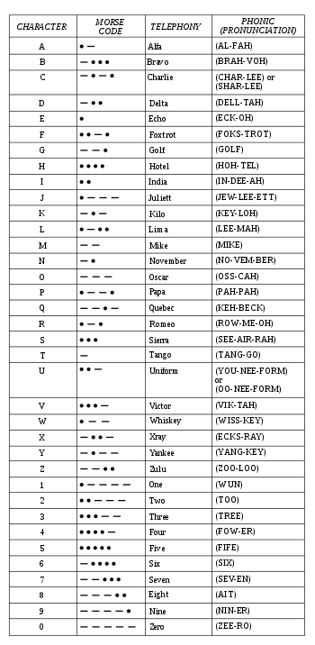

Q code
Code | Question | Answer or Statement
QLE | What is your expected signal? | The expected signal is low...
QNI | May I join the net? | You may check in...
QRA | What is the name (or call sign) of your station? | The name (or call sign) of my station is ...
QRG | Will you tell me my exact frequency (or that of ...)? | Your exact frequency (or that of ... ) is ... kHz (or MHz).
QRH | Does my frequency vary? | Your frequency varies.
QRI | How is the tone of my transmission? | The tone of your transmission is (1. Good; 2. Variable; 3. Bad)
QRJ | How many voice contacts do you want to make? | I want to make ... voice contacts.
QRK | What is the readability of my signals (or those of ...)? | The readability of your signals (or those of ...) is ... (1 to 5).
QRL | Are you busy? | I am busy. (or I am busy with ... ) Please do not interfere.
QRM | Do you have interference? [from other stations] | I have interference.
QRN | Are you troubled by static? | I am troubled by static.
QRO | Shall I increase power? | Increase power.
QRP | Shall I decrease power? | Decrease power.
QRQ | Shall I send faster? | Send faster (... wpm)
QRS | Shall I send more slowly? | Send more slowly (... wpm)
QRT | Shall I cease or suspend operation?/ shutoff the radio | I am suspending operation. /shutting off the radio
QRU | Have you anything for me? | I have nothing for you.
QRV | Are you ready? | I am ready.
QRW | Shall I inform ... that you are calling him on ... kHz (or MHz)? | Please inform ... that I am calling him on ... kHz (or MHz).
QRX | Shall I standby / When will you call me again? | Please standby / I will call you again at ... (hours) on ... kHz (or MHz)
QRZ | Who is calling me? | You are being called by ... on ... kHz (or MHz)
QSA | What is the strength of my signals (or those of ... )? | The strength of your signals (or those of ...) is ... (1 to 5).
QSB | Are my signals fading? | Your signals are fading.
QSD | Is my keying defective? | Your keying is defective.
QSG | Shall I send ... telegrams (messages) at a time? | Send ... telegrams (messages) at a time.
QSK | Can you hear me between your signals? | I can hear you between my signals.
QSL | Can you acknowledge receipt? | I am acknowledging receipt.
QSM | Shall I repeat the last telegram (message) which I sent you, or some previous telegram (message)? | Repeat the last telegram (message) which you sent me (or telegram(s) (message(s)) numbers(s) ...).
QSN | Did you hear me (or ... (call sign)) on .. kHz (or MHz)? | I did hear you (or ... (call sign)) on ... kHz (or MHz).
QSO | Can you communicate with ... direct or by relay? | I can communicate with ... direct (or by relay through ...).
QSP | Will you relay a message to ...? | I will relay a message to ... .
QSR | Do you want me to repeat my call? | Please repeat your call; I did not hear you.
QSS | What working frequency will you use? | I will use the working frequency ... kHz (or MHz).
QST | – | Here is a broadcast message to all amateurs.
QSU | Shall I send or reply on this frequency (or on ... kHz (or MHz))? | Send or reply on this frequency (or on ... kHz (or MHz)).
QSW | Will you send on this frequency (or on ... kHz (or MHz))? | I am going to send on this frequency (or on ... kHz (or MHz)).
QSX | Will you listen to ... (call sign(s) on ... kHz (or MHz))? | I am listening to ... (call sign(s) on ... kHz (or MHz))
QSY | Shall I change to transmission on another frequency? | Change to transmission on another frequency (or on ... kHz (or MHz)).
QSZ | Shall I send each word or group more than once? | Send each word or group twice (or ... times).
QTA | Shall I cancel telegram (message) No. ... as if it had not been sent? | Cancel telegram (message) No. ... as if it had not been sent.
QTC | How many telegrams (messages) have you to send? | I have ... telegrams (messages) for you (or for ...).
QTH | What is your position in latitude and longitude (or according to any other indication)? | My position is ... latitude...longitude
QTR | What is the correct time? | The correct time is ... hours
QTU | At what times are you operating? | I am operating from ... to ... hours.
QTX | Will you keep your station open for further communication with me until further notice (or until ... hours)? | I will keep my station open for further communication with you until further notice (or until ... hours).
QUA | Have you news of ... (call sign)? | Here is news of ... (call sign).
QUC | What is the number (or other indication) of the last message you received from me (or from ... (call sign))? | The number (or other indication) of the last message I received from you (or from ... (call sign)) is ...
QUD | Have you received the urgency signal sent by ... (call sign of mobile station)? | I have received the urgency signal sent by ... (call sign of mobile station) at ... hours.
QUE | Can you speak in ... (language), – with interpreter if necessary; if so, on what frequencies? | I can speak in ... (language) on ... kHz (or MHz).
QUF | Have you received the distress signal sent by ... (call sign of mobile station)? | I have received the distress signal sent by ... (call sign of mobile station) at ... hours.

